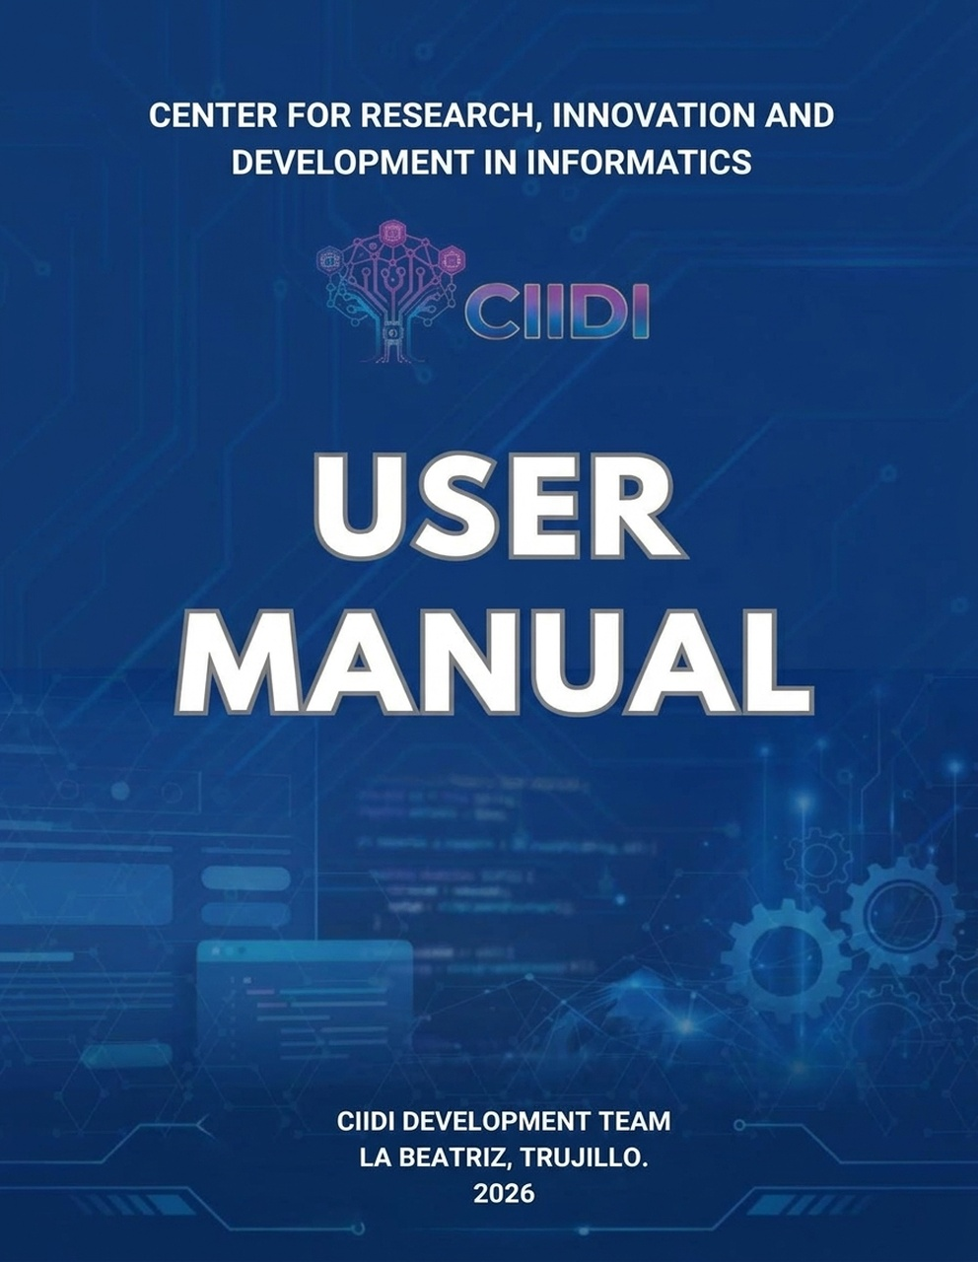
User Manual for the Comprehensive Academic Document Management System for the Scientific Research Committee of the PNF Informatics Supported by Neural Networks.

Authors:
TSU González González Miguel Alejandro V- 32.621.284
TSU Rojo Ramírez José Alejandro V- 30.536.364
TSU Ramírez Duarte Andrus Ruben V- 30.469.331
TSU Pérez Marín José Gregorio V- 31.177.398
Faculty Advisor: Ing. Karina Gutiérrez
Institutional Representative: Dr. Ricardo Dos Santos
Community Representative: Ing. Karina Gutiérrez

Table of Contents
System Introduction 5
1. Installation Guide 6
1.1. Opening the Installer and Environment Verification 6
1.2. Database Credentials Configuration 7
1.3. Defining System Parameters and Services 8
1.4. Creating the System SuperAdmin 10
1.5. Completion Verification 11
2. Basic System Components 13
2.1. Home Page 13
2.2. Sidebar 14
2.3. Top Bar 16
2.4. Footer 18
3. Module – Authentication / Sign In 20
3.1. Authentication View – How to Sign In 20
3.2. Account Creation View – How to Create an Account 21
3.2. Access Recovery View – How to Recover Your Password 22
3.4. Profile - Where to Manage My Data? 23
3.4.1. Account Summary and Institutional Identity 23
3.4.2. Edit My Data Tab 24
3.4.3. Security and Access Tab 26
3.4.4. System Notifications and Feedback 27
4. Module – Socio-Technological Projects Repository 31
4.1. Public Access 31
4.1.1. Article Explorer 31
4.1.2. Unified Search Engine 39
4.2. Internal Management 41
4.2.1. Document Management 41
4.2.2. ONNX AI Model 58
4.2.3. Repository Configuration 62
5. Module – Scientific Articles and Research 69
5.1. Public Access 69
5.1.1. Articles and Research Catalog 70
5.1.2. Authors Directory 74
5.1.3. Article Reader 77
5.2. Internal Management 80
5.2.1. Articles Manager 80
5.2.2. Catalog and Authors Manager 90
5.2.3. Module Settings 98
6. Module – SuperAdmin 105
6.1. Administrator Dashboard 105
6.2. User Management and RBAC Matrix 109
6.2.1. User Community 111
6.2.2. Permissions Matrix (RBAC) and Roles 116
6.2.3. Teaching Staff 121
6.3. Reports and Export 122
6.3.1. Reports – PST 123
6.3.2. Reports – Productive Sector 125
6.3.3. Reports – Users 127
6.3.4. Reports – Auditing 129
6.4. Module Manager 131
6.4.1. Routes and Feature Flags 132
6.4.2. Editing JSON Configurations 134
6.4.3. Module Auditing and Specifications 136
6.5. Backups and Maintenance 137
6.5.1. Database Backups and Import 137
6.5.2. Database Configuration and Emergency Account 139
6.5.3. Maintenance Window 140
6.6. Scheduled Tasks Control 142
6.7. WAF and IP Monitor 149
6.8. Logs and Audit Viewer 152
6.8.1. Active Auditing (Audit Trail) 152
6.8.2. Database Traceability 154
6.8.3. Access Control 155
6.9. SMTP Mail and Templates Manager 156
6.9.1. Send Direct Email 156
6.9.2. Delivery History 159
6.9.3. SMTP Credentials and Diagnostics 160
6.9.4. Institutional Base Layout 162
6.9.5. Templates Catalog 164
6.10. Environment Variables and Configuration 166
6.10.1. Pagination 166
6.10.2. Base Security 167
6.10.3. Environment Variables and Debugging 168
6.10.4. Per-Module Access 169
6.10.5. Footer Configuration 170

System Introduction
The Comprehensive Academic Document Management System, designed for the Scientific Research Committee of the National Training Program in Informatics (PNF Informatics), is an advanced digital repository that integrates multiple operational modules. Its core components include dedicated sections for managing and viewing scientific articles, a centralized administration dashboard, highly detailed user profiles, and an annexed module exclusively dedicated to research lines.
Likewise, it is important to understand the purpose of this system, as the primary objective of this project is to transform traditional operational processes, democratize access to scientific knowledge, and significantly strengthen the technological sovereignty of the institution, establishing a scalable document management model for the region.
Furthermore, the system stands out for integrating a hybrid search engine assisted by neural networks. This capability drastically optimizes response times when locating research material, delivering highly accurate results based on the context of user queries. In parallel, the platform guarantees maximum integrity, confidentiality, and availability of sensitive data by implementing a strict security scheme based on Role-Based Access Control (RBAC), ensuring a reliable digital environment.
Breakdown from installation to full system operation

1. Installation Guide

1.1. Opening the Installer and Environment Verification
The first step of the deployment process consists of opening the automated installer designed to perform a server environment verification before proceeding (see Figure 1). During this critical phase, the system autonomously verifies that all minimum hardware and software requirements are met, evaluating the required PHP version, the allocated memory limit, and the presence of essential extensions.
Likewise, the wizard performs a detailed scan of write permissions across key system directories, ensuring that the storage and configuration folders have the appropriate privileges for installation; proceeding is permitted only after all of these components have been successfully validated.

Figure 1
Installation environment verification
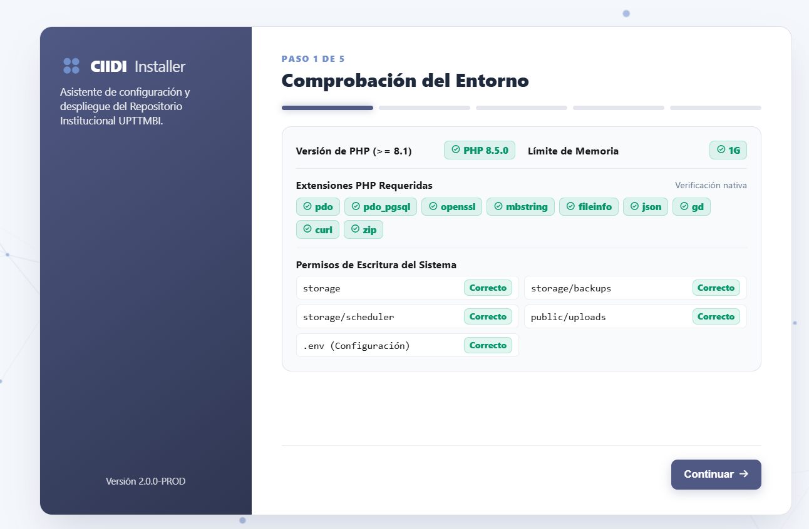
Note. First screen of the installation wizard, where required PHP extensions and write permissions in the institutional server directories are verified. Source: The authors (2026).

1.2. Database Credentials Configuration
Once the initial environment validation is passed, the installation wizard prompts for the connection parameters corresponding to the PostgreSQL database management system (see Figure 2) (the values displayed automatically represent the default parameters of this database engine). The administrator must carefully enter the server host address, specific connection port, database name, and the username and password possessing the necessary privileges to manage tables. To prevent critical configuration errors, the interface provides an interactive button to test the connection, executing a link attempt in real time; only after confirming that communication is established without interruption will the user be authorized to proceed.
Figure 2
PostgreSQL database configuration
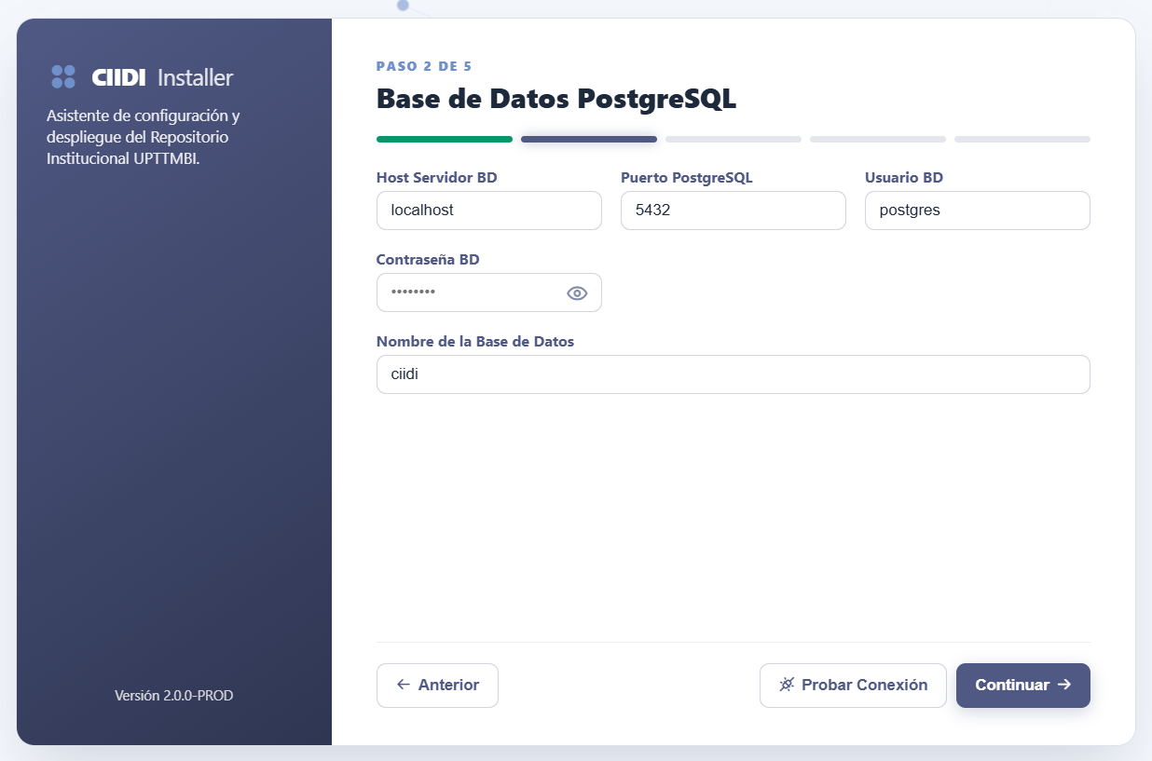
Note. Form for entering the connection credentials for the local database server. Source: The authors (2026).

1.3. Defining System Parameters and Services
The third step is dedicated to defining the fundamental system parameters and complementary services that will ensure proper operation and long-term repository security. Here, institutional identity variables such as the university name and acronym, base access URL, and time zone must be configured, in addition to enabling automated tasks that manage background processes (see Figure 3).
Figure 3
System parameters and services
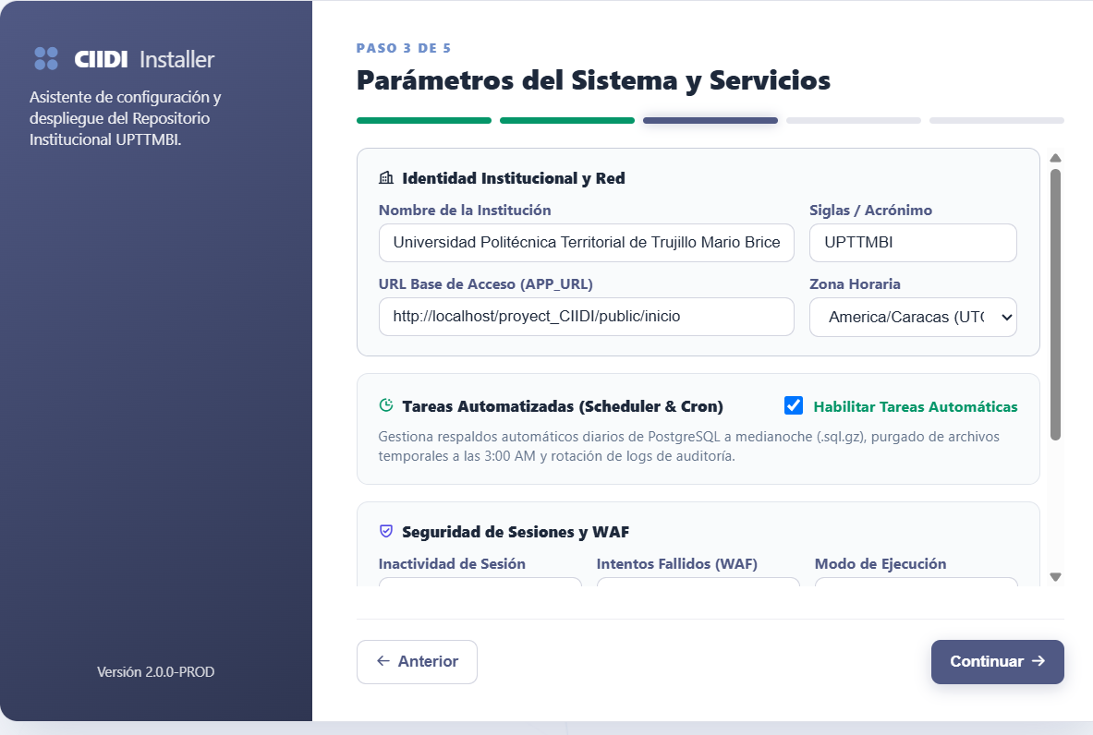
Note. Section for defining institutional identity, network settings, and automated task activation. Source: The authors (2026).
Figure 4
Security and notifications configuration
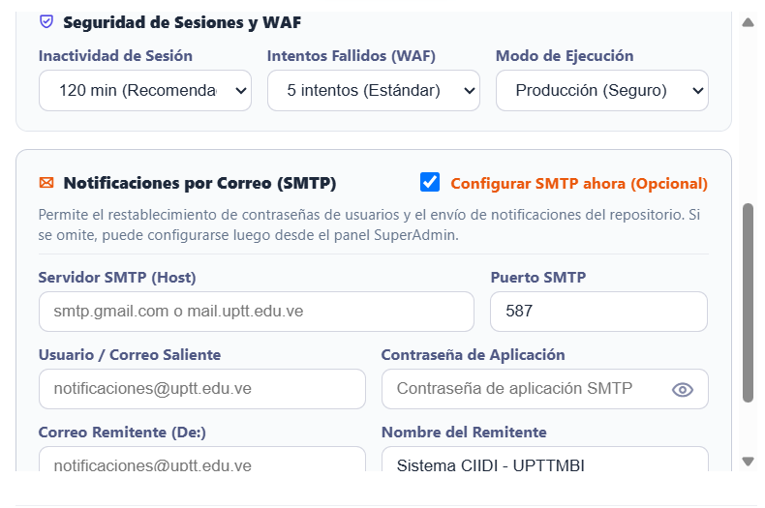
Note. Session inactivity settings, WAF parameters, and optional mail server configuration. Source: The authors (2026).
Furthermore, regarding cybersecurity, this section allows administrators to set inactivity limits for automatic session termination and the maximum number of failed attempts before locking access. It also offers the option (which may alternatively be configured after installation) to set up email notification services via the Simple Mail Transfer Protocol (SMTP) (see Figure 4).

1.4. Creating the System SuperAdmin
Figure 5
SuperAdmin registration
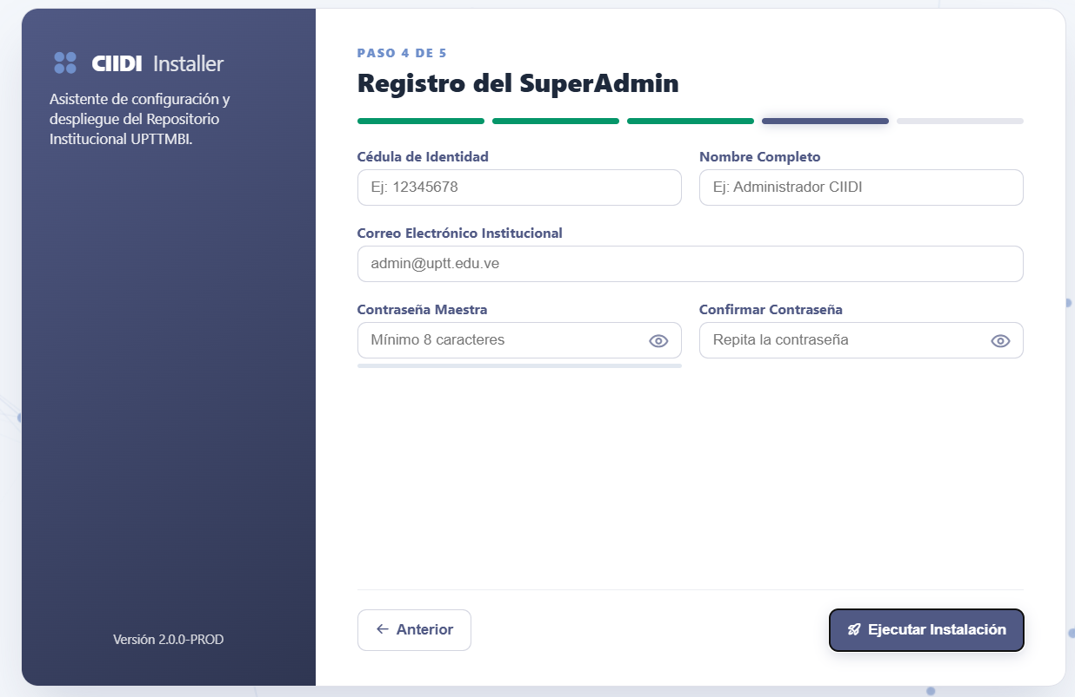
Note. Creation form for the primary user with full privileges across the system. Source: The authors (2026).
Advancing through the configuration process, the fourth step consists of creating the SuperAdmin account (see Figure 5), which represents the highest hierarchical authority within the document platform. This user holds full access and editing permissions across all system modules, enabling management of future configurations regardless of standard restrictions. During this registration, it is mandatory to provide accurate information such as the national identity number, full name, institutional email address, and a master password meeting the required security standards, finally enabling the button to execute the formal system installation.

1.5. Completion Verification
Figure 6
Completed deployment verification
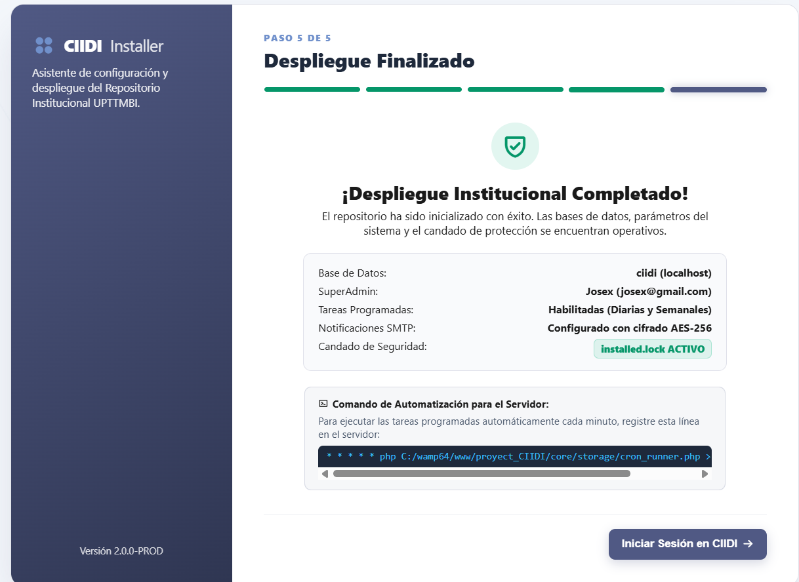
Note. Confirmation screen displaying the installation summary and the server automation command. Source: The authors (2026).
Once installation proceeds, the system presents a completion verification screen (see Figure 6) displaying a detailed summary of all configurations applied during deployment. At this stage, the installer performs a check to certify that no errors or interruptions occurred while copying files or structuring the database. The interface visually confirms that the repository is ready to operate and provides the administrator with an automation script for scheduled tasks (required if they were not activated during installation), finally enabling the button to sign in to CIIDI and access the system.

2. Basic System Components

2.1. Home Page
On this initial landing interface, designed as the public entry point of the institutional platform (see Figure 7), users find a structured presentation that concisely describes each module and tool available within the CIIDI digital repository. This section fulfills a crucial informational and orientation role, highlighting the operational capabilities of the system through dynamic informational cards that visually organize each feature.
Each of these cards has been designed with a focus on user experience (UX), incorporating direct links that allow the academic community to seamlessly explore the different sections of interest while guaranteeing direct and permanent access to the core of the system—namely, the repository of documents and research lines itself.

Figure 7
Home page / Landing page
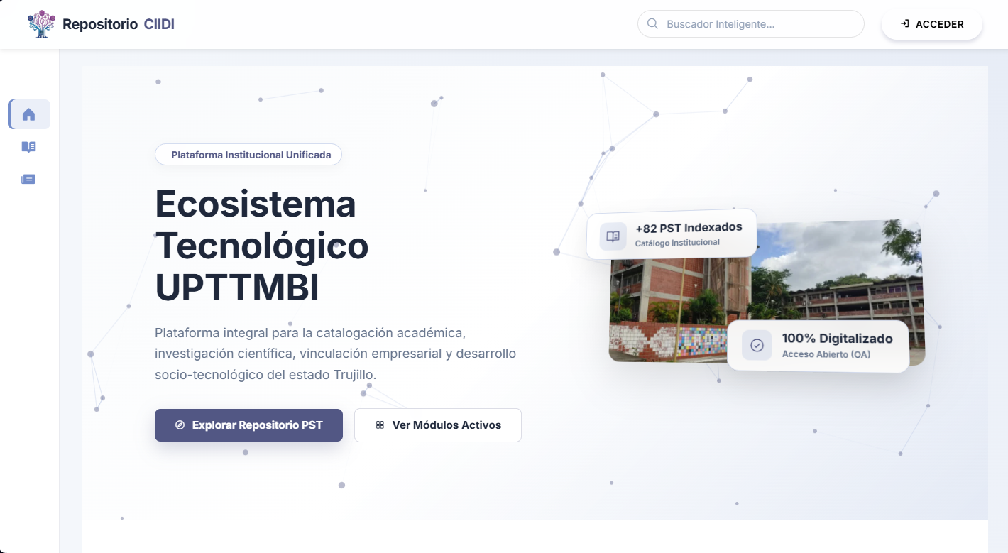
Note. Initial public view of the system containing descriptive information for each section and direct redirections via informational cards. Source: The authors (2026).

2.2. Sidebar
As shown in detail in the navigation interface layout (see Figure 8), the system implements a collapsible sidebar located on the left side of the screen. This component acts as the main navigation menu, containing direct shortcuts to all sections of the system (refer to Figure 7 to view its globally docked state).
To optimize usability, each option is accompanied by a representative icon for rapid identification and a dropdown indicator that reveals nested submenus. For example, the illustration shows how the "Repository" section expands to display specific tools such as project exploration and the unified search engine, enabling deep navigation without having to return to the home page.
In addition to its routing function, this sidebar incorporates a visual feedback system through dynamic states applied to its buttons. When a user is positioned within a specific module, such as the "Home" page, the corresponding button adopts an "active" state, illuminating in a distinctive blue tone to indicate the current location within the site architecture. Conversely, hovering the cursor over inactive elements such as "Repository" produces a subtle contrast shift toward a grayish tone (hover effect), providing a clear visual cue indicating which interactive item is about to be selected before executing the action.
Figure 8
Navigation sidebar
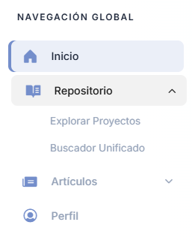
Note. Collapsible side section containing hierarchical shortcuts to all platform modules and submodules. Source: The authors (2026).

2.3. Top Bar
As illustrated in the header detail (see Figure 9), the top bar of the repository has been designed in accordance with modern application header (App Bar) standards, with the primary function of centralizing global tools and providing context regarding the user's session status. This horizontal component is logically divided into three fundamental sections according to their operational purpose within the ecosystem. This layout ensures that critical navigation and interaction elements remain visible and accessible at all times, regardless of which module the user is currently browsing.
Breaking down its structure from left to right, the first section houses the platform's logo and name, representing its institutional identity; clicking this area redirects the user to the home page. Second, the central area contains the module tools zone, used by the repository to display the quick search bar linked to the intelligent search engine. Finally, the right section forms the session and status zone, displaying a widget that indicates the user's current role while serving as a direct link to the user profile, alongside the sign-out option to end the session.
Figure 9
Top Bar interface
Note. Overview of the system header component, including visual identity, quick search bar, profile widget, and sign-out option. Source: The authors (2026).
As part of the Role-Based Access Control (RBAC) security architecture implemented in the system, the interface dynamically adapts according to the authenticated user's privileges. As shown in the corresponding illustration (see Figure 10), when signing in to the platform with "SuperAdmin" credentials, the profile widget located in the top bar modifies its standard behavior.
A dropdown indicator is added which, when activated, reveals an extended menu that cleanly organizes all routes and tools exclusive to comprehensive repository administration. From this privileged menu, the administrator gains direct access to critical maintenance functions such as the general administrator dashboard, comprehensive user management, Web Application Firewall (WAF) monitoring, audit log inspection, and scheduled task configuration.
Figure 10
Profile dropdown expansion for administrators
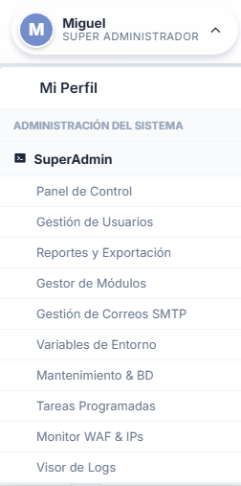
Note. Dynamic dropdown menu exclusive to the SuperAdmin role, displaying access routes to system management tools. Source: The authors (2026).

2.4. Footer
The institutional footer (see Figure 11) is a cross-cutting component present across all platform interfaces, designed to centralize contact information and the corporate identity of the university. Its structure is divided into three columns (the number of columns can be modified as explained in Section 6. Module – SuperAdmin) displaying the address of the main rectoral headquarters, the telephone directory for the various academic campuses, and direct links to official social media channels.
Along its bottom strip, it displays updated copyright notices and development credits corresponding to the PNF Informatics program. The main technical advantage of this component is its dynamic nature: all contact details, locations, mottos, and links can be modified and updated in real time by an administrator from the global system configuration module without intervening in the application's source code.

Figure 11
Institutional footer with contact and campus information
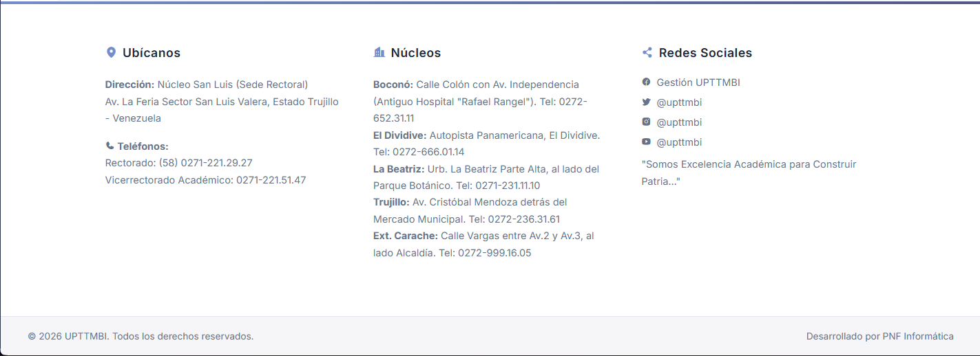
Note. Component centralizing the campus directory, social media links, and credits, whose content is fully manageable from the system configuration.

3. Module – Authentication / Sign In

3.1. Authentication View – How to Sign In
Upon completing installation and/or whenever a user attempts to access protected sections of the platform, the system presents the authentication view (see Figure 12). On this screen, the user is required to enter their national identity number along with the security password established during initial registration. As an additional safeguard to mitigate risks associated with automated malicious attacks, the form integrates a straightforward anti-bot verification challenge that must be solved properly before entering the system, while displaying options at the bottom to create a new account or recover a forgotten password.
Figure 12
Sign-in screen
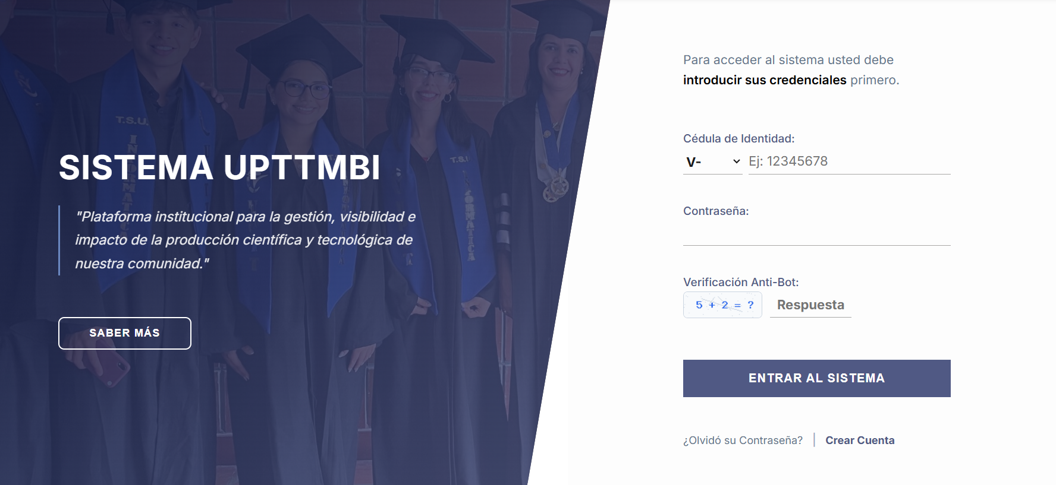
Note. Main authentication interface requiring national identity number, password, and anti-bot verification. Source: The authors (2026).

3.2. Account Creation View – How to Create an Account
The interface dedicated to creating new accounts is structured to securely and efficiently collect essential personal information from students or staff wishing to join the ecosystem (see Figure 13). This section requires entering the national identity number along with nationality prefix, the individual's full name, and a valid email address, which is essential for subsequent notifications.
A particularly notable aspect of this form is its dynamic password security component, which features a real-time strength indicator bar evaluating the entered password against minimum security requirements, followed by solving the integrated CAPTCHA challenge to successfully complete registration.
Figure 13
Account creation form

Note. Registration view for new users featuring a dynamic password strength indicator. Source: The authors (2026).

3.2. Access Recovery View – How to Recover Your Password
Designed with usability and user assistance in mind, the system includes an access recovery view (see Figure 14) intended to assist users who have lost or forgotten their login credentials. Within this section of the platform, the affected user has the flexibility to select their preferred validation method, initiating the recovery process by entering either their national identity number or, alternatively, their email address. Once the chosen identifier is entered and the corresponding anti-bot CAPTCHA is solved, the system dispatches a secure link to restore access, while keeping an option visible at all times to return to the sign-in screen if the password was remembered or the section was accessed inadvertently.
Figure 14
Access recovery
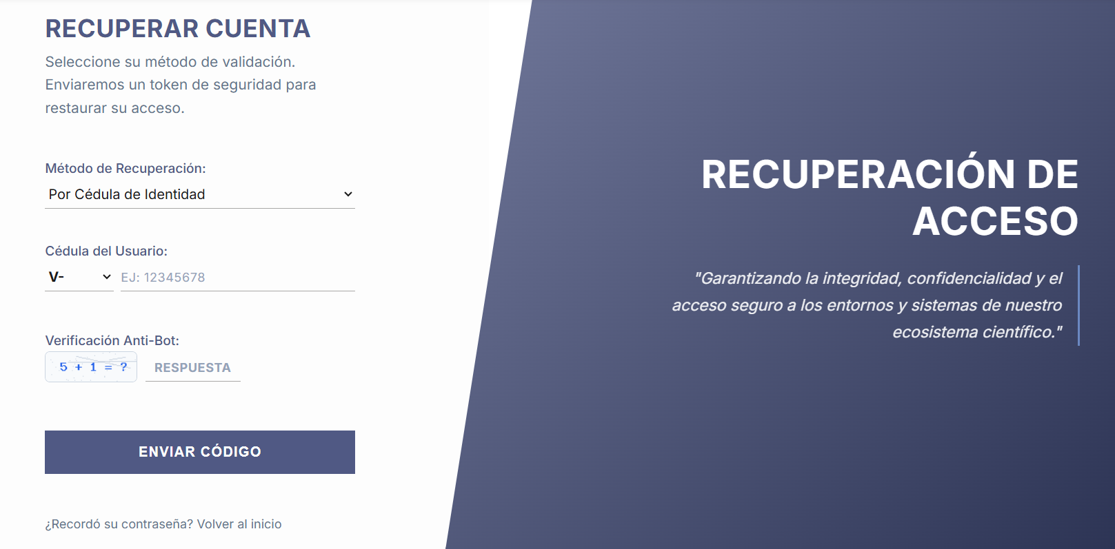
Note. Interface for requesting a password reset via national identity number or institutional email address. Source: The authors (2026).

3.4. Profile - Where to Manage My Data?
The User Profile section functions as the personal control and auditing center within the CIIDI platform, providing each member with a secure space to manage their digital identity. Serving as the default landing screen for standard users upon signing in, this module centralizes contact data updates, activity metrics review, and security barrier configuration. In doing so, the system ensures transparent control over the user's institutional information, organizing all operations into three consecutive functional tabs.

3.4.1. Account Summary and Institutional Identity
Upon signing in, the platform displays by default the first functional tab titled "Account Summary" (see Figure 15). This interface presents a two-column informational dashboard designed according to usability criteria to facilitate an at-a-glance reading of the user's current status. On the left section, the "Personal and Institutional Record" component consolidates the individual's immutable identification details, including their registered full name, national identity number, associated notification email address, assigned hierarchical role on the platform (for example, Level 2 Faculty), and respective academic department.
Simultaneously, the right section details "Account Status and Access", providing essential security and telemetry metrics including email verification status, cumulative historical login count, and exact timestamps for both initial system registration and the latest activity detected by the server.
Figure 15
User profile: Account Summary tab
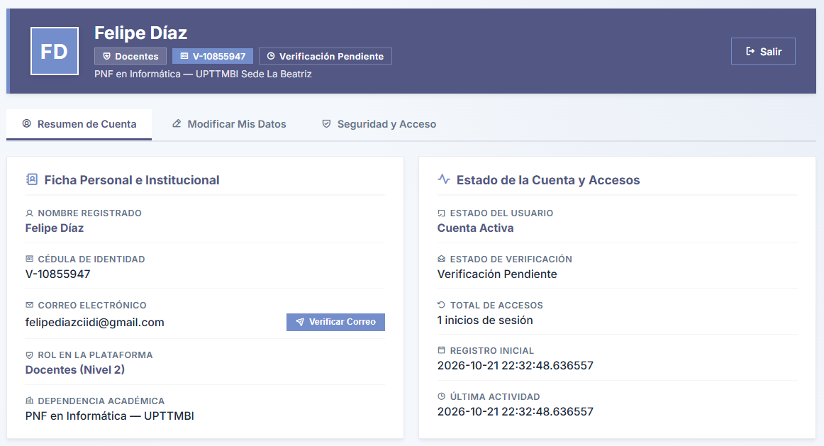
Note. Main management interface displaying registered personal details, institutional record, and security status of the current account.

3.4.2. Edit My Data Tab

Figure 16
User profile: Edit My Data tab
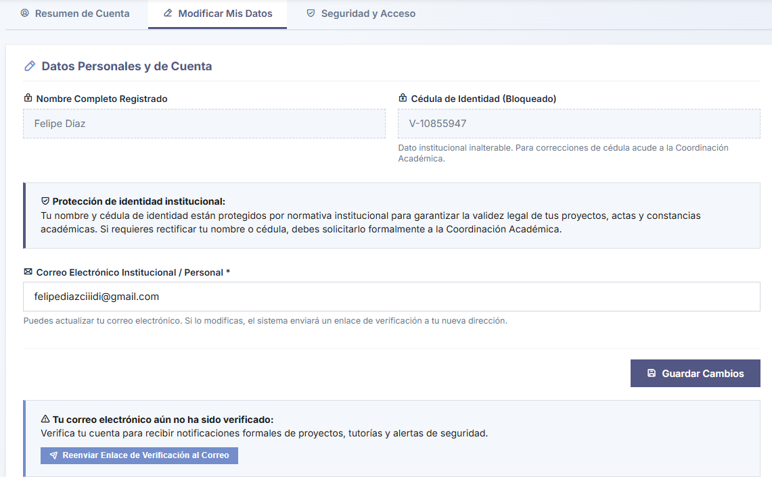
Note. Contact information update interface, illustrating the security lock on institutional identity fields and email verification options.
Navigating to the second tab of this module, the user finds the "Edit My Data" interface (see Figure 16), designed under strict security and institutional data protection parameters. To guarantee the legal validity of projects, records, and academic certificates generated by the repository, critical identity fields such as Registered Full Name and National Identity Number are locked by default, requiring any official correction to be formally processed through the Academic Coordination office.
Nevertheless, the system grants the user full autonomy to manage and update their Institutional or Personal Email Address; upon modifying this text field and saving changes, the platform automatically dispatches a new security link to the provided address. Additionally, the interface includes a preventive warning banner with a dedicated button to resend the verification link if the account still holds a pending verification status.

3.4.3. Security and Access Tab
Figure 17
User profile: Security and Access tab
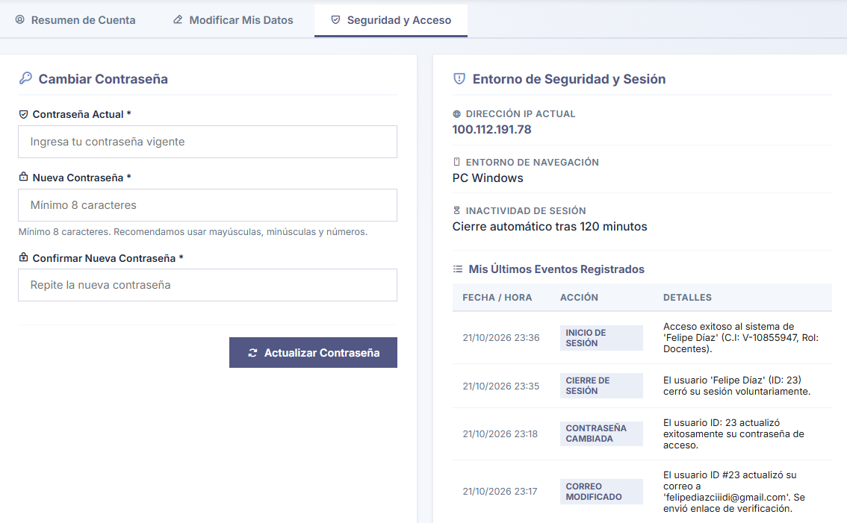
Note. Control panel for secure credential updates, local network environment auditing, and chronological logging of user session events.
Finally, the third profile tab, titled "Security and Access" (see Figure 17), concentrates the essential cryptographic and auditing tools for credential protection and continuous session activity monitoring. In the left panel, the system provides a secure form for changing the password, requiring mandatory validation of the current password before allowing entry and confirmation of a new password meeting the recommended minimum eight-character standard.
Meanwhile, the right panel, titled "Security and Session Environment", serves as a real-time audit log for the user. It displays vital technical details such as the current connection IP address, the operating system environment in use, and the scheduled inactivity timeout for automatic session termination. In addition, a detailed chronological table lists the latest recorded events, enabling the user to audit their own sign-ins and sign-outs to proactively detect any anomalous activity or unauthorized access.

3.4.4. System Notifications and Feedback
When interacting with profile configuration and security options, the system is programmed to display visual notifications informing the user of the outcome of their actions, ensuring transparent and continuous communication. When a user chooses to validate their identity and clicks the button to resend the verification link, the platform displays an informational alert confirming that the email has been successfully dispatched (see Figure 18). This message instructs the individual to check both their primary inbox and their junk or Spam folder, ensuring that the temporary security token can be located and activated to enable all institutional account features without delay.
Figure 18
Confirmation link dispatch notification
Note. System alert confirming successful delivery of the validation email to the user's inbox.
Similarly, if the user decides to modify their institutional or personal email address from the corresponding tab, the system executes a database update routine and displays a visual success notification (see Figure 18). This alert confirms that the records have been updated properly and explicitly warns that the newly entered address requires mandatory validation; the platform automatically sends a new cryptographic link to the newly registered email address, placing the account in a pending verification state until the user confirms ownership of that inbox.
Figure 19
Email address update notification
Note. Success message after updating the email address, indicating the requirement to verify the newly provided address.
In the realm of credential management, the platform maintains strict oversight over security updates executed from the user's control panel. Once the individual satisfactorily completes the password change form—entering their current password accurately and setting a new one that satisfies all required security policies—the system confirms the transaction via a clear success notification (see Figure 20). This message assures the user that the former password has been permanently revoked from the database and that the new encrypted credential is immediately active to safeguard their institutional information.
Figure 20
Password update notification

Note. Visual confirmation that the user's access credentials have been successfully modified and saved.
Additionally, the system integrates preventive validations to guide the user and avoid operational redundancies while editing personal information. For example, if the user clicks the save button without altering any characters in the available text fields, the system detects this redundant action and displays an alert indicating that no changes were recorded in the submitted data (see Figure 21).
Figure 21
No changes detected notification

Note. Preventive alert displayed when the user attempts to save the form without having made any changes to the information.

Conversely, during the critical credential update process, if the user makes a typographical error and the new password is not identical across both verification fields, the platform halts the operation and displays an error alert indicating the mismatch (see Figure 22). This immediate feedback proactively prevents the user from locking themselves out due to a simple typing mistake.
Figure 22
Password mismatch alert

Note. Validation error message generated when mismatched passwords are entered in the security update form.
In addition to this safeguard, if the user enters an incorrect current password while attempting to validate their identity, the security engine detects the discrepancy and issues an explicit warning (see Figure 23). This validation cancels any modification in the database, acting as a defense mechanism in the event that an active session is left unattended and an unauthorized third party attempts to alter repository access parameters without knowing the original password.
Figure 23
Incorrect current password alert

Note. Security error message generated by the system when current password validation fails during a credential update attempt.

4. Module – Socio-Technological Projects Repository
The functional core of the CIIDI platform resides in its Socio-Technological Projects (PST) repository, an environment designed to manage, preserve, and showcase the scientific production of the academic community. This module is structured into two main areas: a public environment optimized for information discovery and a restricted administrative panel for document management and configuration of the underlying search engine.

4.1. Public Access
The public access area of the repository is designed to democratize knowledge, allowing any visitor to interact with the research catalog without requiring prior authentication. This section prioritizes usability and information retrieval efficiency through intuitive interfaces and advanced search engines powered by neural networks.

4.1.1. Article Explorer
The main project explorer interface (see Figure 24) serves as the entry point for public consultation. It features a primary search bar connected to the Unified Search Engine, accompanied by statistical panels summarizing the volume of indexed projects, authors, and benefited communities. Additionally, it facilitates thematic navigation through interactive cards grouping research works according to established institutional research lines, such as Information Systems, Educational Informatics (Edumatics), Application Development, and Networks and Telecommunications.
Figure 24
Socio-Technological Projects explorer main page
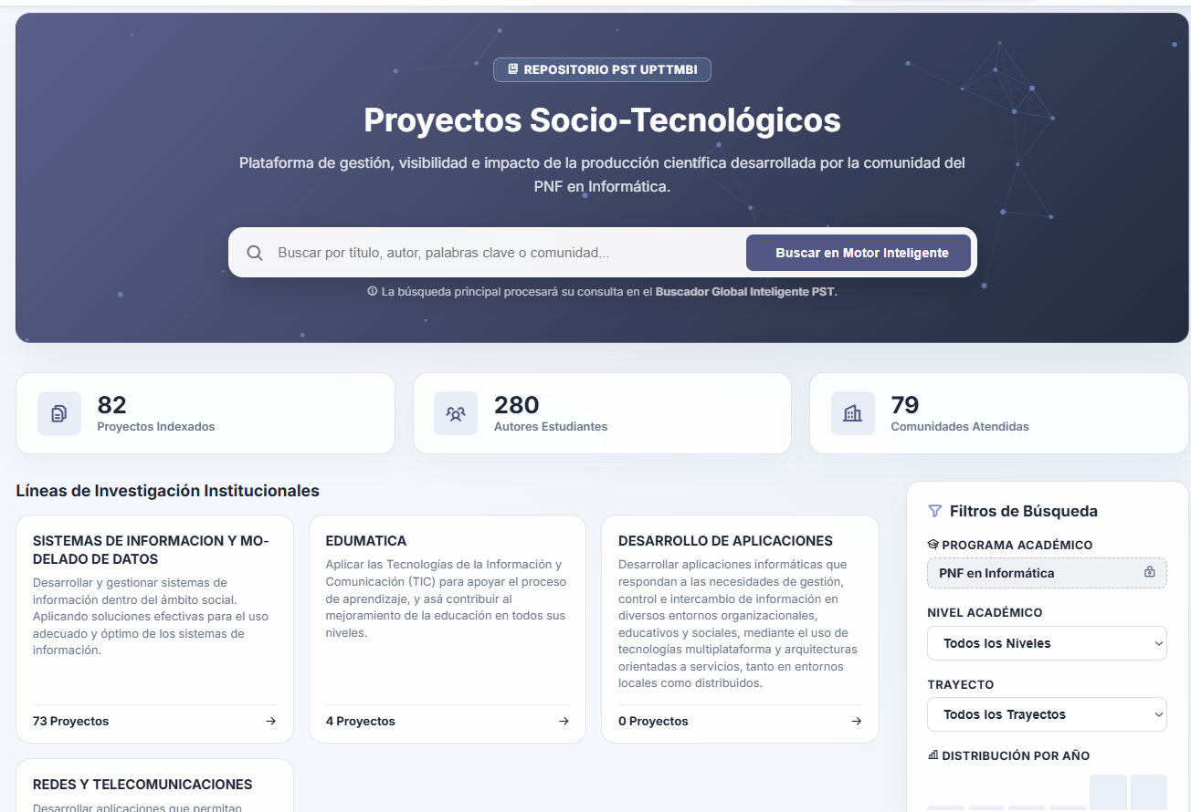
Note. Public access interface centralizing intelligent search, repository metrics, and navigation across institutional research lines.
Scrolling further down the same page, the user accesses the General Project Bank (see Figure 25), a detailed list-format view organizing research works chronologically. This interface previews essential metadata such as the title, participating authors, academic level, served community, and publication year, while offering actions to open the full project view, generate a citation, or download the file. Furthermore, to refine results, a multi-filter side panel enables narrowing the search by academic program, academic track (Trayecto), research line, and operational dimension, ensuring precise information discovery.
Figure 25
General Project Bank list view with filtering panel
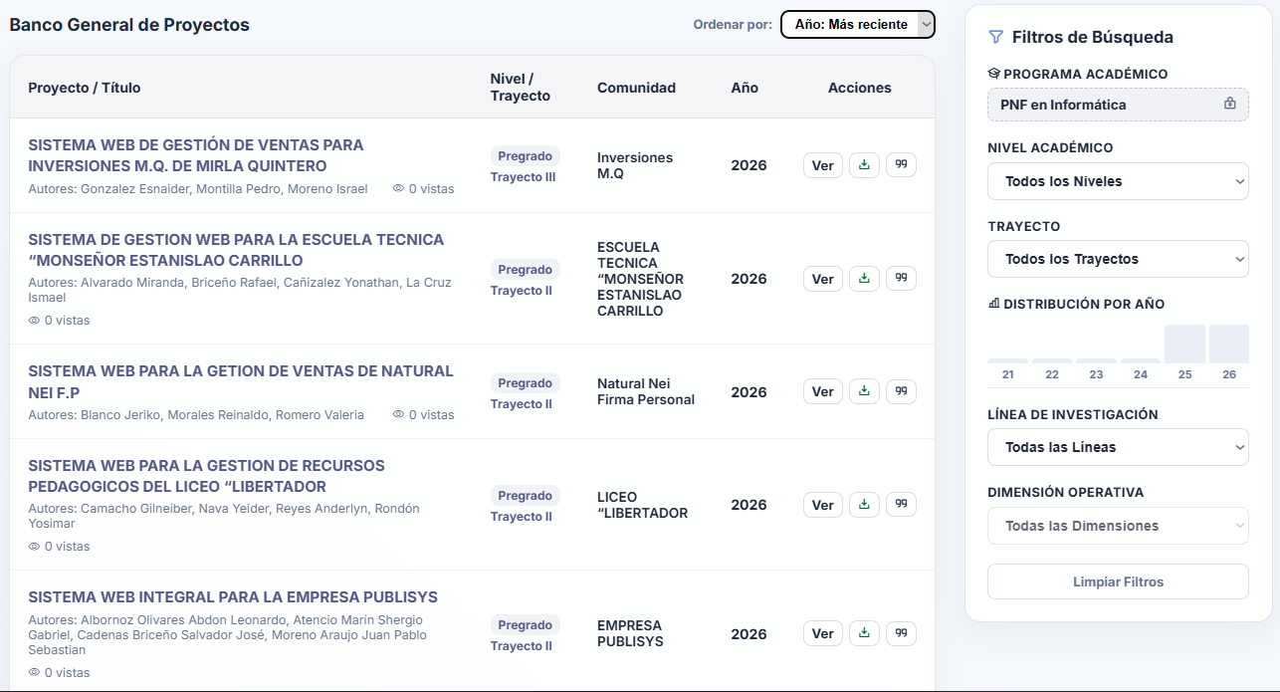
Note. Detailed research catalog allowing multiple filters to narrow results according to academic and operational criteria.
To promote academic rigor and facilitate referencing of published works, the system integrates an automated citation generator tool (see Figure 26). Upon selecting a specific project, the user can instantaneously extract its structured bibliographic reference in the most widely used international standard formats—APA (7th edition), IEEE, and Vancouver—streamlining the research workflow and ensuring proper attribution to the original authors.

Figure 26
Automated academic citation generator tool
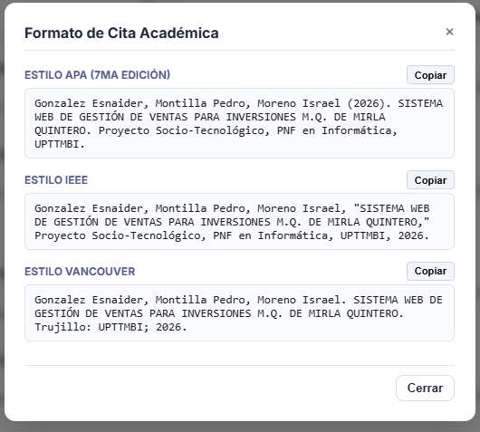
Note. Modal window providing the bibliographic reference of the selected project in APA, IEEE, and Vancouver formats.
Once the user selects “View” on a project, the system displays a comprehensive view of the research work (see Figure 27), presenting a technical record of the project. This screen highlights the title of the work and the project team (authors and faculty advisors), and categorizes the research by detailing its academic level, benefited community, research line, and defense date, providing full academic context prior to accessing the complete document.
Figure 27
Detailed technical record of the socio-technological project

Note. Header of the project preview detailing the team of authors, faculty advisors, and academic classification metadata.
In the lower section of the project view (see Figure 28), the system presents the Epistemic Matrix and Official Abstract, offering an in-depth synthesis of the general objective and methodology employed. Additionally, this interface integrates a recommendation engine suggesting "Related Research in the Same Line", calculating the affinity percentage via artificial intelligence so users can discover related works and broaden their research perspective.

Figure 28
Epistemic matrix and related research recommendation engine
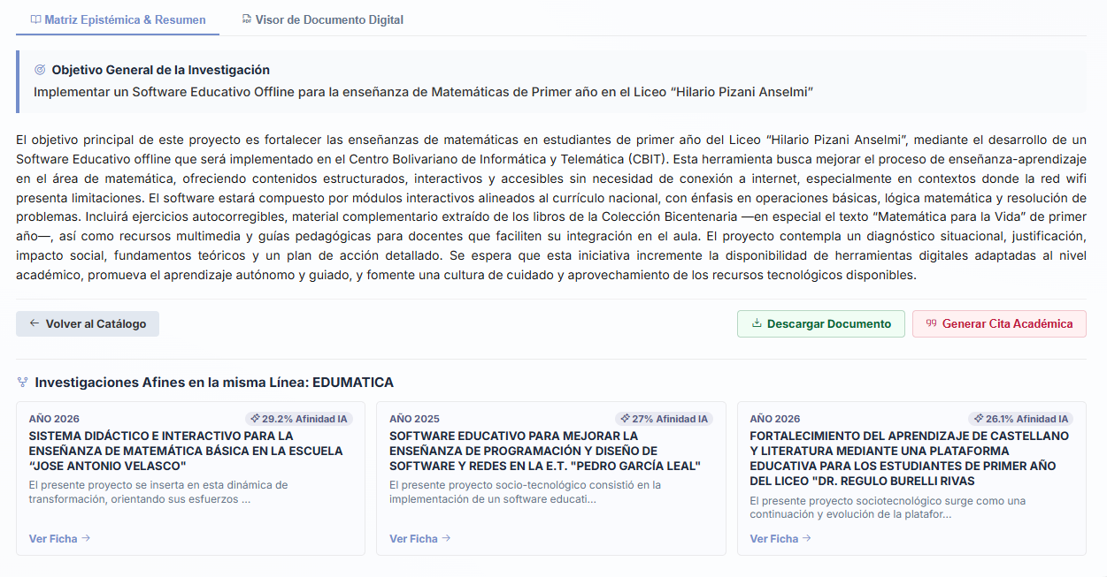
Note. Section presenting the project abstract and suggesting related research based on semantic affinity within its research line.
For direct consultation of the material, the repository incorporates an integrated Digital Document Viewer (see Figure 29). This tool enables previewing the original file (PDF or Word document) directly within the browser without requiring prior downloads. The viewer includes essential navigation controls, zoom adjustments, full-width mode, and printing options, ensuring a smooth and accessible reading experience.

Figure 29
Integrated digital document viewer (Word)
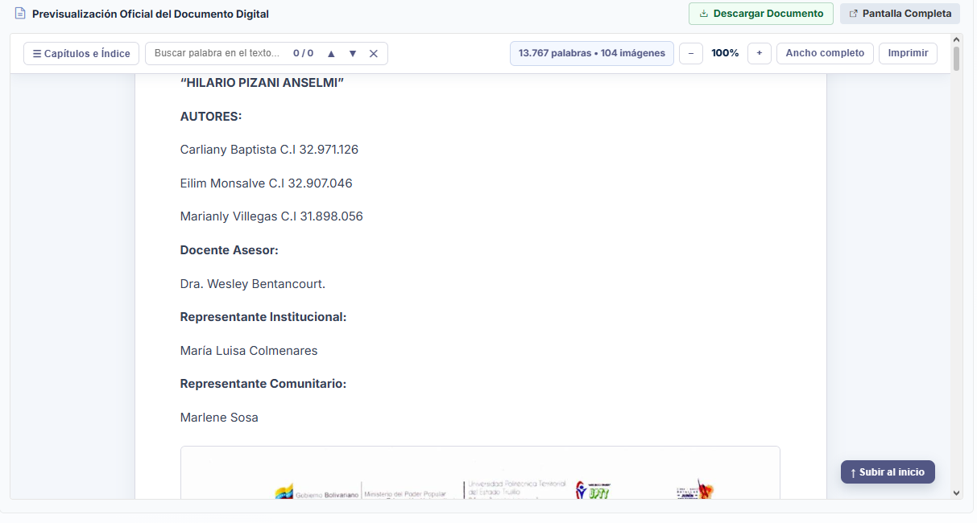 Note. Integrated document preview within each project reader, including format-specific tools and options for Download and Full Screen.
Additionally, it is worth highlighting the viewer's dual compatibility, supporting projects stored in either Word or PDF format, as detailed in the reading interface (see Figure 30). As in the previous case (see Figure 29), the system displays a suite of navigation tools including a side panel for previewing page thumbnails or document headings, zoom controls, and canvas rotation options.

Figure 30
Integrated digital document viewer (PDF)
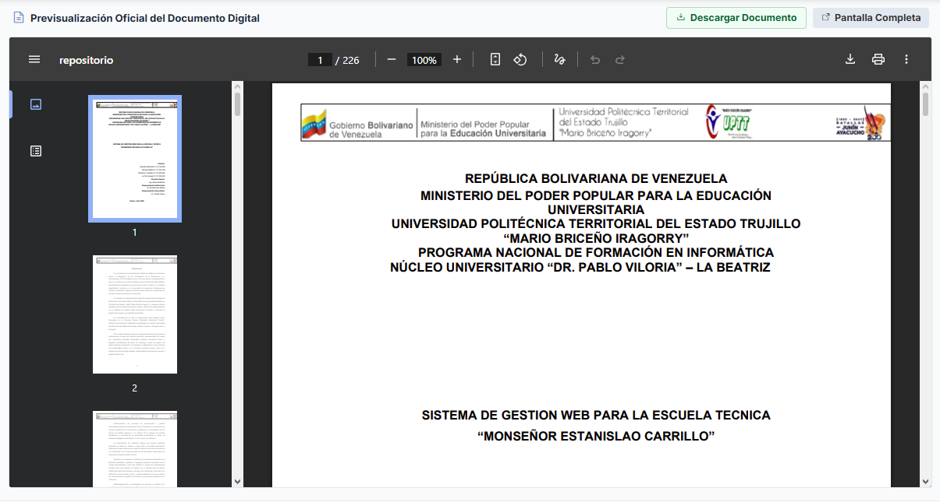
Note. Document viewer interface illustrating the navigation toolbar, side thumbnails panel, and access to full-screen reading mode.
Finally, for users requiring an immersive reading experience free from visual distractions (see Figure 31), the repository interface incorporates a dedicated button in the upper-right corner that expands the document view to "Full Screen". This architectural adaptability ensures that users can thoroughly consult manuals, theses, and socio-technological projects directly within the web environment without downloading files, preserving content fidelity regardless of the original file format uploaded by the authors.

Figure 31
Integrated full-screen document viewer (Word)

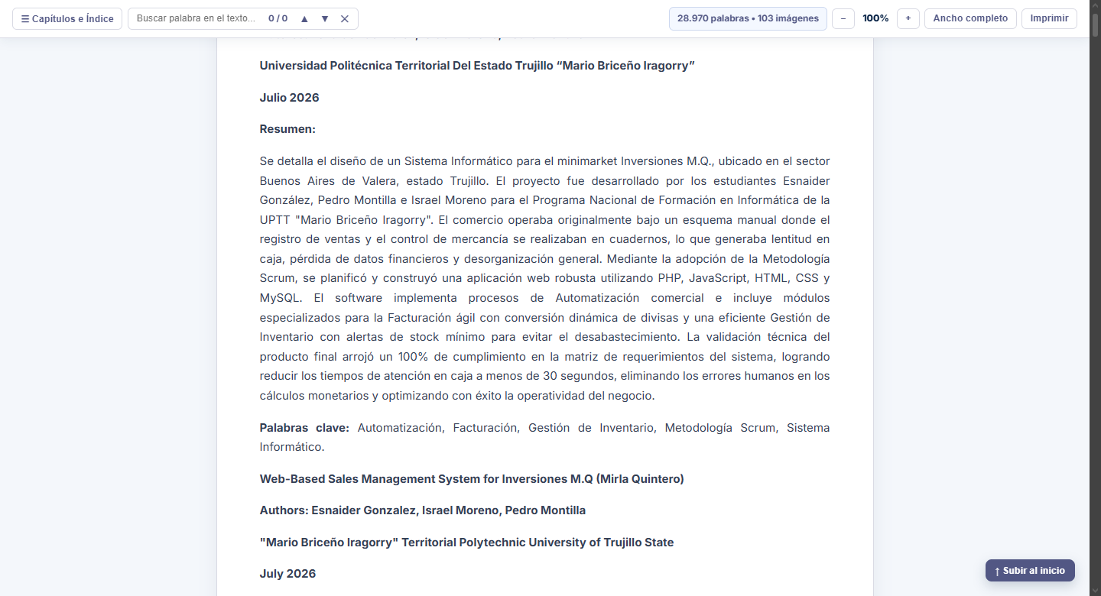
Note. Full-screen document viewer interface, opening in a new browser tab while remaining part of the repository

4.1.2. Unified Search Engine
The unified search engine (see Figure 32) represents one of the most prominent technological innovations of the CIIDI repository. Unlike traditional searches based solely on exact keyword matching (Standard Text Search), this component integrates a toggle switch to activate "Semantic Search with Neural Networks". This advanced feature processes queries by analyzing the conceptual meaning and context of the entered terms, locating relevant research even when the user's phrasing does not match the project's original title verbatim.
Figure 32
Unified search engine interface with semantic options
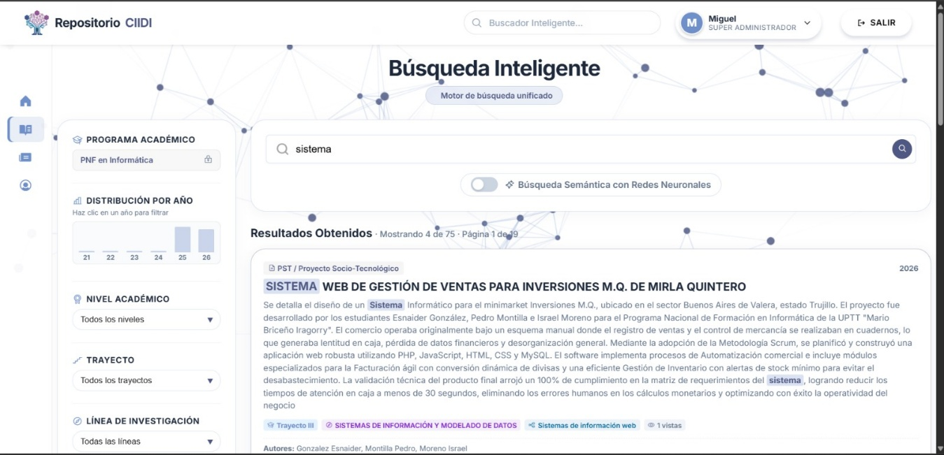
Note. Advanced search interface allowing users to switch between standard text-matching queries and neural-network-powered semantic searches.
When executing a query via semantic search, the system presents "AI Semantic Match Results" (see Figure 33). In this view, each retrieved project includes a percentage indicator (e.g., 27.3% AI Similarity) reflecting the degree of conceptual affinity evaluated by the artificial intelligence model (XLM-RoBERTa ONNX Model) relative to the user's search intent, thereby prioritizing the most relevant results from a deep semantic perspective.

Figure 33
Search results powered by AI semantic matching
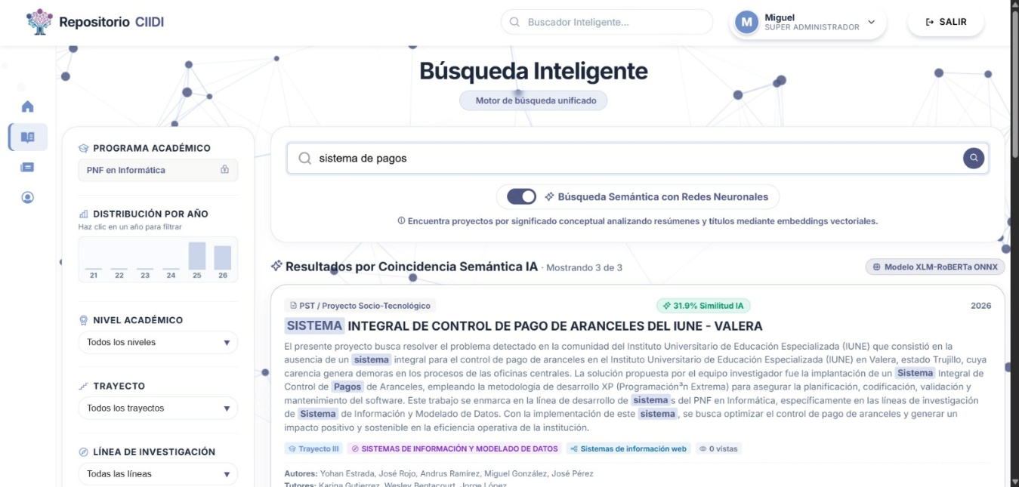
Note. Results display indicating the conceptual similarity percentage calculated by the artificial intelligence model for each research project.

4.2. Internal Management
This section documents the exclusive administration tools designed for authorized personnel (SuperAdmin, Coordinators, and Faculty). Unlike the public access environment, Internal Management requires strict authentication (RBAC) and provides full control over the document lifecycle, enabling staff to upload new projects, audit metadata, manage catalog visibility, and administer the underlying artificial intelligence engine.

4.2.1. Document Management
The PST Document Management panel acts as the operational command center of the repository (see Figure 34). Upon entering, the authorized user is greeted by a metrics dashboard that consolidates vital information, detailing the total number of projects registered in the catalog, the number of research works visible to the public, the volume of attached files (PDF, Word, or Git repositories), the drafts pending completion, and physical storage consumption on the server; in turn, these metrics act as interactive buttons that apply specific filters according to their content.
Below these indicators is a search bar with applicable filters, along with buttons to access the “ONNX AI” neural network model options, a button to export the listing directly in Excel format, the empty catalog option for broad-range deletion, and the button to add new projects to the system. Continuing further down, an interactive table is displayed listing all projects, allowing managers to quickly view the status of each research work and its associated team of authors, as well as execute direct administrative actions such as hiding, editing, or deleting records, among others.
Figure 34
Main PST Document Management Panel
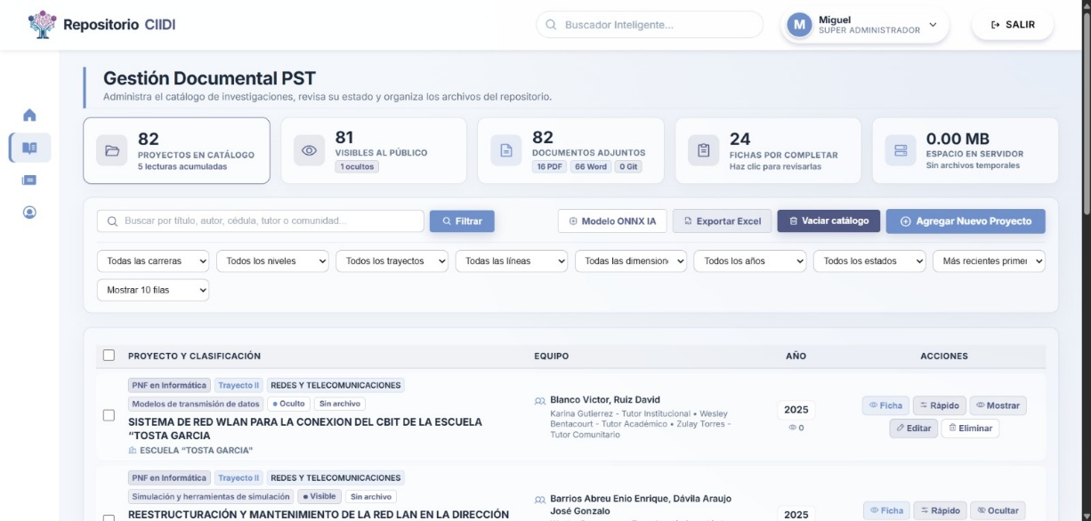
Note. Administrative dashboard consolidating storage metrics, catalog visibility, and quick management tools for each research project.
To facilitate locating research works within the administrative environment, the platform incorporates an advanced filtering panel (see Figure 35). This internal engine allows coordinators to cross-reference multiple variables simultaneously, filtering the listing by degree program, academic track, research line, presentation year, and even document visibility status (public or hidden). This granular segmentation capability is essential for conducting large-scale audits or quickly locating a specific file among hundreds of historical records.
Figure 35
Advanced Filtering Tool in Document Management
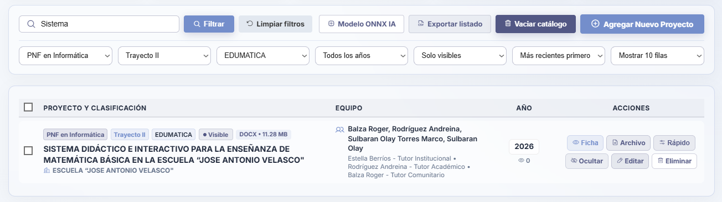
Note. Interface displaying combined search options to segment the project listing according to academic and operational criteria.
To optimize large-scale administrative tasks, the interactive document management table includes multiple-selection checkboxes (see Figure 36). This functionality makes it possible to simultaneously select multiple listed research works and perform deletion actions on them. When two or more projects are selected, the system dynamically displays a lower central button showing the count of marked items (e.g., "5 selected") and enables the "Delete selected" option, in addition to allowing users to select all checkboxes on the current page at the top of the table, right next to “Project and Classification”.
Figure 36
Multiple Project Selection for Deletion
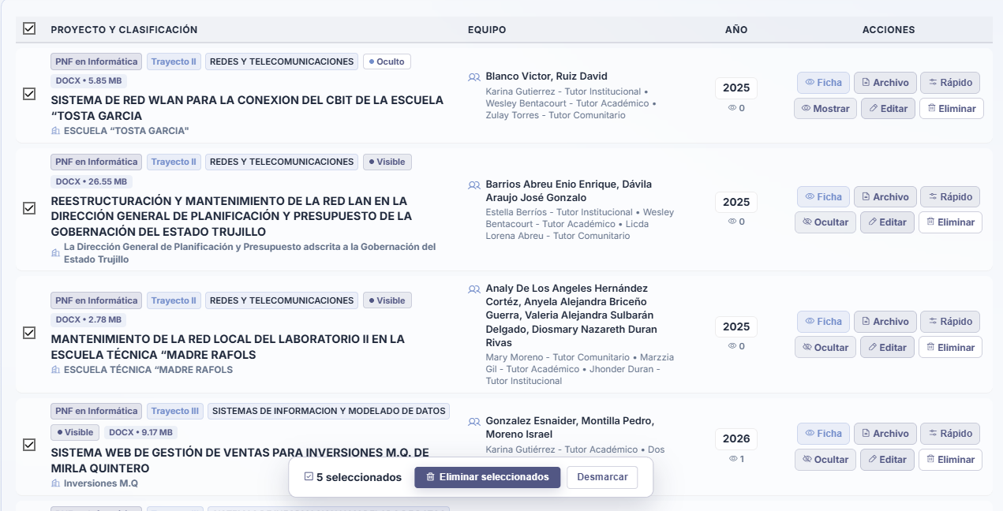
Note. Interface illustrating the simultaneous selection of multiple research works and the activation of the dynamic button to execute batch deletion.
As mentioned at the beginning of this section, the metrics are not only informative but also interactive, allowing quick-access preset filters to be applied. Starting with this functionality is the metric for projects visible to the public; directly beneath this figure is a label highlighting the number of projects tagged as “hidden,” and clicking on this card sets “Hidden only” as the active search filter (see Figure 37).

Figure 37
Preset Filter Triggered from the Metrics Panel
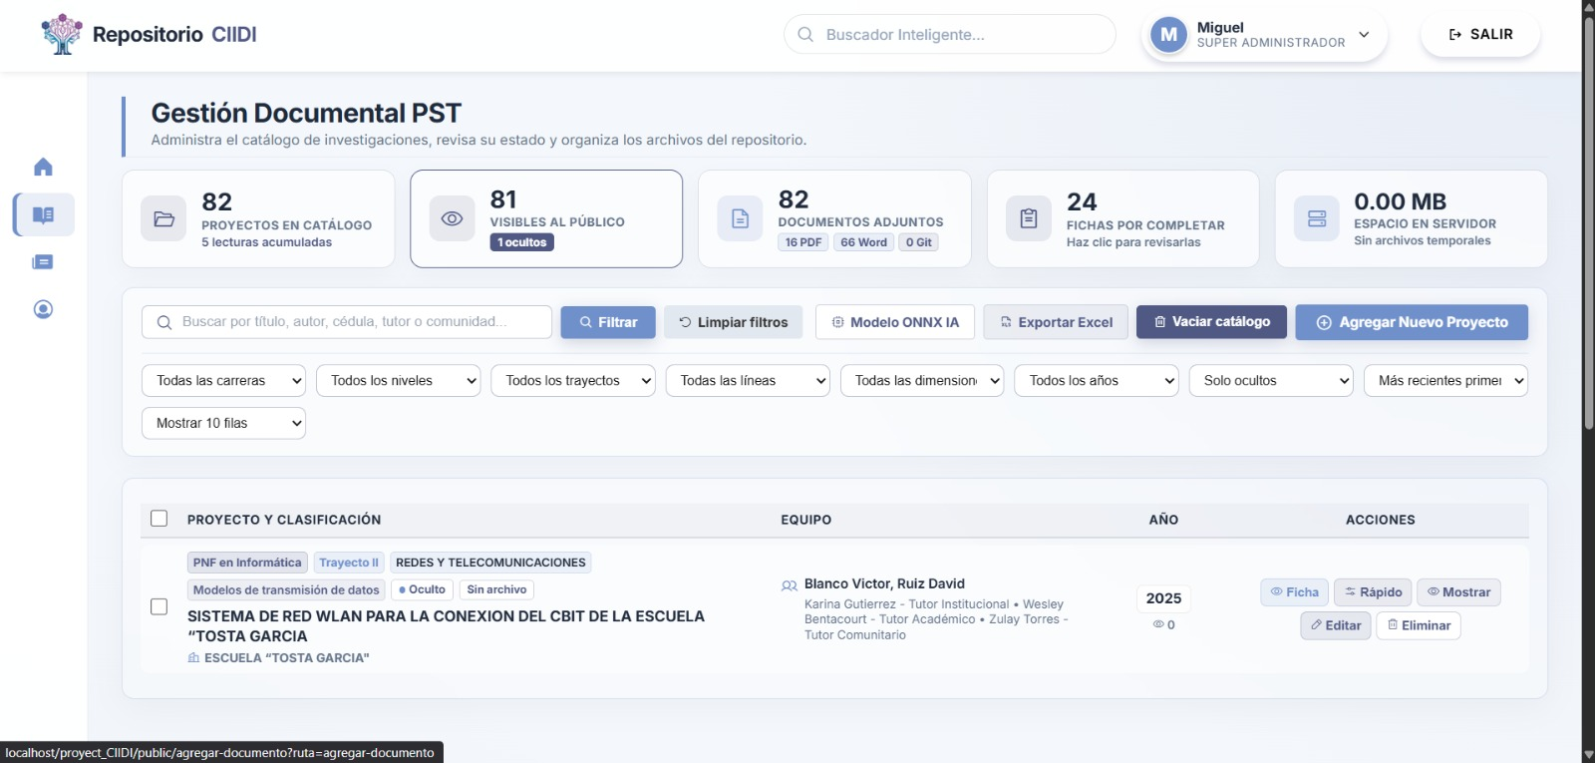
Note. Document management view after activating the automatic hidden projects filter by clicking on the interactive dashboard card.
Extending this segmentation capability, the panel also allows research works to be filtered based on the physical format of the digital file hosted on the server (see Figure 38). By selecting a specific format from the corresponding dropdown menu, the administrator can quickly isolate all projects uploaded with the PDF extension or, alternatively, those registered in Word format; continuing with the interactivity of the metrics, this is one of the preset filters, allowing the format to be selected directly through its respective labels.

Figure 38
Filtering Research Works by Digital File Format
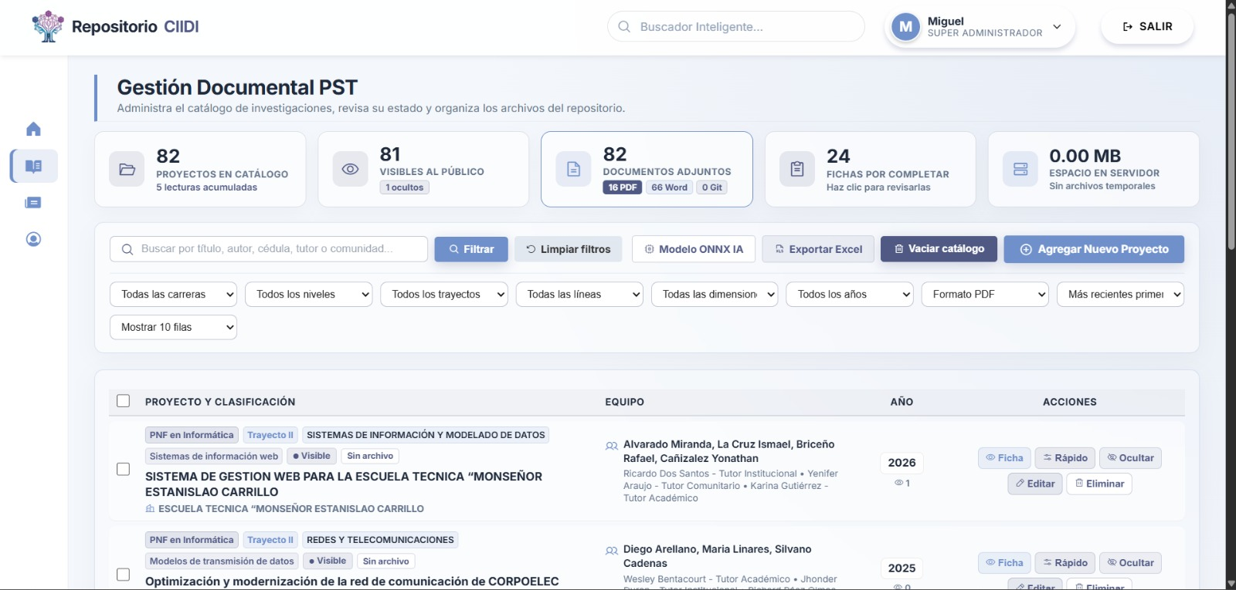
Note. Listing of socio-technological projects segmented exclusively by attached document type (PDF) through the advanced panel.
Finally, we find the records pending completion, which refer to projects lacking one or more data fields required to reach 100% completeness. This percentage is indicated when creating the project, and if incomplete, the record is submitted with the “Pending completion” tag. As shown (see Figure 39), the metric indicating the number of projects in this state applies that preset filter; for a project to no longer be marked as “Pending completion,” it simply needs to be edited to add the missing fields.

Figure 39
Filtering by “Records Pending Completion”

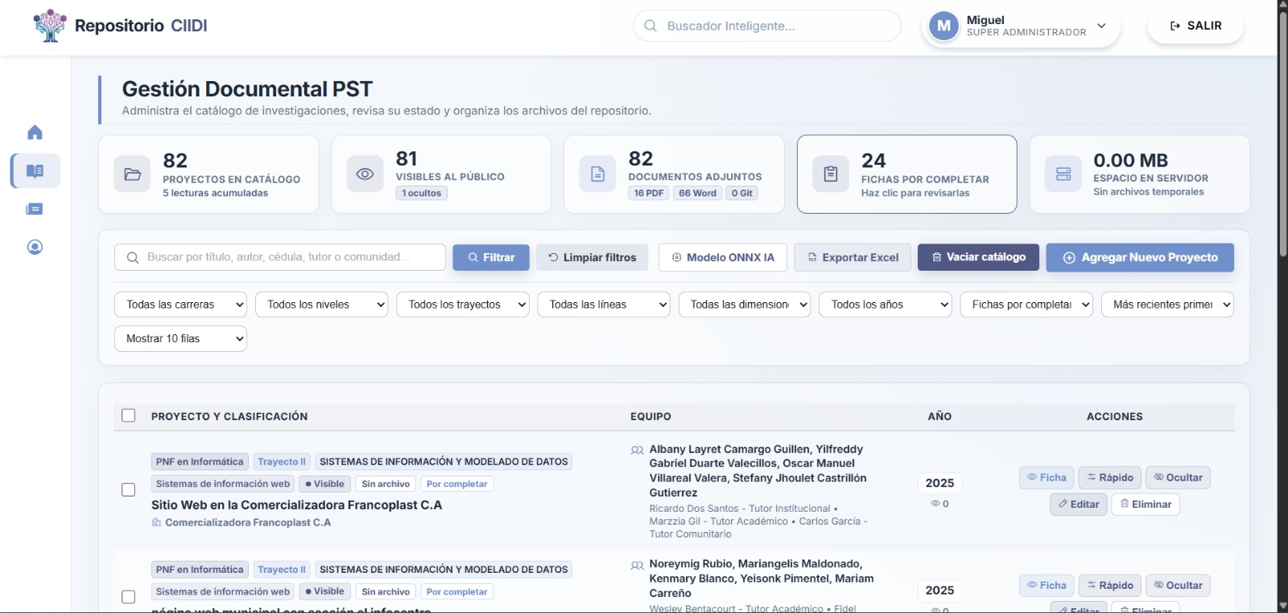
Note. Project table results after simultaneously applying filters for academic track, research line, and publication status.
To maintain server health and ensure optimal database performance, the module includes a temporary file cleanup tool. Clicking the “clean” button located on the storage card of the metrics dashboard when temporary files exist triggers a sweep routine that identifies and removes residual files or caches generated during upload failures (see Figure 40). The platform momentarily pauses its processes to report the outcome of this operation, detailing the exact number of temporary files deleted and the exact storage volume (in Megabytes) freed and made available again to the institutional server.

Figure 40
Server Storage Optimization Notification
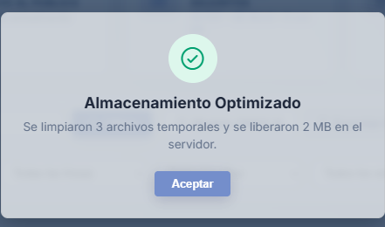
Note. Success alert detailing the number of temporary files removed and the disk space recovered after executing the cleanup routine.
Additionally, the system provides tools for large-scale data lifecycle management through the "Bulk Deletion and Catalog Purge" option (see Figure 41). Safeguarded behind a strict credential validation layer, this function makes it possible to purge multiple projects simultaneously by applying specific year, degree program, or operational dimension filters. As an intelligent precaution to preserve the relational integrity of the ecosystem, the tool provides a checkbox that, when enabled, instructs the database to retain the directory of previously registered authors and advisors, significantly streamlining future research uploads by the same academic staff.

Figure 41
Bulk Deletion and Catalog Purge Interface
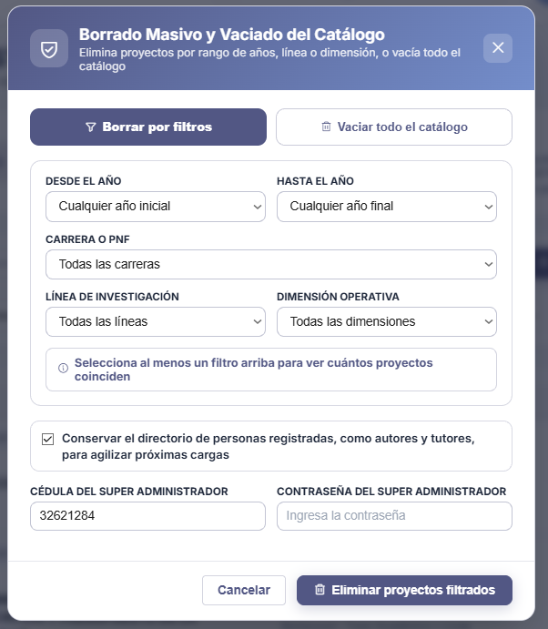
Note. Advanced administrative tool enabling batch deletion of research works, protected by mandatory security re-authentication.
Next is the quick preview tool, which displays the complete technical record in a wide modal window (see Figure 42). This administrative view faithfully replicates the public layout of the final project, showing in detail the authors involved, the assigned advisors, the general objective, and the epistemic abstract without requiring the user to leave the document management panel.

Figure 42
Administrative Preview of the Technical Record
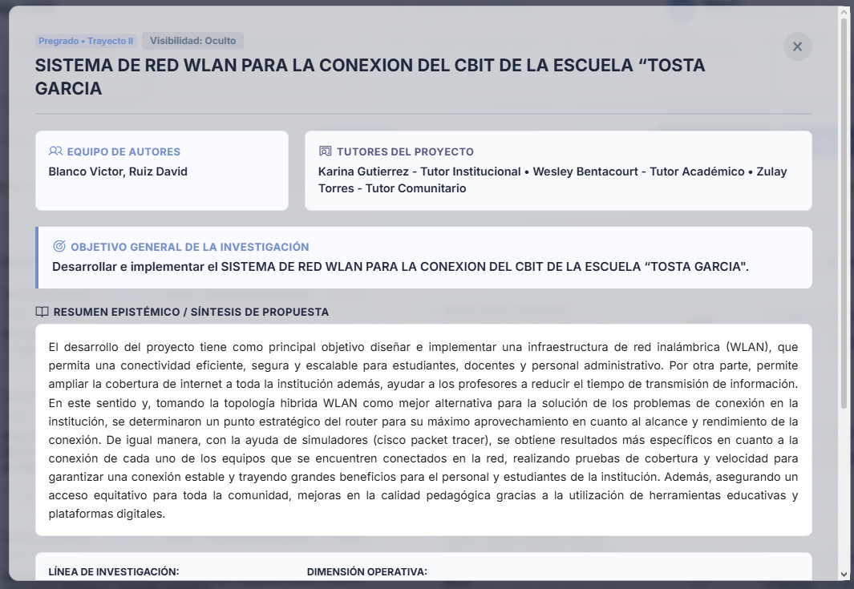
Note. Pop-up window allowing administrators to audit the structure, abstract, and metadata of the research project before authorizing its public indexing.
To correct minor typographical errors or modify operational parameters without loading the extensive full-edit form, the system provides a tool called "Quick Project Adjustment" (see Figure 43), accessible via the “Quick” button in the project actions column. This simplified interface allows the coordinator to swiftly modify surface-level yet classification-critical data—such as the project title, academic program, creation year, linked research line, or source code repository link—as well as directly manage the project's visibility.

Figure 43
Quick Project Adjustment Modal
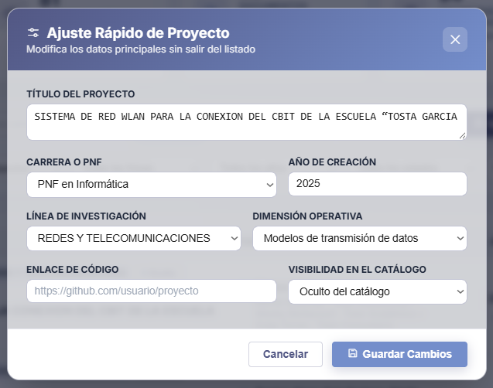
Note. Agile editing tool for modifying primary metadata and managing document visibility without loading the full edit form.
For structural modifications affecting the authors or the comprehensive content of the research work, selecting the “Edit” option redirects the user to the "Edit Socio-Technological Project" interface (see Figure 44). This form covers 100% of the project record, enabling in-depth editing of indexing metadata as well as reassignment or correction of the information corresponding to linked students and advisors. Furthermore, in the right-hand side panel, this view allows management of the attached digital file, offering the option to replace the original document (PDF or Word) with an updated version while keeping the existing database record intact.
Figure 44
Advanced Form for Editing Projects
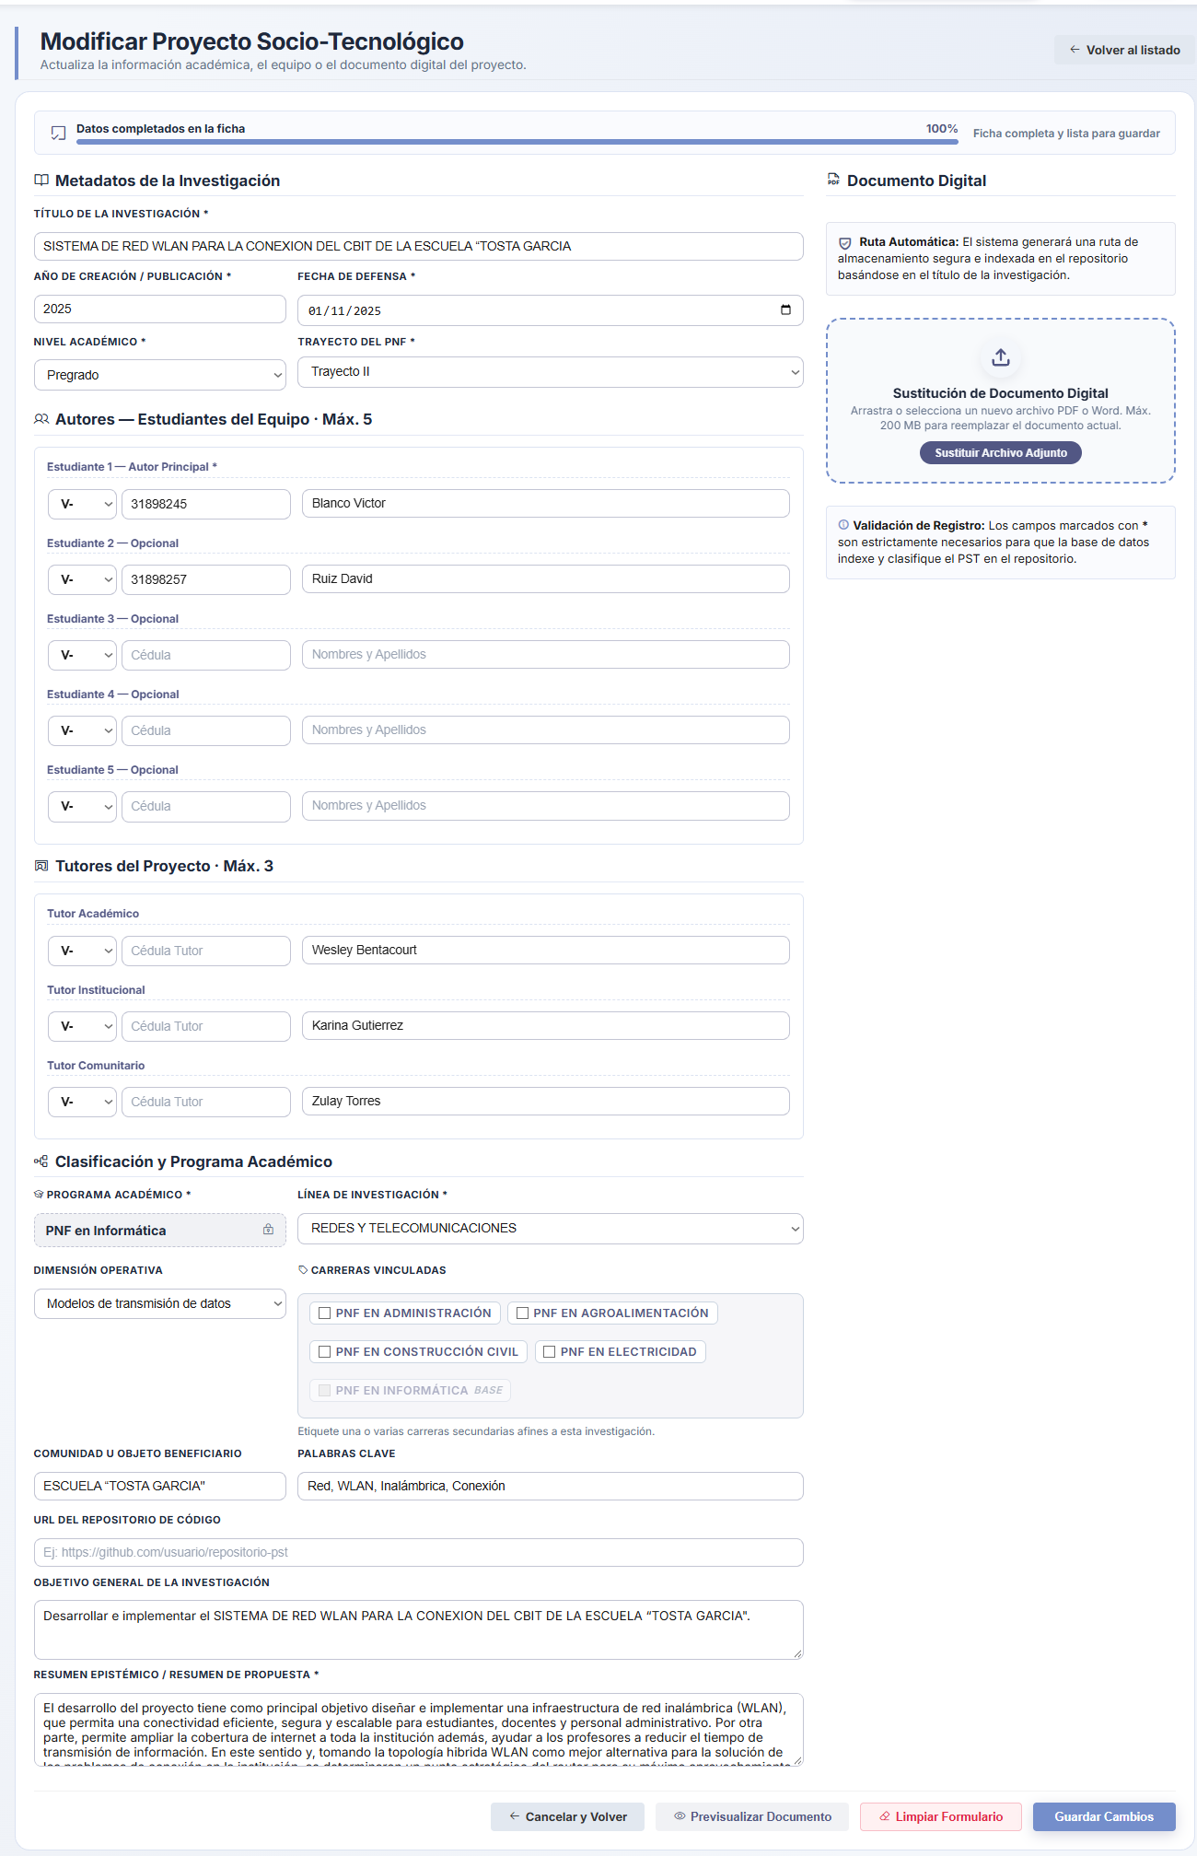
Note. Comprehensive editing interface allowing modification of all metadata and project team members, as well as replacement of the original document file.
Similarly, the "Register New Project" interface (see Figure 45) shares the same architectural layout as the editing form, ensuring consistency in the user experience. In this section, the manager must thoroughly complete all required fields to catalog a new research work, ranging from basic metadata to the epistemic abstract and digital file upload. A progress indicator at the top dynamically evaluates the completeness of the record, ensuring that no vital information is omitted before allowing the document to be indexed in the public repository; if an incomplete project is submitted, it is automatically marked as “Pending completion”.

Figure 45
Registration Form for New Socio-Technological Projects
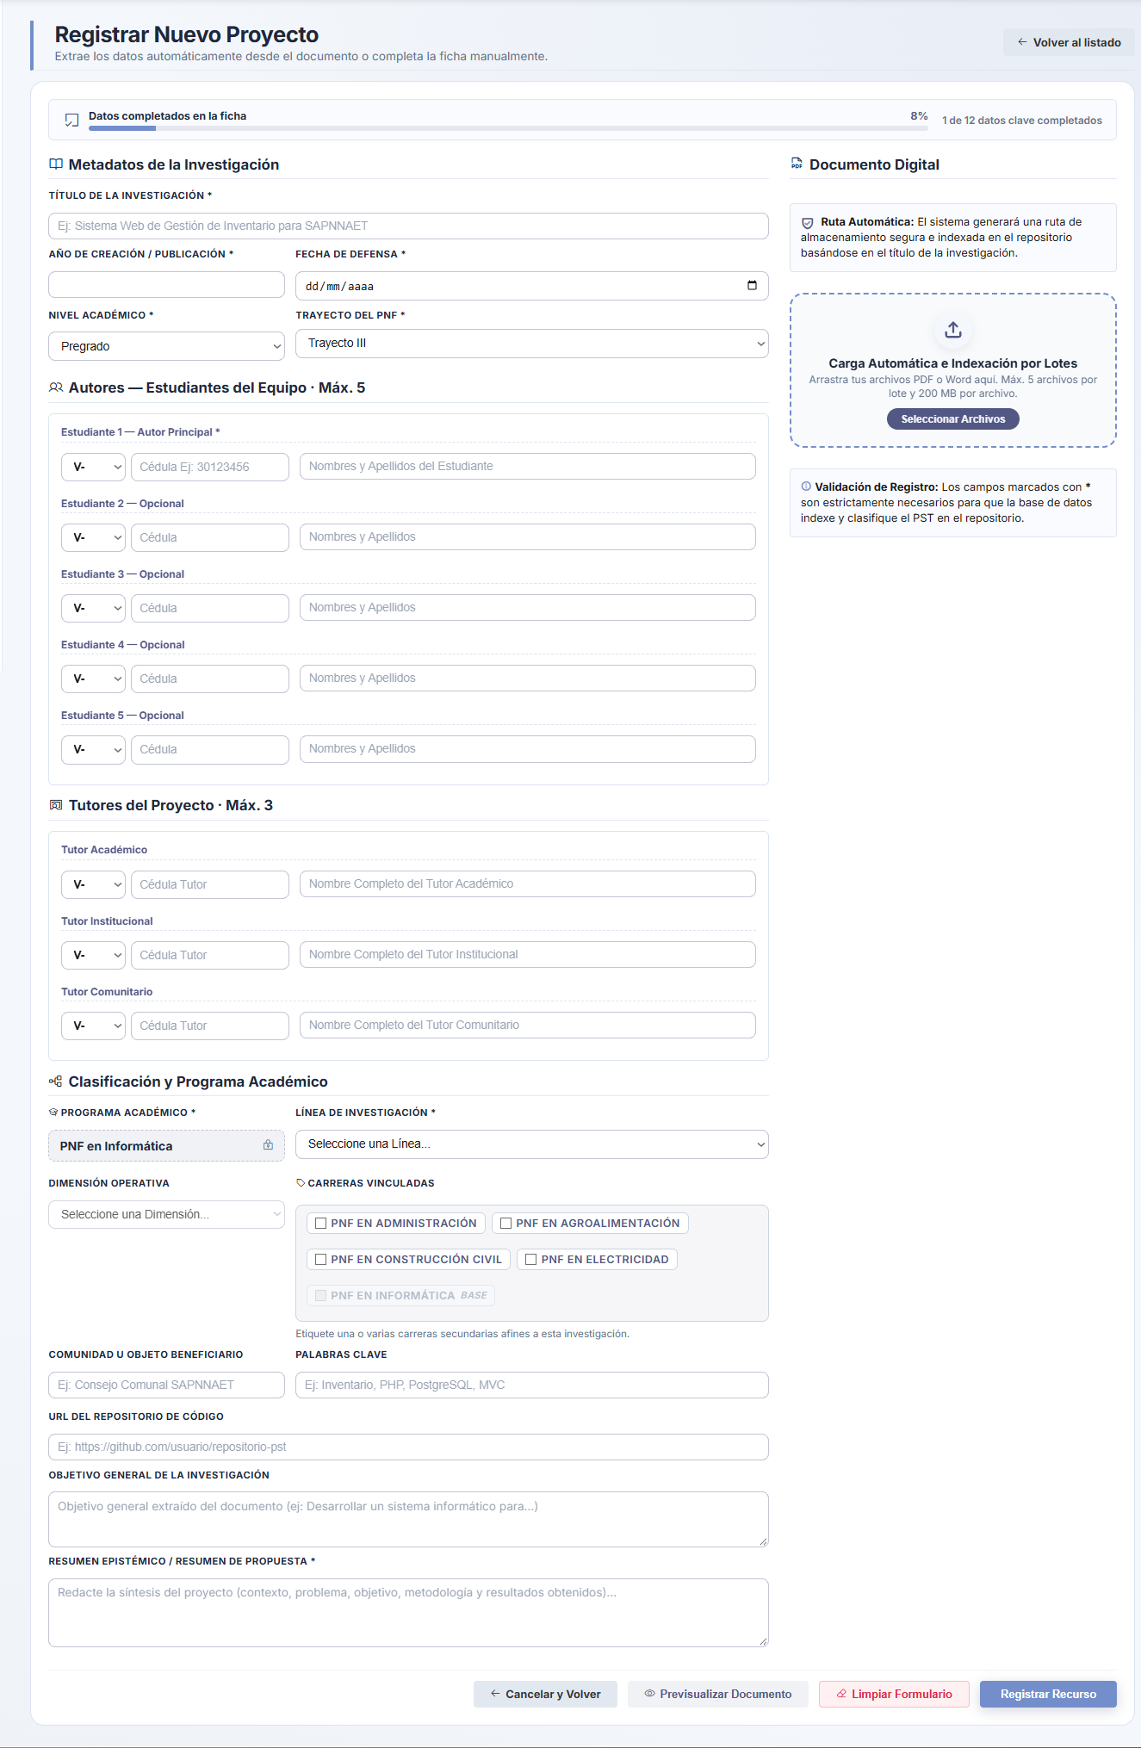
Note. Research registration interface requiring structured entry of metadata, academic classification, and digital file upload.
As an alternative to manual entry, the platform incorporates an "Automatic Upload and Batch Indexing" workflow (see Figure 46), designed to significantly accelerate the institutional digitization process. Upon dragging or selecting multiple documents (PDF or Word), the system processes the queued files, automatically extracting baseline metadata to pre-fill the form. The administrator can monitor the upload status of each document in an interactive side panel, and projects can be submitted even while others remain in the same queue (see Figure 47), allowing the manager to register documents individually or all at once.
Figure 46
Automated Data Extraction When Uploading a Project
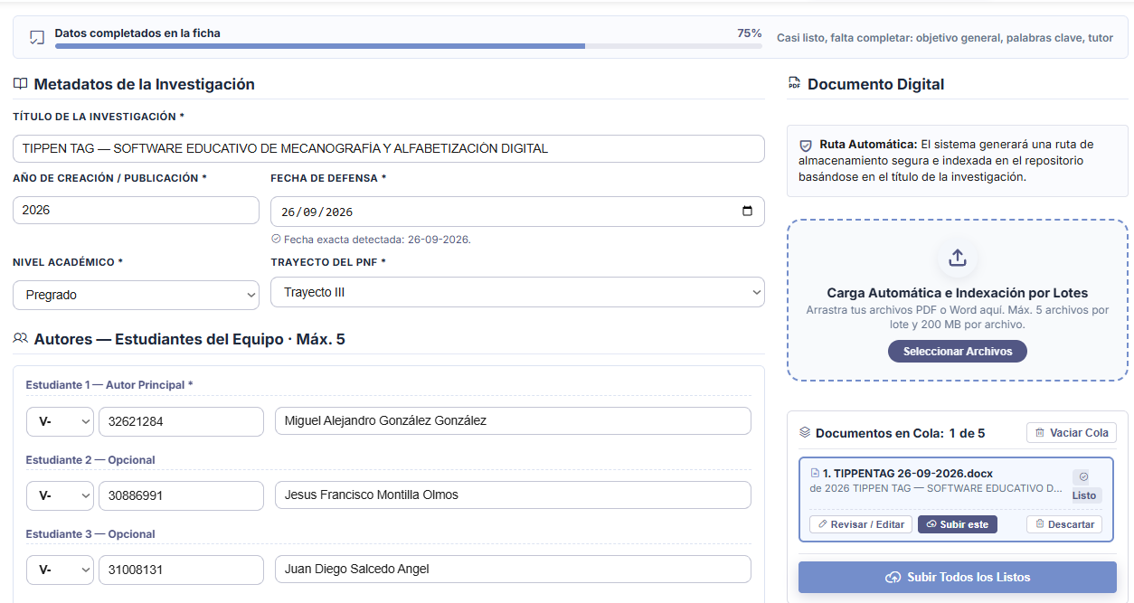
Note. Mass indexing tool that queues digital documents and pre-loads basic metadata to streamline administrative registration.
Figure 47
Confirmation of a Project Successfully Saved While Queued
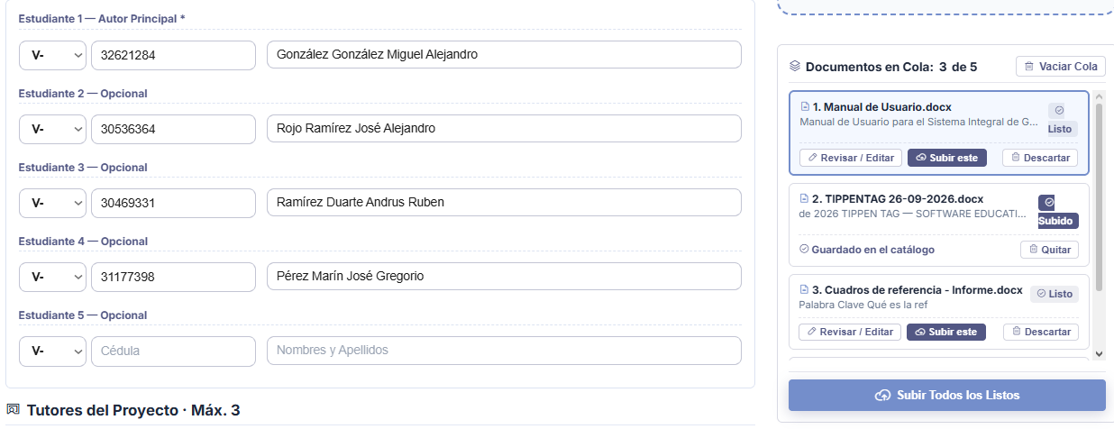
Note. Projects can be managed separately; in the figure, the second project was uploaded first before proceeding to manage the first one, and in both cases basic data was automatically extracted from the files.
To conclude the project upload and editing section, the repository provides an option to preview the document prior to upload, allowing users to verify that its content is neither lost nor corrupted and confirm that the correct file is being submitted. As shown (see Figure 48), it features the same tools as the integrated viewer (see Figure 29), except that because the file is not yet hosted on the server, the download and full-screen viewing options are not displayed.

Figure 48
Preview of the Uploaded Document
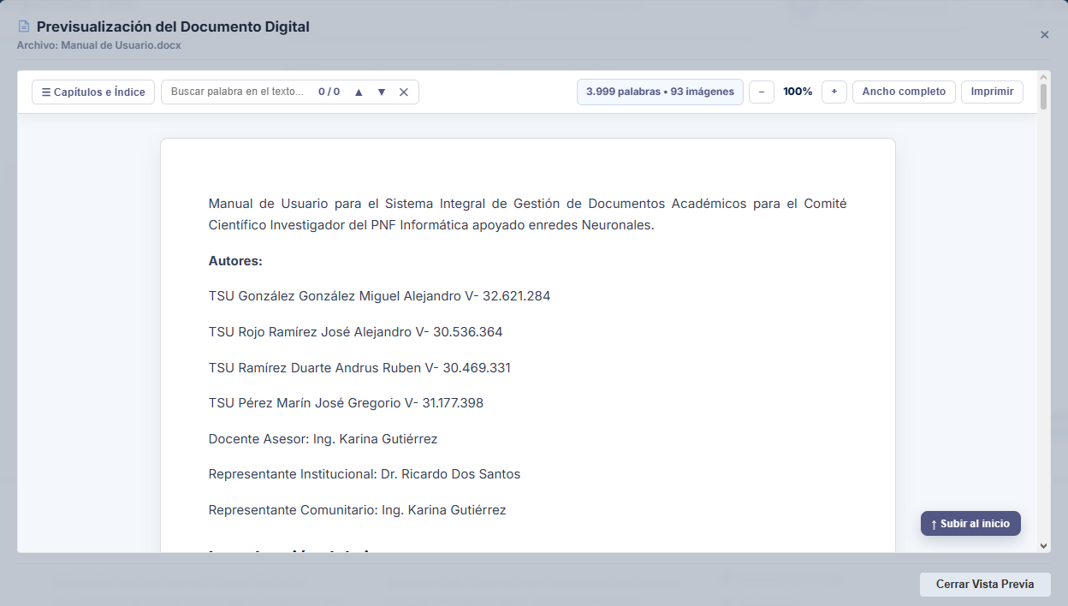
Note. It provides straightforward tools for reviewing the file prior to upload and is compatible with both Word and PDF formats.
Finally, the document management workflow includes strict validations for individual project deletion (see Figure 49). When requesting the removal of a record from the main panel, the platform displays a critical confirmation dialog warning the administrator that this action is permanent and irreversible, and that it will result in the physical deletion of attached files on the server. Once the user confirms the action via the "Yes, delete" button, the system executes the database query and displays a Successful Operation notification (see Figure 50), certifying that the research work has been completely purged from the catalog and the storage space freed.

Figure 49
Validation Dialog for Project Deletion
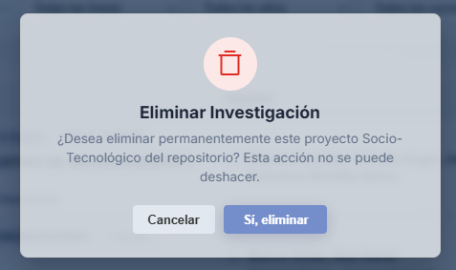
Note. Security mechanism requiring explicit administrator confirmation before proceeding with the permanent deletion of a research project.
Figure 50
Successful Research Deletion Notification

Note. Visual confirmation generated by the platform after executing the complete removal of the project and its linked files from the database.

4.2.2. ONNX AI Model
The analytical core of the CIIDI platform is managed through the ONNX Neural Network Model Management Panel (see Figure 51), an advanced interface designed exclusively for supervising and calibrating the semantic search engine. This technical dashboard exposes critical real-time performance metrics, such as the global vector precision index, the exact inference latency per query, and the coverage level of indexed projects through the pgvector extension in the PostgreSQL database.
Additionally, the panel allows administrators to granularly tune the hyperparameters of the Artificial Intelligence model (based on the XLM-RoBERTa architecture), providing the ability to define the maximum cosine distance threshold for considering a match valid, set token processing limits (SentencePiece), and weight the conceptual priority of specific fields such as the research abstract, keywords, and general objective, thereby ensuring that the search engine delivers highly relevant results tailored to the academic reality of the institution.

Figure 51
ONNX Neural Network Model Management Panel
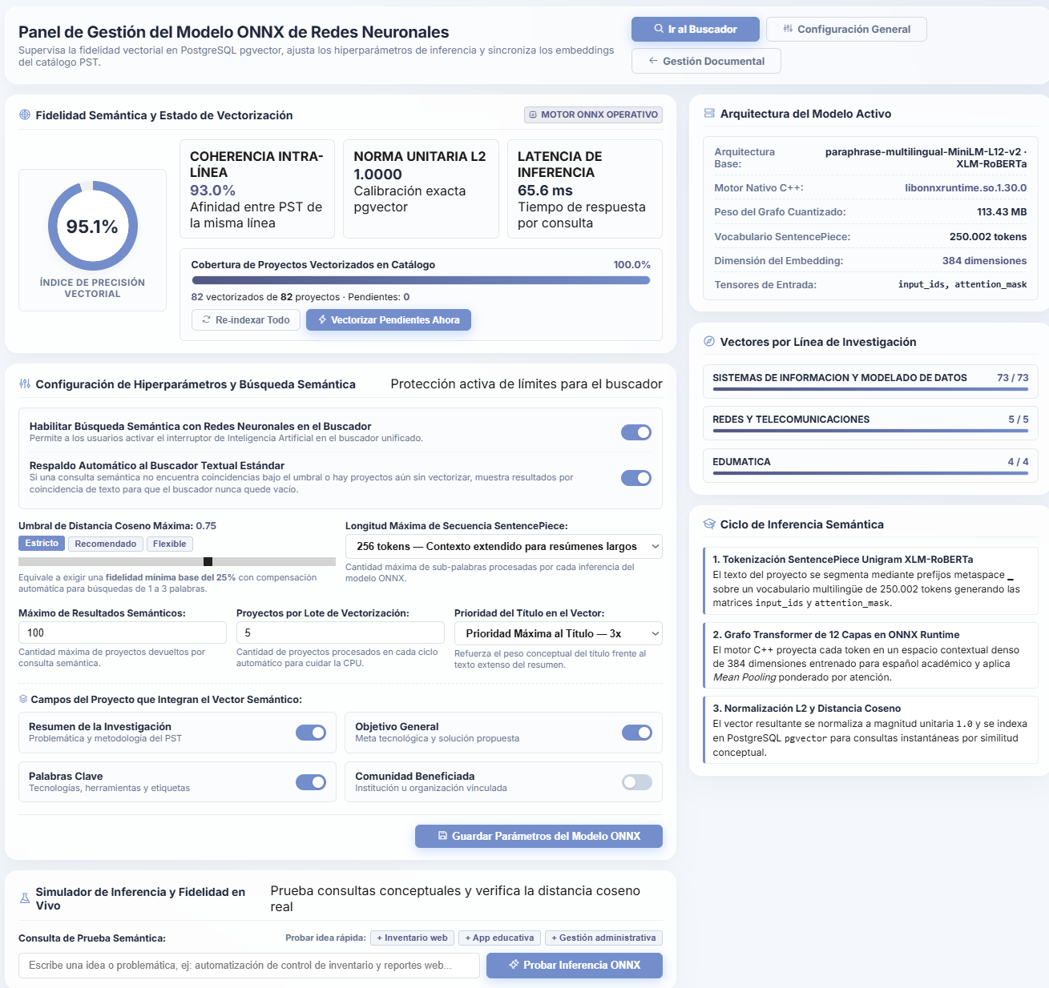
Note. Advanced control dashboard for semantic search hyperparameter calibration, latency monitoring, and database vector synchronization.
To empirically validate the engine configuration before applying it to the public environment, the module incorporates a "Live Inference and Fidelity Simulator" (see Figure 52). This analytical tool allows repository administrators to write test queries in natural language and execute instantaneous semantic inferences, with the option of using preset example queries.
The results returned by the simulator break down the behavior of the model, displaying total operation latency, the number of processed tokens, and—crucially—mathematically exposing the fidelity level of each retrieved project by calculating its actual cosine distance relative to the submitted query. This level of algorithmic transparency is indispensable for diagnosing conceptual drift and fine-tuning the accuracy of the Unified Search Engine without interrupting service to end users.
Figure 52
Live Inference and Fidelity Simulator
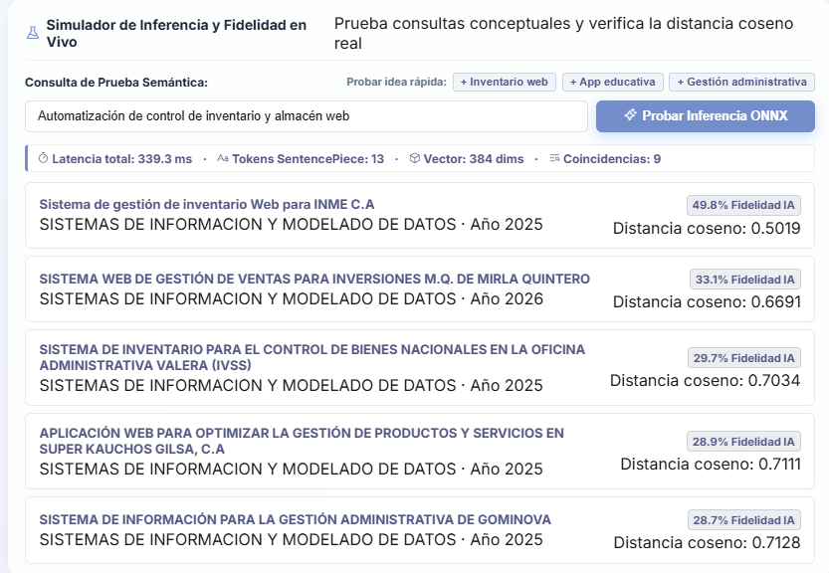
Note. Diagnostic tool enabling semantic search testing and visualization of the mathematical cosine distance calculation for each match.

4.2.3. Repository Configuration
The general behavior, display preferences, and environment rules of the project catalog are centrally administered through the Repository Parameter Management panel. In its first tab, titled "Citation Formats" (see Figure 53), the platform provides a template generator powered by dynamic variables that automatically structures bibliographic references.
The administrator has full control to edit or delete existing templates (such as APA 7th Edition, IEEE, and Vancouver) using smart insertion tags (e.g., {autores}, {anio}, {titulo}), previewing in real time how the resulting citation will be formatted in the public environment. Likewise, the system supports creating new referencing formats from scratch, ensuring platform scalability in response to future updates in international academic standards.

Figure 53
Dynamic Template Management for Citation Formats
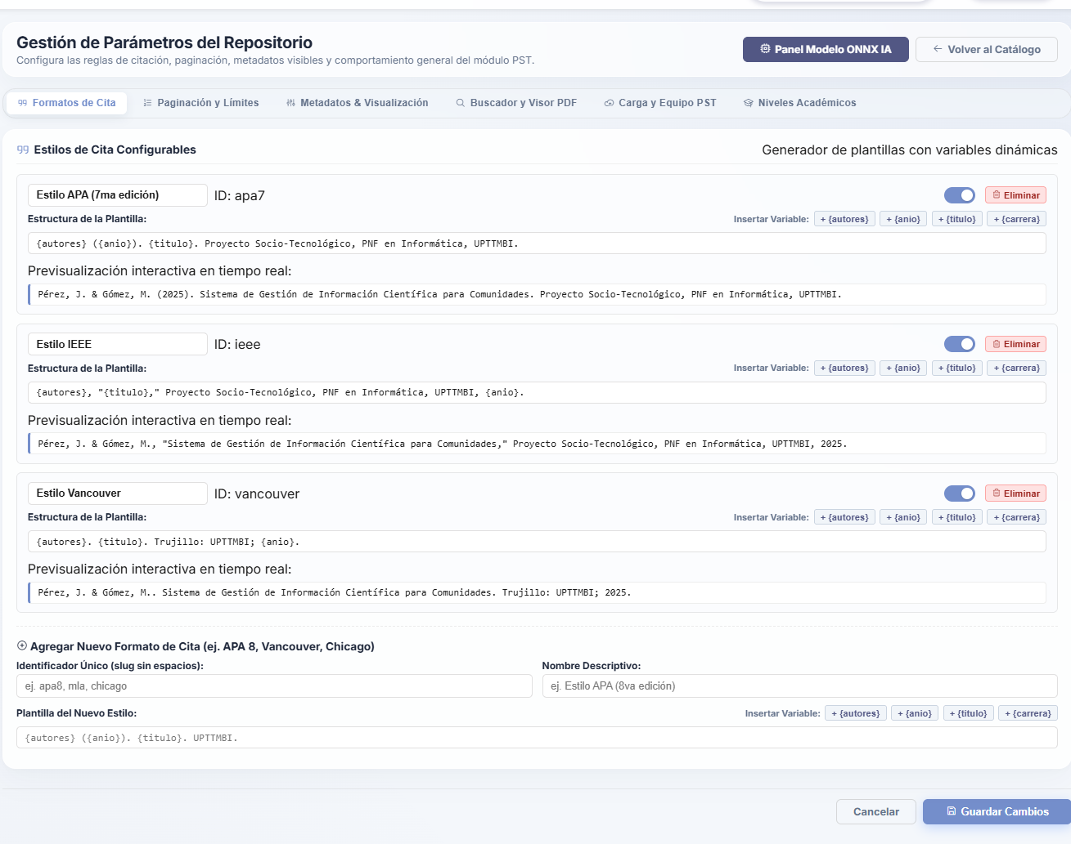
Note. Interface enabling real-time creation, editing, and previewing of bibliographic referencing schemes using dynamic variables.
Navigating to the "Pagination and Limits" tab (see Figure 54), the system offers granular control over the volume of information presented to users during queries. From this section, the coordinator can toggle the overall navigation behavior of the repository, setting the desired loading mode (such as traditional numbered pagination) and numerically defining the maximum number of projects rendered per page in both the main catalog and the Unified Search Engine results view. Likewise, this section makes it possible to cap the volume of related research works suggested by the artificial intelligence engine at the bottom of each technical record, optimizing server performance by preventing query overload and ensuring a smooth, clutter-free user experience.
Figure 54
Pagination and Query Settings Configuration

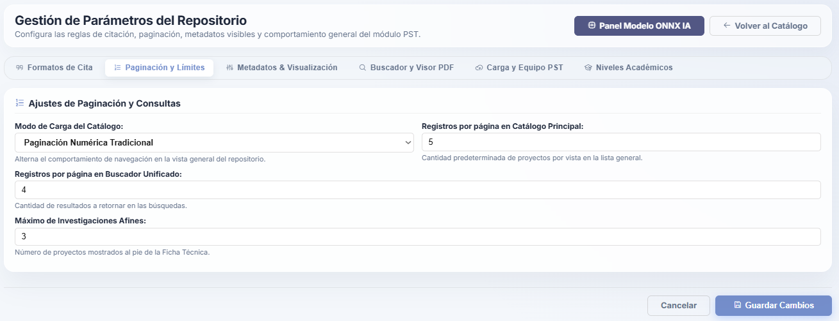
Note. Control panel for defining result density across the general catalog, the Unified Search Engine, and related research suggestions.
The "Metadata and Display" tab (see Figure 55) focuses on standardizing institutional nomenclature and governing privacy controls over cataloged information. This interface empowers the administrator to define the official suffix or technical nomenclature identifying the resource type across all system tags and search results (for example, "PST / Socio-Technological Project").
Additionally, it includes a panel of quick-configuration toggles governing "Field Visibility in Technical Record," granting the authority to globally hide or display sensitive or structural data—such as the direct link to the Git repository containing the project's source code, the name of the beneficiary community or entity, and the categorization corresponding to the academic level and PNF track to which the research belongs.
Figure 55
Nomenclature and Metadata Visibility Control
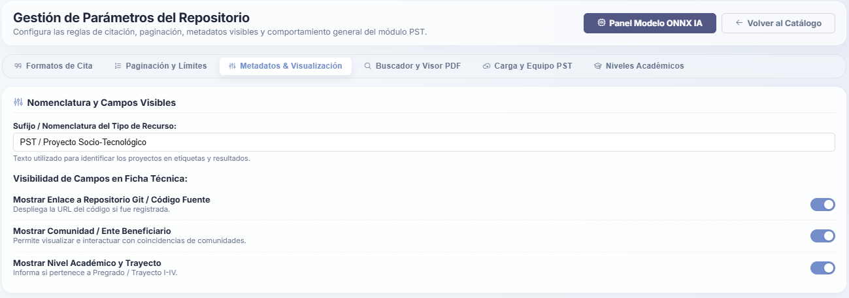
Note. Interface for standardizing resource naming conventions and managing which information fields remain visible to the general public on the technical record.
Regarding usability and file distribution, the "Search Engine and PDF Viewer" tab (see Figure 56) consolidates interactive options that enrich the reading experience. The administrator can configure explorer behavior by enabling dynamic filters by degree program, defining the minimum year for the publication histogram, and activating visual highlighting of text matches.
However, the most critical function of this section lies in document viewer parameterization, where administrators can enable the advanced toolbar (for zoom and navigation), allow direct downloading of original files, and—as an intellectual property protection mechanism—set the security level required to authorize downloads, restricting document retrieval, for example, exclusively to users with registered and authenticated accounts in the system.
Figure 56
Parameterization of Search Engine and Document Viewer Behavior
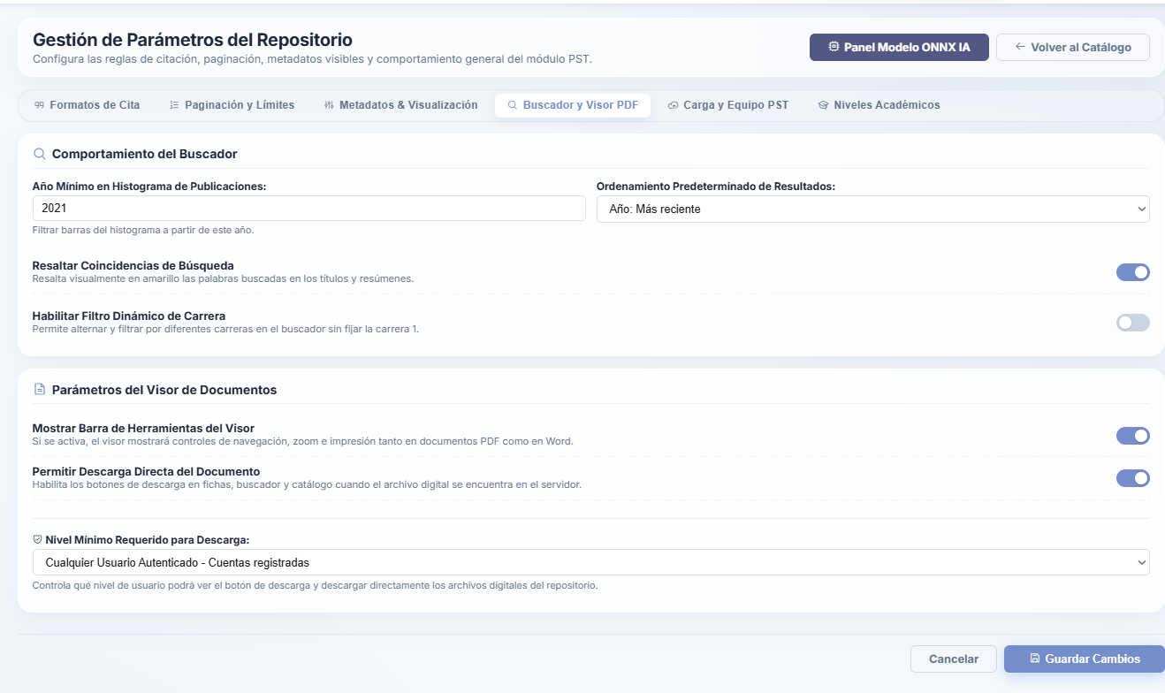
Note. Panel for configuring search highlighting, enabling viewing tools, and defining the security levels required to download digital files.
To guarantee server stability during research registration workflows, the "Document Upload and Processing Restrictions" tab (see Figure 57) establishes strict data-handling limits. This panel defines the maximum allowed size per individual file (in Megabytes) and the maximum number of documents that can be processed simultaneously during batch indexing, preventing bandwidth bottlenecks.
Concurrently, an initial page limit is configured for automatic metadata extraction, thereby optimizing RAM consumption. Within this same context, the system allows organizational caps to be defined for project teams, setting the maximum number of student authors and the limit of advisors that may be linked to a single Socio-Technological Project.
Figure 57
Configuration of Upload Restrictions and Structural Limits
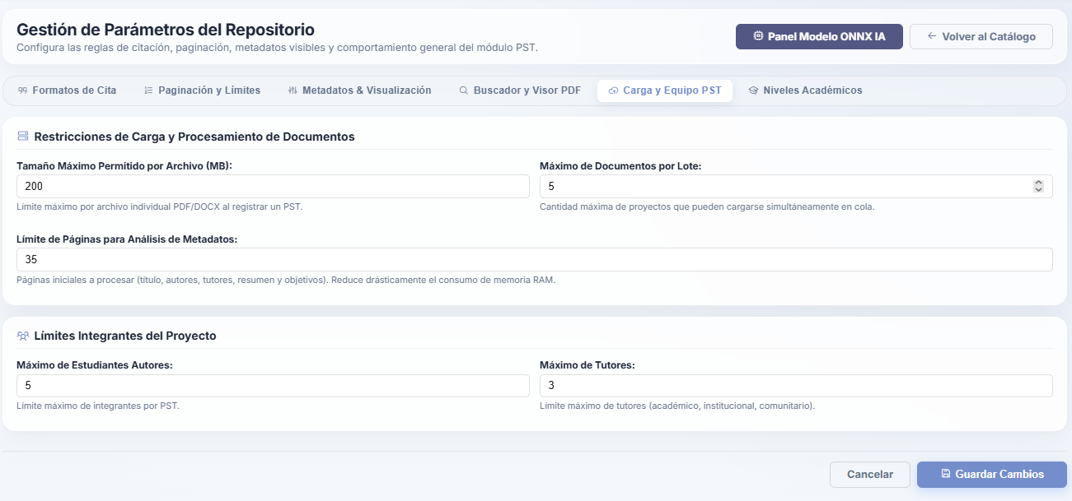
Note. Technical panel for establishing file size limits, batch indexing density, and maximum member caps per research team.
Finally, the academic architecture of the repository is managed through the "Academic Levels" tab (see Figure 58), which adapts the platform to the various degree tiers offered by the university institution. From this administration interface, the coordinator can add, edit, hierarchically order, or deactivate levels such as Undergraduate, Specialization, Master's, or Doctorate, assigning unique identifier codes to each.
In addition, a notable feature of this management section is the ability to determine whether a specific study level requires enabling the "PNF Tracks" selector in registration forms and search filters (typically applicable to Undergraduate studies), ensuring that the cataloging structure remains fully aligned with the curricular design of active training programs.
Figure 58
Management of Academic Levels and Curricular Hierarchy
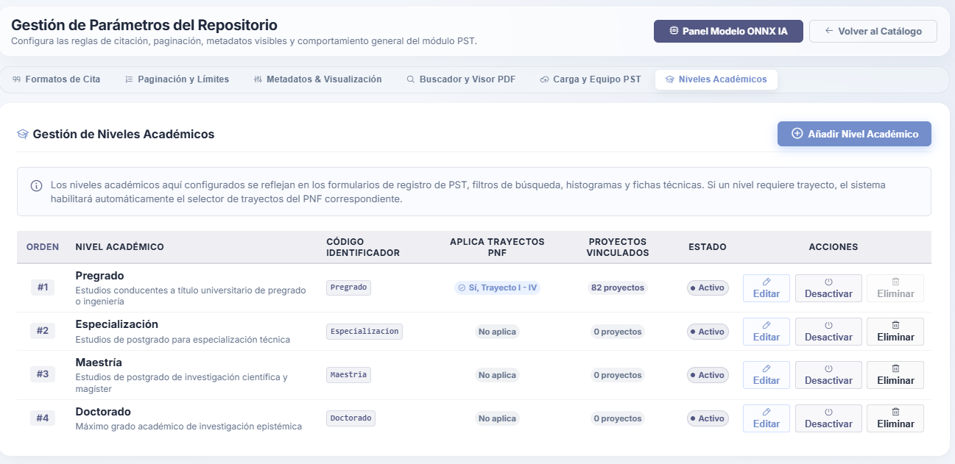
Note. Interface for administering the various academic degrees supported by the repository and linking them to National Training Program tracks.

5. Module – Scientific Articles and Research
Like the socio-technological projects ecosystem, the Scientific Articles Module is built upon an architecture strictly segmented by role-based access control (RBAC) authorization levels. On one hand, it provides a Public Access environment focused on information discovery, immersive reading, and researcher visibility without requiring credentials. On the other hand, behind an authentication barrier, it safeguards a robust Internal Management section that equips digital journal administrators and editors with all the tools needed to control the publication lifecycle, audit the authors catalog, parameterize system display settings, and manage physical storage of graphic assets on the server.

5.1. Public Access
The Articles Module represents the academic dissemination core of the CIIDI platform, specifically structured to maximize the visibility of knowledge generated by the institutional community. Within its Public Access branch, the primary component is the Articles and Research Catalog (see Figure 59), a landing interface that welcomes visitors with a minimalist design centered on information search and discovery.
This initial screen strategically divides navigation into two core tabs—the publications inventory and the researchers directory—integrating a primary search engine in its header along with a quick-filter carousel organized by categories and thematic tags, facilitating intuitive exploration of academic literature without requiring prior authentication.

5.1.1. Articles and Research Catalog
Figure 59
Articles Catalog Landing Page
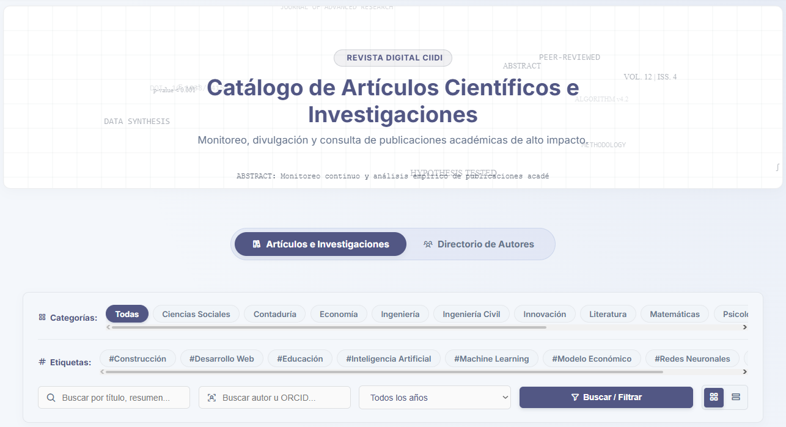
Note. Public landing interface of the module, highlighting the central search bar and the structural separation between publications and authors.
To adapt to user reading preferences and screen resolutions, the catalog implements a flexible display system. By default, results are presented in a "Grid View" (see Figure 60), which displays articles as interactive cards that visually highlight the journal or project cover, title, primary authors, and technical volume and issue identifiers.
Alternatively, visitors can switch to a "Spaced List View" (see Figure 61), a more analytical horizontal layout that prioritizes reading the title and descriptive metadata, optimizing vertical space and proving particularly useful when reviewing large volumes of results after applying advanced search parameters.
Figure 60
Grid or Card View of Articles
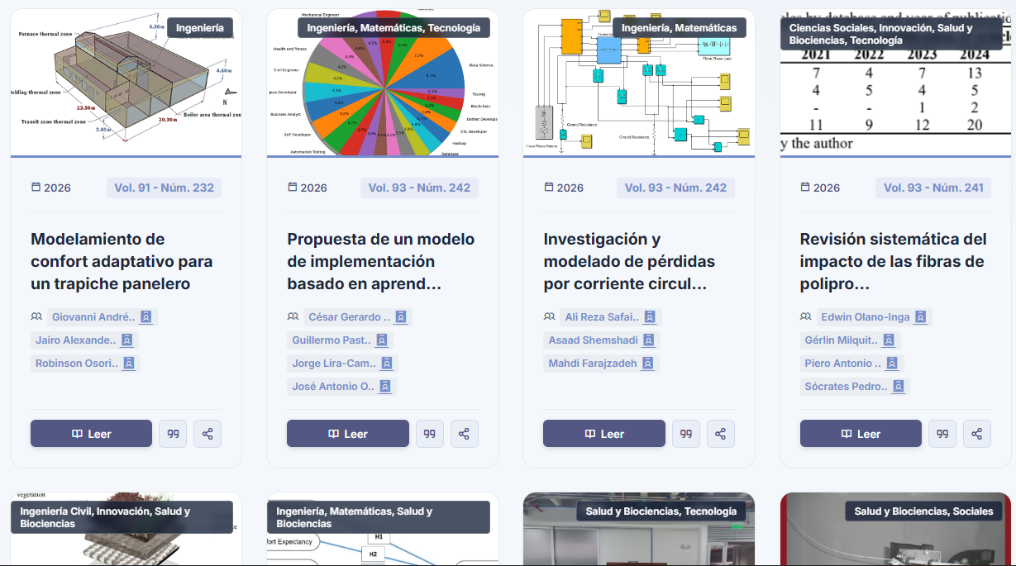
Note. Card-based visual layout prioritizing graphic elements and essential metadata for each publication.
Figure 61
Spaced List View of Articles

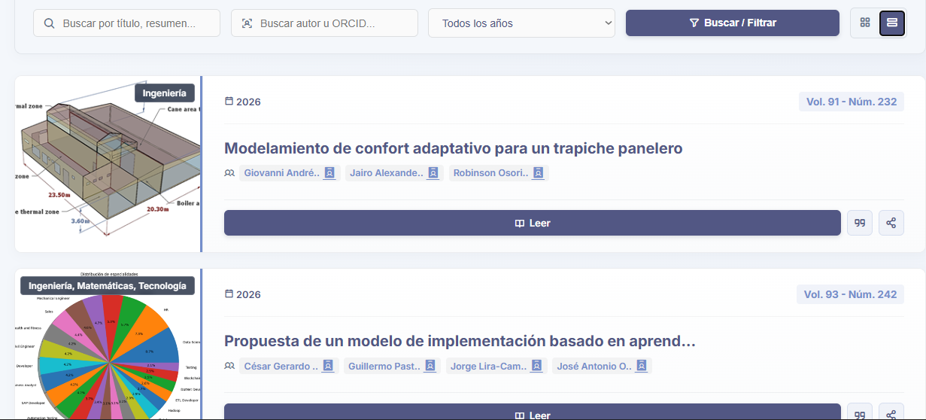
Note. Alternative display layout organizing articles horizontally to facilitate rapid scanning of titles and metadata.
Information retrieval efficiency is significantly enhanced by an advanced multi-filter search engine (see Figure 62). This dynamic tool enables researchers to cross-reference key variables such as search terms, thematic categories, and publication years, instantaneously updating on-screen results and indicating via tags ("Active filters") the operational parameters governing the current query.
As a high-precision complement, the system supports "Search by ORCID" (see Figure 63), allowing users to enter a researcher's standardized alphanumeric identifier to explicitly and directly isolate all publications associated with their authorship—effectively mitigating homonymy issues common in bibliographic databases; however, if the author's ORCID is unknown, users can simply search by name.

Figure 62
Active Multi-Filter Search Engine
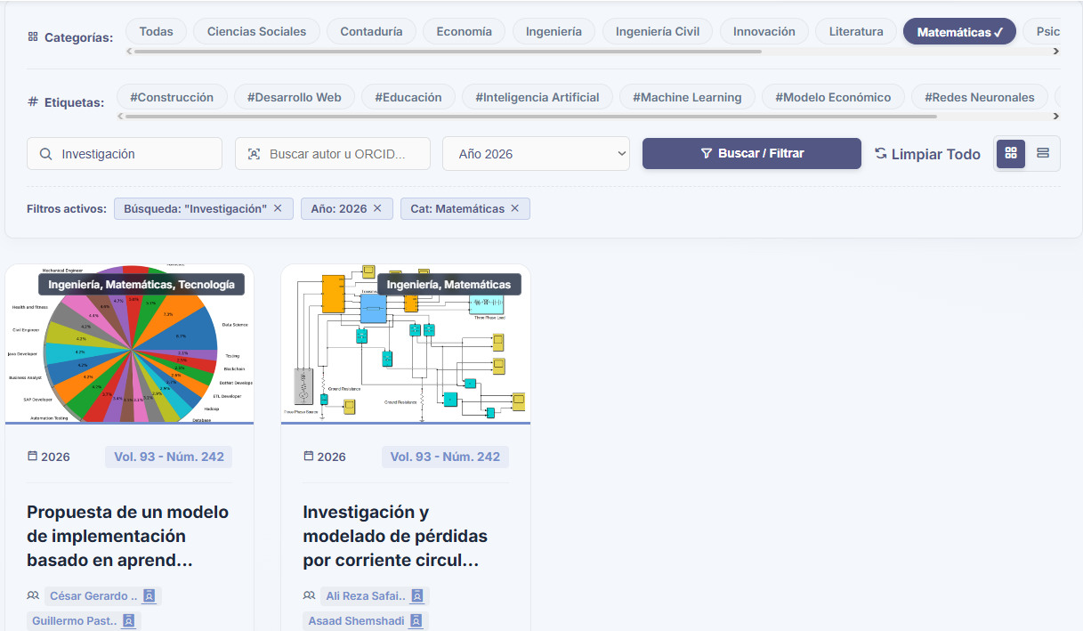
Note. Search interface demonstrating the simultaneous application of category and year filters, with active parameter indicators.
Figure 63
Search by Author ORCID
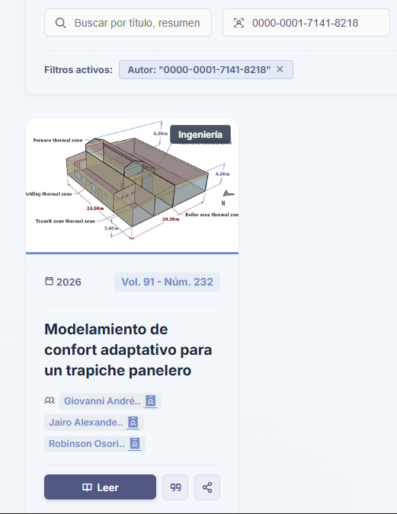
Note. Query engine configured to retrieve specific publications linked to a researcher's unique digital identifier.
To consolidate its utility as a direct research support tool, the module integrates an automated bibliographic reference generator (see Figure 64). Just as in the socio-technological projects repository, this modal window enables students and academics to instantaneously extract citations for the selected article under the most rigorous international standards. The system syntactically formats author names, research title, volume, issue number, and the digital journal's ISSN code, ensuring strict rigor in knowledge attribution and streamlining the construction of theoretical frameworks for future works.
Figure 64
Automated Academic Citation Generator
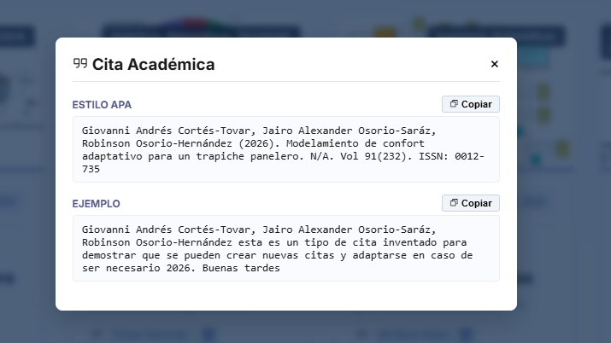
Note. Modal interface processing article metadata to produce standardized bibliographic references ready to be copied.

5.1.2. Authors Directory
Continuing with the overview of the dissemination ecosystem, it is structurally enriched and humanized through the Authors Directory (see Figure 65), a section dedicated exclusively to showcasing the academic background and profiles of researchers linked to articles published in the CIIDI repository.
This public interface presents an organized grid of individual cards, where each profile card displays the author's full name, verifiable ORCID code, and an excerpt of their biography or professional summary. This visual layout not only formally recognizes the research contributions of staff members, but also catalyzes academic collaboration networks by allowing visitors and peers to quickly identify active specialists across diverse branches of scientific knowledge.
Figure 65
Main Tab of the Authors Directory
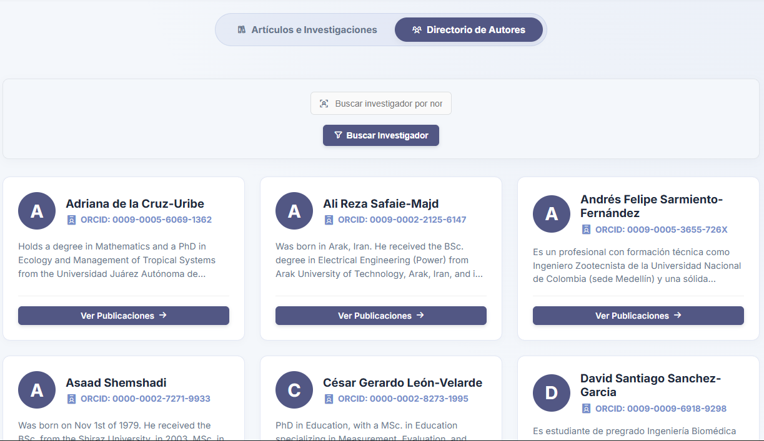
Note. Public catalog of researchers summarizing the academic identity, ORCID identifier, and biography of registered authors; it belongs to the same screen as the Articles and Research Catalog.
Clicking on a particular researcher routes the user to the detailed "Author Profile" (see Figure 66). This view functions as a high-fidelity digital academic portfolio, centralizing the individual's full biography, personal website hyperlinks, and linked ORCID code within a formal institutional header.
In the lower section, the system dynamically groups and renders the complete history of "Scientific Publications" in which the author has participated, incorporating dedicated internal filtering controls so users can specifically examine that researcher's body of work without operational interference from the general catalog—functioning similarly to applying an author filter in the main catalog, yet in a cleaner presentation.
Figure 66
Detailed Academic Profile of the Researcher
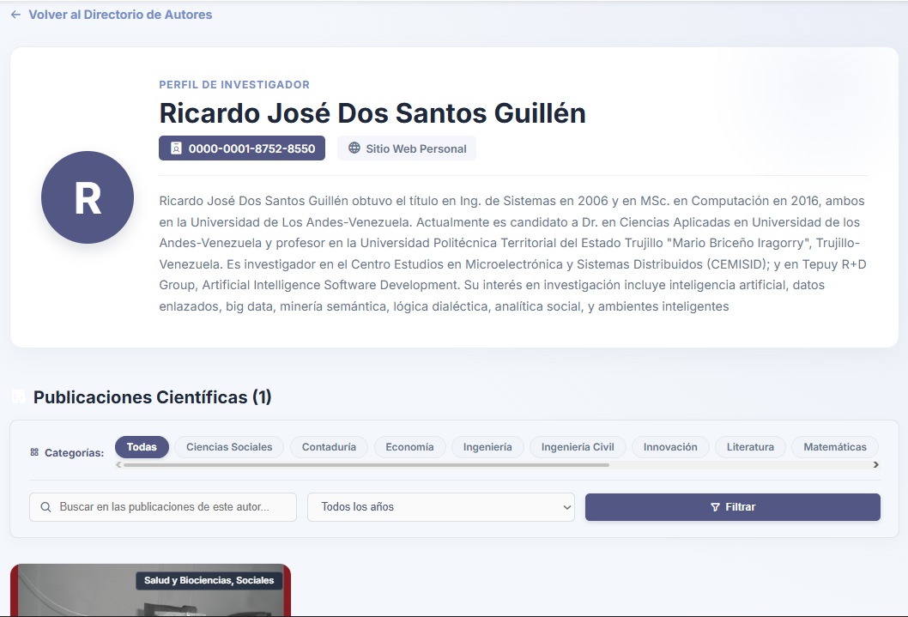
Note. Consolidated profile showcasing the author's background and interactively grouping all of their indexed publications.

5.1.3. Article Reader
Direct engagement with scientific content takes place through the "Article Reader," an interface meticulously optimized for in-depth assimilation of technical information. The header of this view (see Figure 67) serves as the primary contextual anchor, presenting the official title of the work with dominant typographic hierarchy.
Immediately below, the cataloging attributes of the document are displayed through visual badges indicating associated thematic areas, publication year, Volume, and Issue number, sequentially accompanied by interactive buttons identifying and linking each participating co-author (whose profile can be accessed directly from here), along with a direct link to the Digital Object Identifier (DOI) leading to the article's original publisher, as well as citation and share options—the latter simply copying the DOI to the clipboard.
Figure 67
Article Reader Header
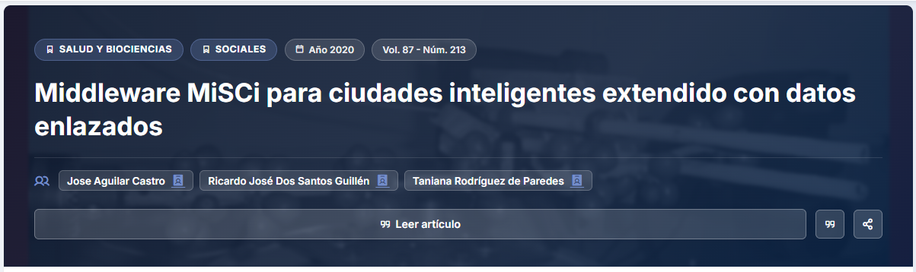
Note. Upper section of the reading view displaying the hierarchically styled title, classification tags, and participating authors.
Continuing with the reader layout, the informational core of the reading view is architecturally divided into two functional columns (see Figure 68). In the main left block, the full Abstract is presented, providing an accurate synthesis of the study's methodology and findings, followed by the keywords or tags that facilitate algorithmic indexing.
In parallel, within the right-hand side column, the system displays the "Article Technical Record," a comprehensive metadata box certifying the legitimacy and traceability of the publication by detailing the internal resource ID, endorsing publisher or entity, corresponding ISSN, and a direct shortcut to citation formats, unifying administrative context within a clean interface.
Figure 68
Article Abstract, Tags, and Technical Record
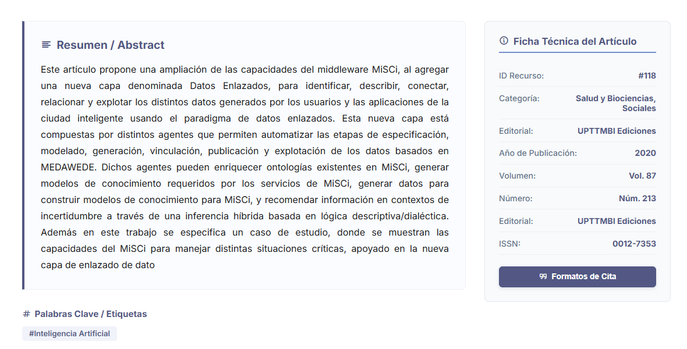
Note. Interface contrasting the research abstract content with a lateral cataloging metadata panel.
Finally, to foster audience retention and encourage organic discovery of complementary literature, the lower section of the reader integrates an algorithmic "Recommended Articles" component (see Figure 69). This dynamic block analyzes the categories, tags, and metadata of the current document in real time to populate an interactive carousel of publications sharing thematic affinity with the active reading; this feature reduces platform bounce rates and guides researchers across related knowledge ecosystems without needing to return to the main search bar to formulate new queries.
Figure 69
Recommended Articles Carousel
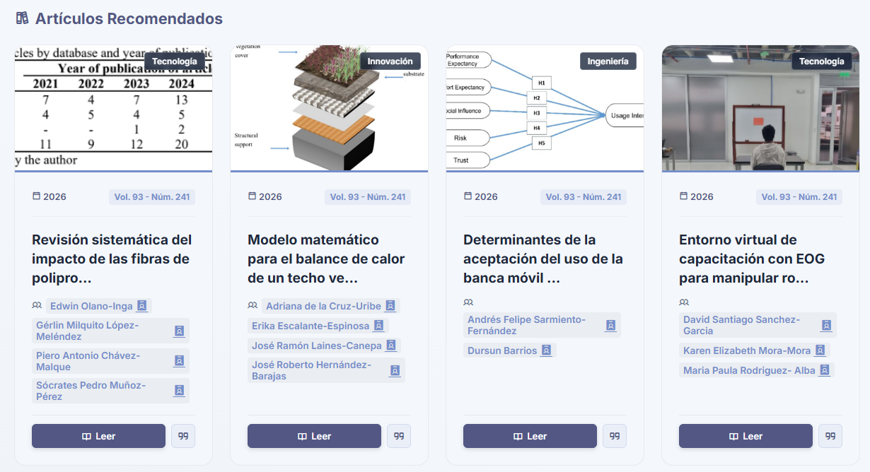
Note. Automated section suggesting complementary readings based on the thematic affinity of the currently viewed article.

5.2. Internal Management
This section documents the control panel reserved exclusively for the editorial team and system administrators. The internal management environment centralizes create, read, update, and delete (CRUD) operations for digital journal articles, ensuring metadata integrity and comprehensive control over parametric catalog entities such as categories, tags, publishing houses, and researcher profiles.

5.2.1. Articles Manager
The operations center for publication administration is embodied in the Scientific Articles Manager panel (see Figure 70). This interface provides editors with a dynamic control table listing all research works registered in the system, displaying each item's unique identifier (ID), cover thumbnail, full title, volume or year details, and thematic category. Notably, in addition to the search bar, the header of this manager provides direct shortcuts to the catalog manager (which defines parameters such as tags, publishers, and other key attributes for articles) and to the new article registration form.
To streamline high-volume administration, the table incorporates an instant text search bar and a badge system that immediately indicates each document's status in the public showcase ("Visible" or "Hidden"), accompanied on the right side by direct action buttons allowing editors to toggle visibility immediately, edit, or delete the record.
Figure 70
Articles Management Panel with Search Bar and Quick Shortcuts
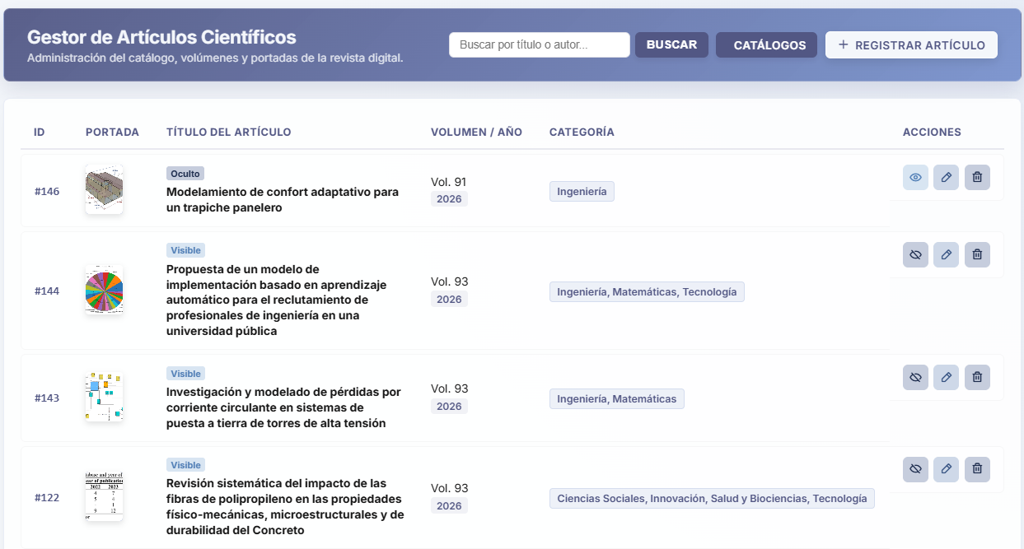
Note. Administrative control table listing the publications inventory, exposing key metadata and direct operational action buttons.
Publishing an article in the repository is carried out through the structured "Register New Article" form (see Figure 71). This interface segments data entry into semantic blocks: "General Information" for the title, abstract, categories, and official link (DOI); and "Publication" for recording the year, volume, issue number, and ISSN code.

Figure 71
Registration Form for New Articles
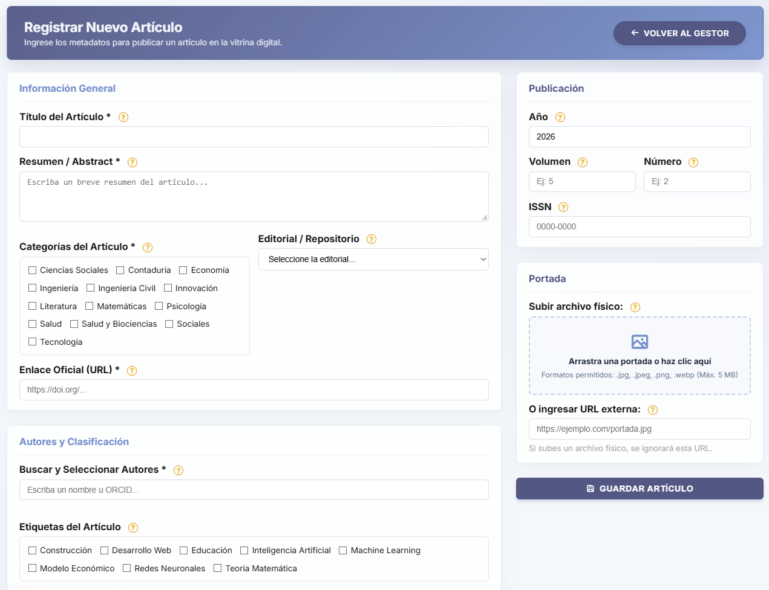
Note. Interface segmenting bibliographic metadata capture, thematic classification, and cover graphic asset management.
This is followed by a dedicated "Cover" section, allowing the administrator to upload a physical image file to the server via a drag-and-drop area or, alternatively, provide an external URL to reduce local storage load. Finally, the authors and classification section makes it possible to assign respective authorship attributions and add indexing tags. Once all required fields are validated by the system and processed in the database, the platform issues a "Successful Operation" notification (see Figure 72), certifying that the article has been properly saved and published in the repository's digital showcase.
Figure 72
Successful Article Publication Notification

Note. Visual confirmation generated by the system after properly processing and indexing the new research article in the database.
For correcting metadata or updating existing publications, the system redirects the editor to the "Edit Article" view (see Figure 73). This interface mirrors the architectural structure of the registration form to maintain user experience consistency, while instantaneously pre-loading all information stored on the server.
Within this environment, the administrator can overwrite any attribute—from the abstract to the current cover—using an interactive component that allows replacing the physical image hosted in the system with a new graphic file. Upon saving the changes and submitting the request to the server, the platform responds with a success alert (see Figure 74), confirming that the article has been updated without affecting its unique identifier or database relationships.
Figure 73
Editing Articles
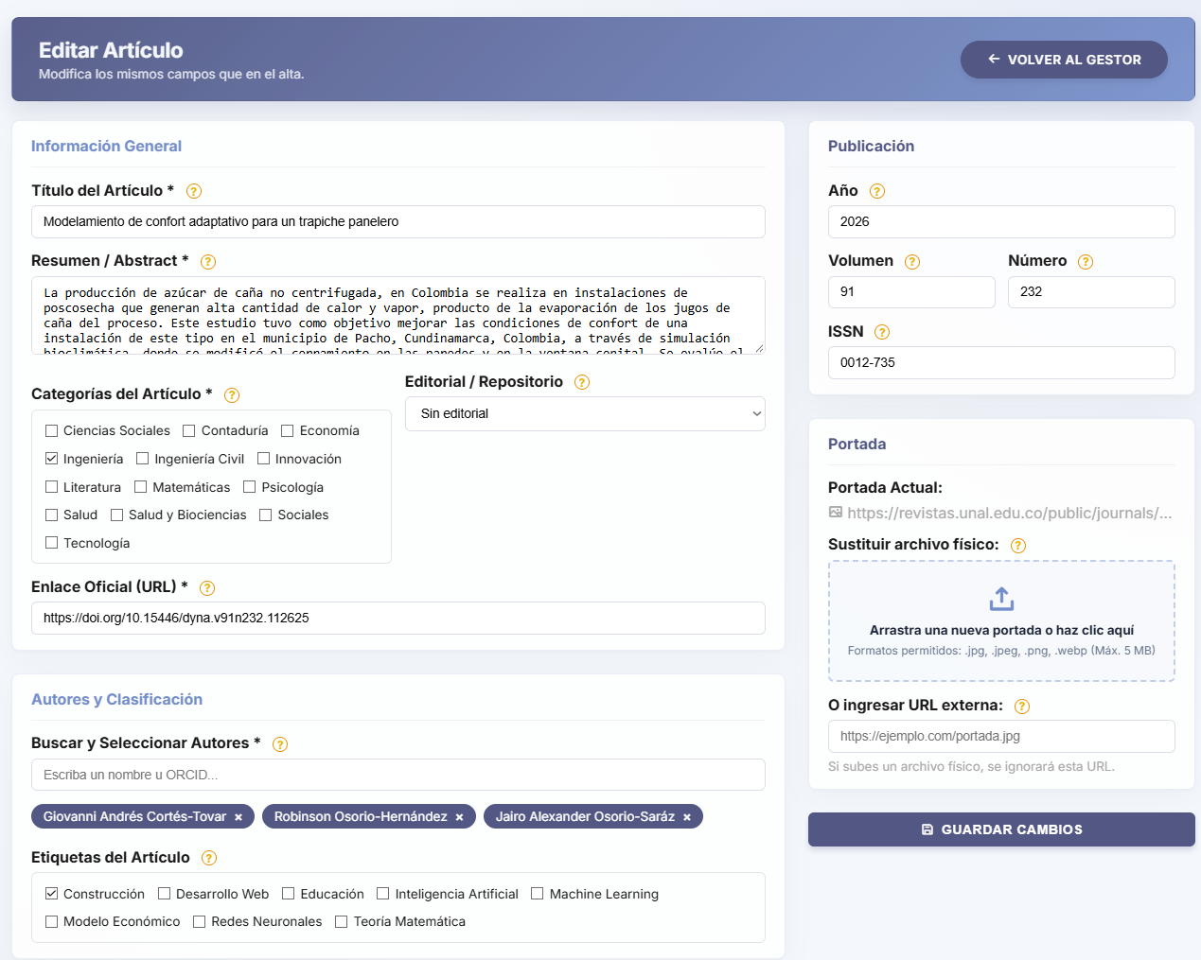
Note. Update form that pre-loads research data, enabling metadata modification and cover image replacement.

Figure 74
Successful Record Update Notification


Note. System message certifying the successful update of article data in the institutional repository.
Continuing with actions applicable to articles, deleting an article from the catalog is treated as a critical operation requiring explicit validation. When the manager clicks the delete button, the system interrupts the workflow by displaying a warning modal window (see Figure 75) informing the user of the permanent and irreversible nature of this action and emphasizing that attached files (such as the cover image) will be permanently deleted from the physical server. Following administrator confirmation, the platform executes the cascading deletion transaction and presents a final notification (see Figure 76), certifying that both the record and its linked files have been removed from the system.

Figure 75
Security alert for article deletion
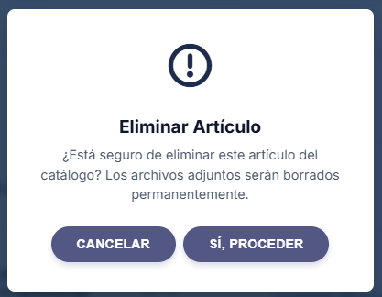
Note. Confirmation window that prevents accidental deletion, warning about the permanent removal of files on the server.
Figure 76
Research deletion confirmation
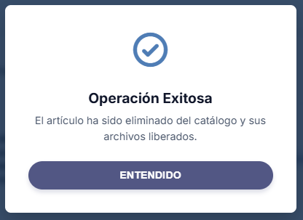
Note. Notification confirming the complete deletion of the article and the successful release of the occupied storage space.

5.2.1.1. Dynamic Author Management
A highly sophisticated aspect of the registration and editing forms is the "Authors and Classification" block, which was previously only mentioned and whose operation is explored in depth in this section; to link researchers to an article, the platform provides a dynamic search engine (see Figure 77); as the administrator types a name or an ORCID code, the system queries the database and displays a list of exact matches, preventing profile duplication.
However, if the researcher is not registered in the system, the intelligent component reveals a proactive option (see Figure 78) prompting the manager to register the new author directly from the search field, eliminating the need to leave the main editing form to perform this administrative task.
Figure 77
Dynamic researcher search bar in the form
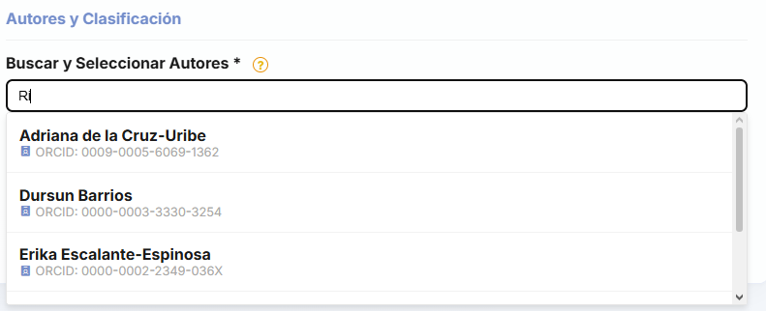
Note. Interactive component that queries the database in real time to link existing authors by their name or ORCID.
Figure 78
Quick registration option for unindexed authors
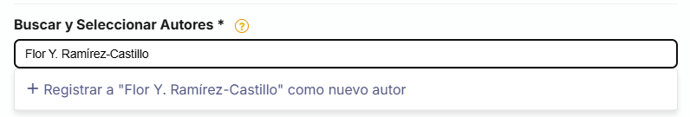
Note. Contextual action displayed by the search bar when the query yields no matches in the current directory.
Upon selecting the creation of a new profile, the system displays an overlay modal window titled "Register New Author" (see Figure 79); in this interface, the administrator must provide the researcher's foundational data: Full Name, mandatory ORCID code (to guarantee international record uniqueness), and optionally, a website and a biographical summary if available; once created, the profile is immediately linked to the research being registered or edited.
Figure 79
Quick registration modal for new authors
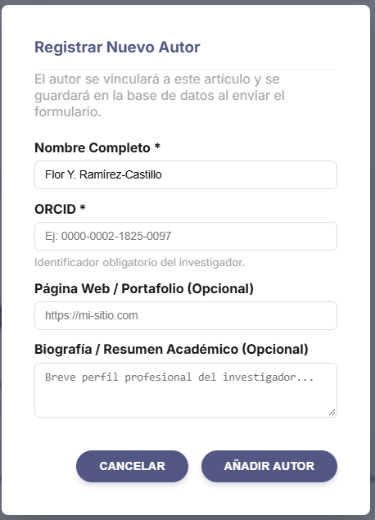
Note. Pop-up form to register a researcher in the system without interrupting the article registration workflow.
Once linked, the selected authors are visually represented as interactive tags or "chips" below the search bar (see Figure 80), allowing the editor to easily remove them if a mistake is made and ensuring full control over the order and composition of the research team before submitting the form to the database.
Figure 80
Visual representation of linked authors

Note. Tag-based (chip) visualization of the researchers assigned to the publication, featuring direct controls for their removal.
To safeguard the relational integrity of the database, the saving engine implements a profile reconciliation logic (see Figure 81), whereby if the administrator links a newly created author whose ORCID already belongs to a consolidated profile in the system, the platform detects this collision while updating the article; in response, the system intelligently merges the information, replacing the duplicate author with the preexisting original profile and issuing an informational alert within the success notification to inform the manager of the automatic normalization performed on the researcher's data.

Figure 81
Author profile reconciliation notification

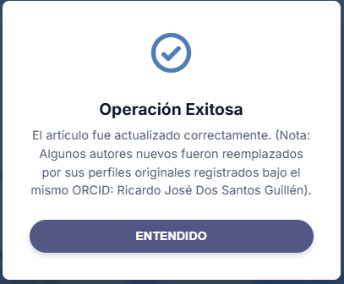
Note. Success message notifying of the automatic detection and unification of duplicate authors through ORCID code validation.

5.2.2. Catalog and Authors Manager

5.2.2.1. Categories
The taxonomic organization and relational structuring of the journal are governed from the Catalog and Authors Manager, a modular panel designed to administer the system's parametric entities; its architecture is divided into thematic tabs, starting with the "Catalog Categories" panel (see Figure 82), where the editor can view, search, add, or delete the major subject areas (e.g., Social Sciences, Engineering) that govern public navigation—notably, it is on the basis of these categories that the journal relates similar articles within the reader.
Figure 82
Scientific catalog categories manager
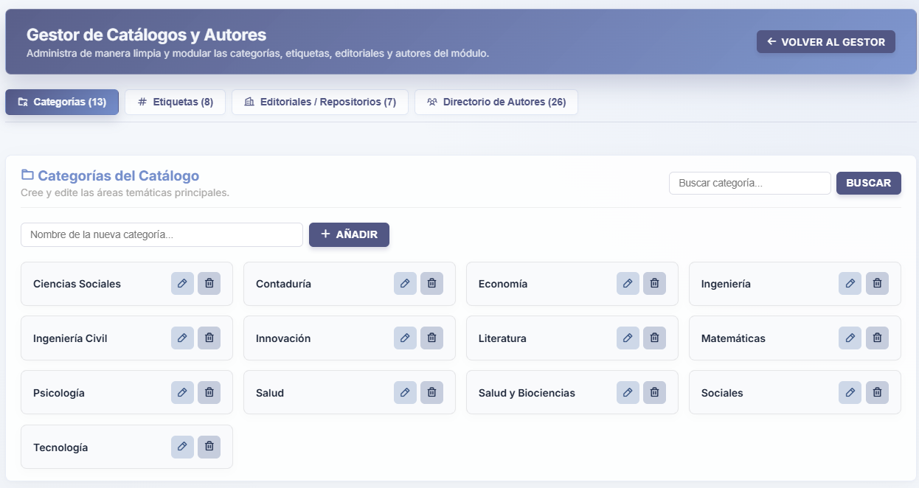
Note. Interface for centralized administration of the main subject areas that group research works across the platform.

5.2.2.2. Tags
Similarly, the "Search Tags" tab (see Figure 83) enables the management of specific keywords (e.g., #MachineLearning, #Education) used for rapid and granular indexing of articles, facilitating the scalability of the institution's controlled vocabulary; both this interface and the remaining tabs provide quick management tools so that, as shown below, there is no need to leave this manager to create or modify the information it handles.

Figure 83
Search tags administration panel
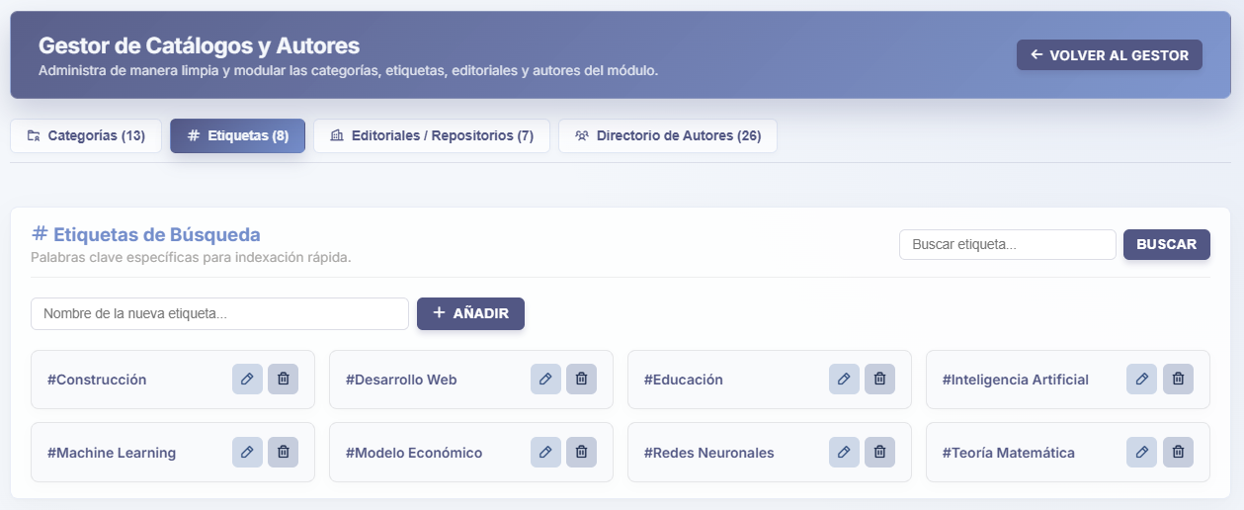
Note. Control environment for registering and editing the keyword vocabulary that optimizes article indexing.

5.2.2.3. Publishers/Repositories
Expanding its parametric capabilities, the system includes a tab dedicated to "Publishers and Institutional Repositories" (see Figure 84); this section empowers the administrator to formally register the names of publishing houses, databases, or external entities (such as IEEE, SciELO, or Elsevier) backing the publications hosted in the journal, ensuring metadata traceability and bibliographic standardization.

Figure 84
Publishers and repositories administration
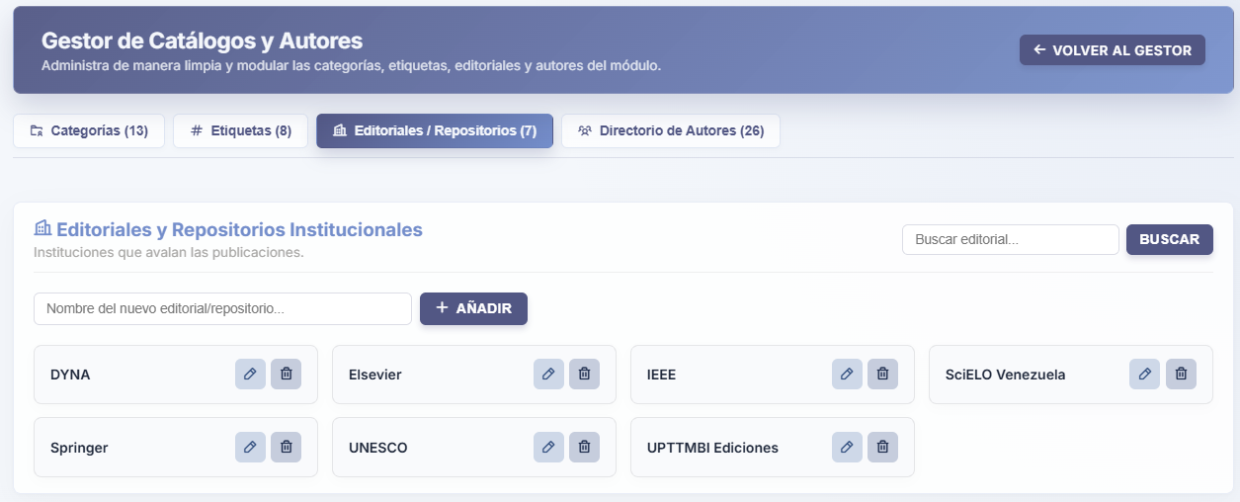
Note. Interface for standardizing the institutional entities and publishing houses that endorse the articles in the system.

5.2.2.4. Authors Directory
Meanwhile, the "Registered Authors Directory" tab (see Figure 85) serves as the master database of researchers, offering an exhaustive table listing each expert's name and ORCID identifier and providing the manager with direct tools to search for specific profiles, audit their data, or remove obsolete records from the institutional ecosystem; author creation is reserved for the article registration section in order to prevent authors without available articles in the repository.

Figure 85
Master table of the registered authors directory
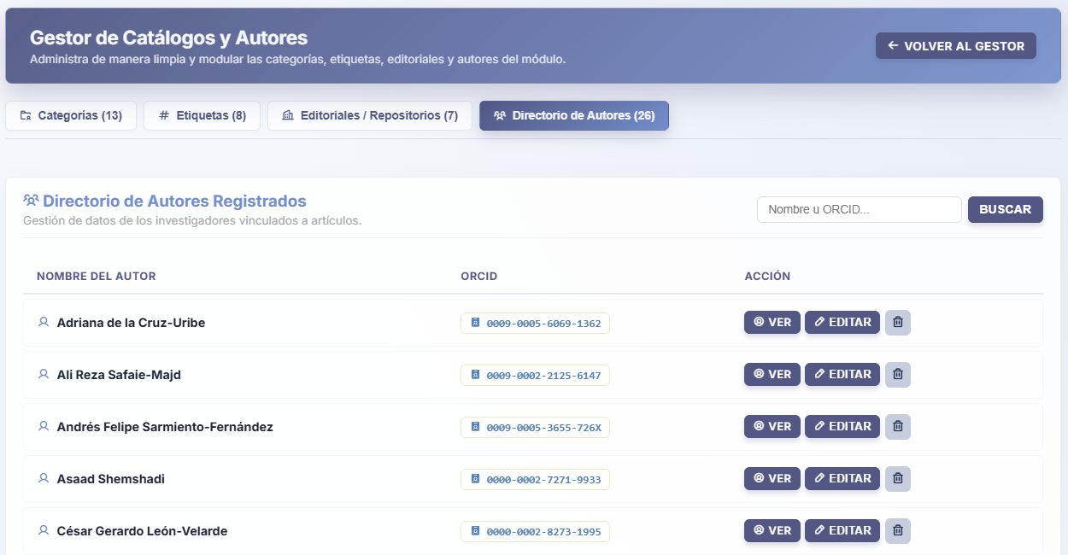
Note. Administrative listing of all researchers cataloged in the database, featuring profile editing and cleanup options.
Updating these parametric entities is carried out through modal windows optimized to avoid interrupting the administrative workflow; when editing a category, tag, or publisher, the universal "Edit Record" modal is displayed (see Figure 86), a minimalist component that allows rectifying the item's name while warning that the change will cascade across all linked publications.
In the case of researchers, the specialized "Edit Author Data" modal is invoked (see Figure 87), enabling comprehensive modification of the professional's academic identity by allowing the coordinator to simultaneously update their name, ORCID code, web links, and technical biography directly in the central database.
Figure 86
Universal parametric editing modal
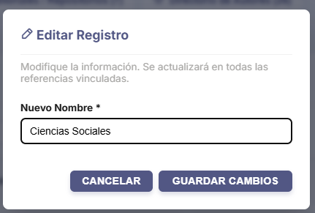
Note. Agile interface used to rename categories, tags, or publishers, propagating relational changes automatically.
Figure 87
Author data update form

Note. Dedicated modal for comprehensive editing of the profile, credentials, and biography of an already registered researcher.
The lifecycle of catalog entities contemplates deletion operations under preventive security schemes; if the administrator decides to purge a category, tag, or publisher, the platform requires confirmation via the "Delete Category" modal (see Figure 88), demanding a deliberate action to avoid disruptions across the article ecosystem.
Every operation completed within this modular manager triggers precise traceability notifications—whether confirming that the "Successful Operation" corresponded to creating a new entity (see Figure 89), updating an existing record (see Figure 90), or permanently deleting the entry (see Figure 91)—ensuring that the user has full certainty regarding the impact of their actions on the database.
Figure 88
Validation for parametric entity deletion
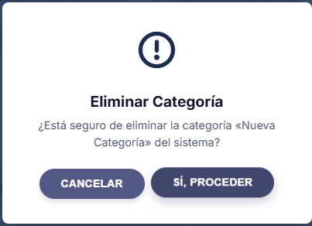
Note. Confirmation window required to remove categories, tags, publishers, or authors (hereinafter collectively referred to as an “entity”) from the system, preventing accidental operational errors.

Figure 89
Notification of successful catalog registration
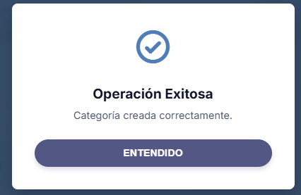
Note. Visual alert certifying the successful insertion of a new parametric entity (in this case, a category) into the database.
Figure 90
Parametric record update notification
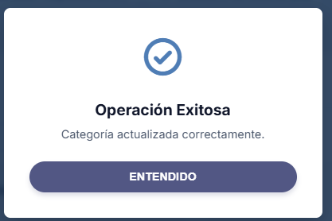
Note. Message confirming that the modifications applied to an entity (in this case, a category) have been saved and propagated successfully.

Figure 91
Category deletion confirmation
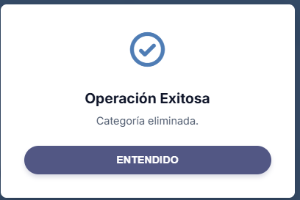
Note. System alert confirming the permanent deletion of an entity (in this case, a category) and its unlinking from associated articles.

5.2.3. Module Settings
To ensure maximum adaptability of the Digital Journal, the module provides a centralized Settings panel governing its structural behavior. The first tab, "Citation Formats" (see Figure 92), hosts an interactive generator for academic citation styles; this component allows the administrator to create, activate, deactivate, or delete predefined templates (such as APA 7 or custom formats), using injectable dynamic variables (e.g., {autores}, {volumen}, {issn}) to structure the exact syntax with which the system will build public references, ensuring strict compliance with the institution's bibliographic guidelines without altering the source code.

Figure 92
Dynamic academic citation style generator
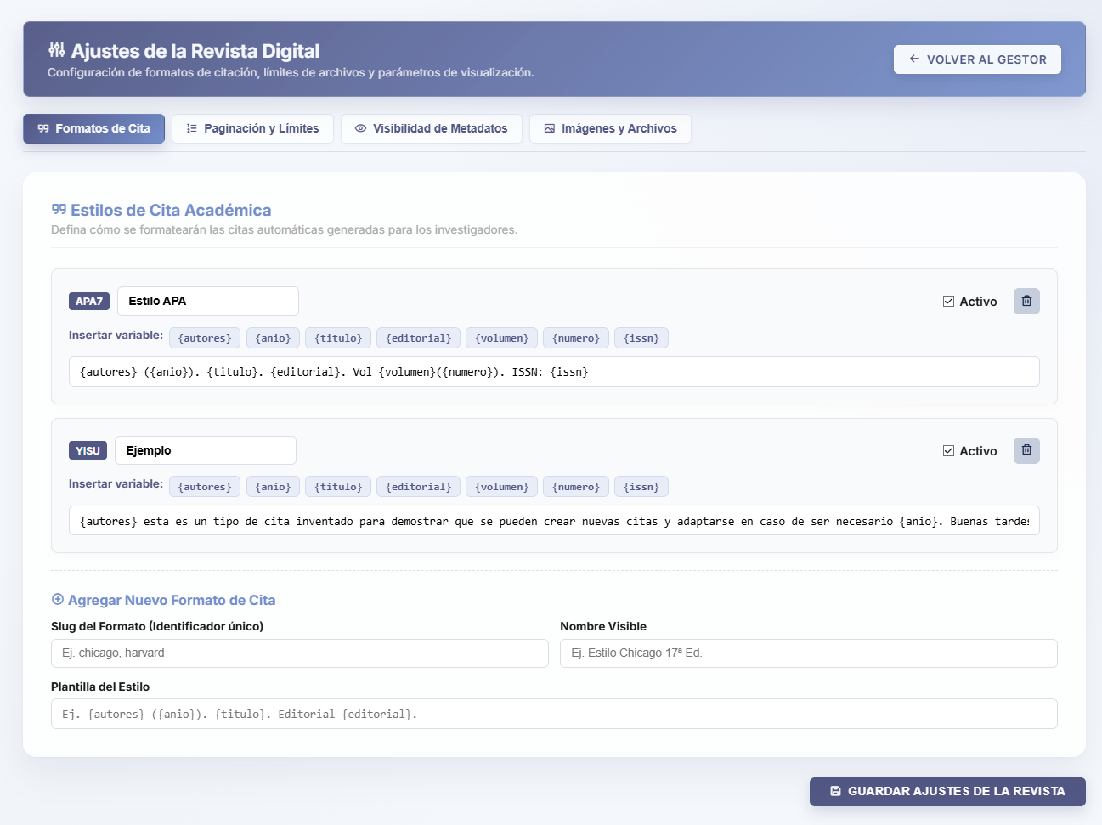
Note. Interface for configuring the syntactic structure of bibliographic references using interactive injectable variables.
The density of information displayed to users is meticulously regulated from the "Pagination and Limits" tab (see Figure 93). This control environment allows the editor to numerically define the system's rendering thresholds, establishing how many articles are displayed per block in the public catalog grid, how many records the administrative manager lists per page, the maximum number of recommended articles calculated by the algorithm at the end of each reading, and the base year delimiting the chronological filter of the main search engine, thereby optimizing load times and server performance in high-concurrency environments.
Figure 93
Pagination parameters and query limits
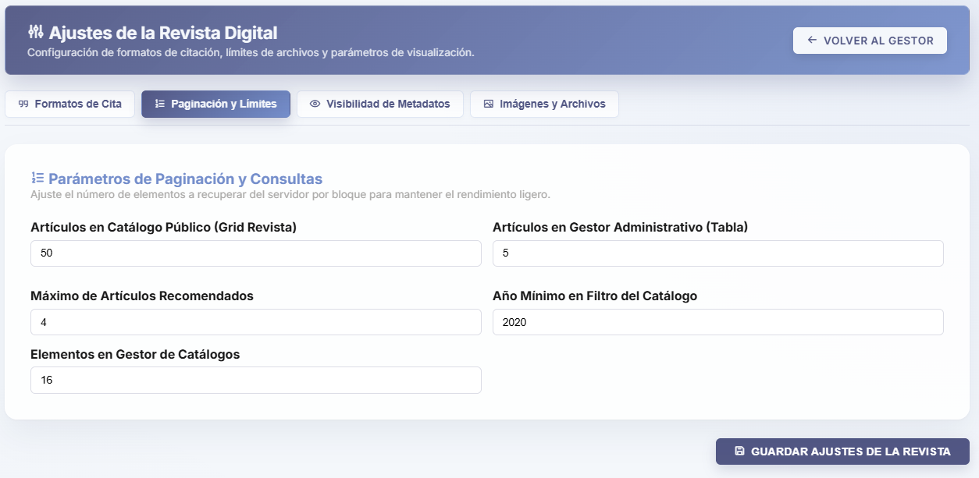
Note. Panel for adjusting the number of items returned by the database, balancing information density with system performance.
Metadata exposure policies are managed through the "Metadata Visibility" panel (see Figure 94); via a toggle-switch interface, the administrator can globally enable or disable the display of specific data fields within the cards and technical sheets of articles rendered in the public catalog, including the ability to hide the name of the publisher or institutional repository endorsing the research, the numeric badge corresponding to the Volume and Issue Number, or the international ISSN registration code, allowing information density to be adapted to the journal's current aesthetic and privacy guidelines.
Figure 94
Global metadata visibility control
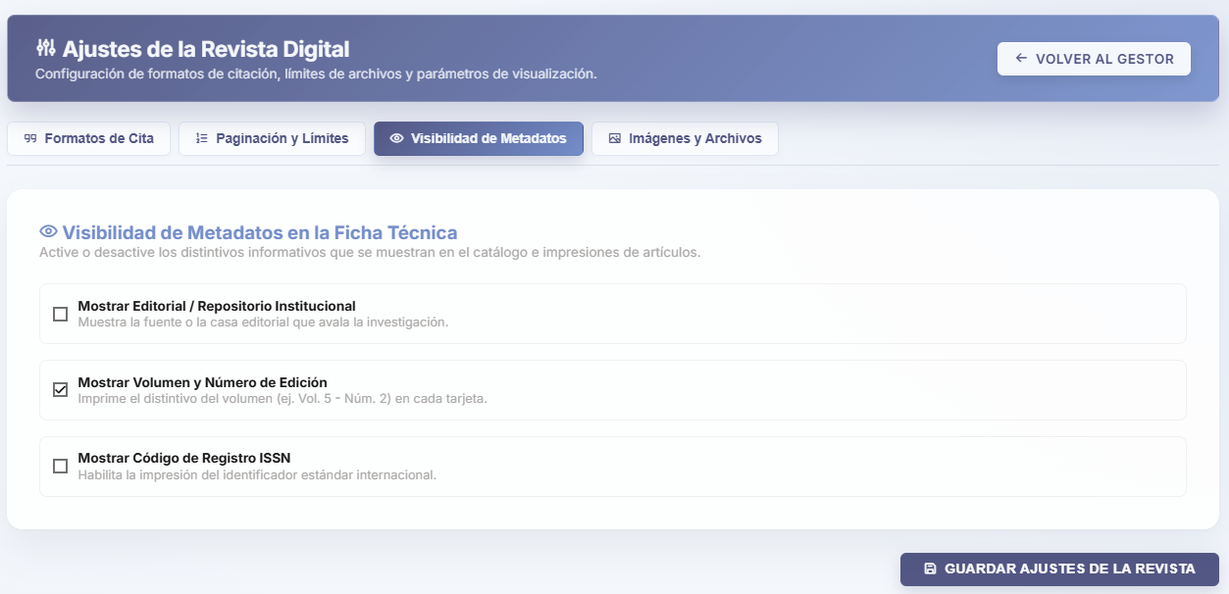
Note. Quick configuration interface to hide or show specific informational fields on article presentation cards.
To safeguard the server's physical infrastructure, the "Images and Files" tab (see Figure 95) enforces operational restrictions on graphic resources; the upper panel establishes security limits by defining the maximum allowed size per image (in Megabytes) and explicitly declaring authorized image extensions (e.g., .jpg, .png, .webp) to mitigate the risk of storage saturation and vulnerabilities.
In its lower section, it incorporates an "Image Storage Manager," an interactive library listing all orphaned or active cover images hosted in the server's physical directory, allowing the administrator to audit each file's individual size and identify whether the image is linked to an article in the system or is unused.
Figure 95
Upload restrictions and graphic storage manager
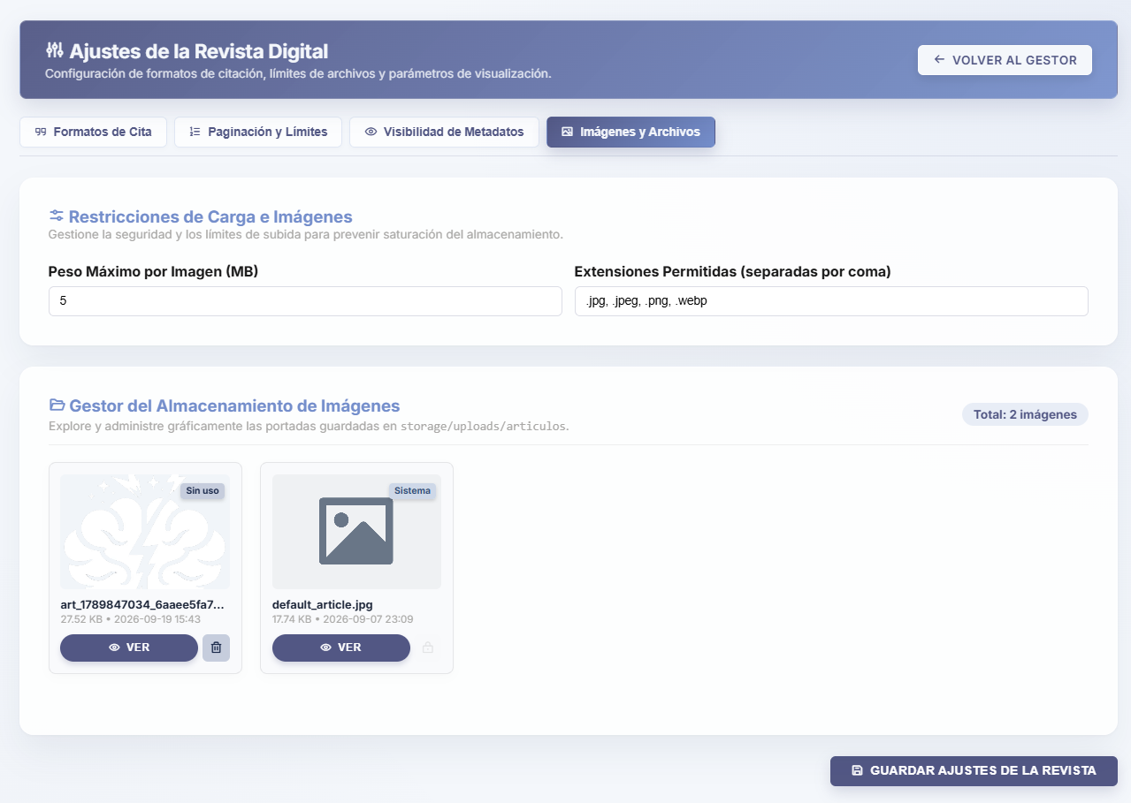
Note. Technical environment for setting file size limits and formats, integrating a library to audit cover images hosted on the server.
The storage manager provides direct tools for reviewing multimedia resources. Clicking the "View" button on any image invokes a high-resolution "Preview" (see Figure 96) inside a modal window, allowing the administrator to visually inspect the cover's quality and, if required, open the file directly in a new browser tab to verify its absolute URL in the system.
Figure 96
High-resolution preview of graphic resources
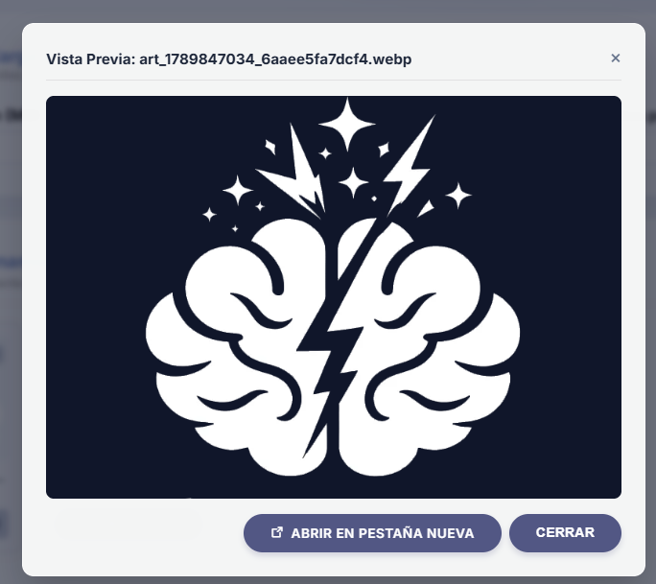
Note. Pop-up window facilitating visual inspection of cover images physically stored in the platform's internal directories.
Maintenance operations on physical resources are governed by strict security policies; when the administrator orders the removal of a cover image from the storage library, the system requires critical confirmation via the "Delete Image from Server" modal (see Figure 97), emphatically warning that this transaction will physically and permanently erase the file from the institutional hard drive.
Once all of these digital journal parameters have been configured and refined, the coordinator must save the module's general changes, triggering a comprehensive "Successful Operation" notification (see Figure 98) certifying that the new operational configuration and validation rules have been successfully applied across the entire platform.
Figure 97
Critical validation for physical file deletion
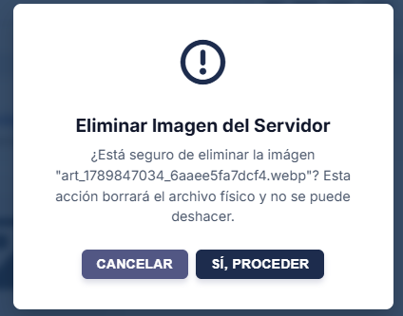
Note. Preventive security alert requiring explicit confirmation before permanently erasing an image from the server's hard drive.
Figure 98
Module configuration save confirmation
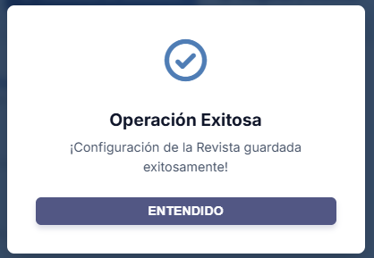
Note. Final notification confirming the proper saving and application of all parameters, limits, and restrictions configured for the journal.

6. Module – SuperAdmin
The SuperAdmin Module constitutes the primary governance, infrastructure, and cybersecurity center of the CIIDI ecosystem; designed under the principle of absolute privilege within the Role-Based Access Control (RBAC) architecture, this environment is strictly reserved for the institution's highest technical authority, represented in the system as “Super Administrator” with privilege level 0 so that it serves as the foundation of this privilege hierarchy.
Through its specialized consoles, the general administrator holds full control over access policies, real-time server telemetry, forensic event auditing, background process automation (Cron Jobs), PostgreSQL database backups, and deep parameterization of the system core's environment variables.

6.1. Administrator Dashboard
To begin, the first view presented upon signing in as a system administrator is the Super Administrator Dashboard (see Figure 99), which serves as the unified command center for global supervision of the platform. Upon accessing this interface, the system displays a modular grid of direct navigation cards grouping the nine critical infrastructure areas: User Management and RBAC, Reports and Export, Module and Route Manager, Maintenance and DB Backups, Scheduled Tasks and Cron, WAF and IP Monitor, Logs and Audit Trail Viewer, Mail and SMTP Management, and Environment and System Variables.
Additionally, in the upper-right corner of the header, the console incorporates an immediate action button labeled "Test Core Response" (see Figure 101), designed to run health diagnostics on the application core at any operational moment, and scrolling further down this dashboard reveals additional information relevant to platform administration.
Figure 99
Central administrative console of the Super Administrator Dashboard
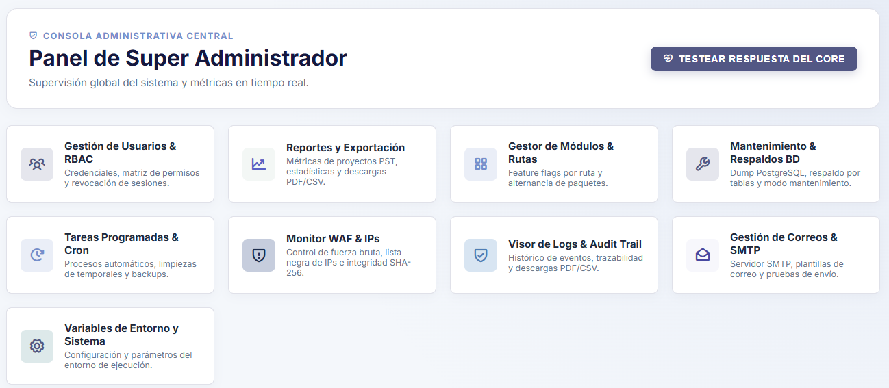
Note. Main view of the command center organizing access to the platform's nine administration and infrastructure subsystems through interactive cards. Source: The authors (2026).
As mentioned earlier, in the lower section of this same main view, the system integrates the Technical Telemetry and Server Status panel (see Figure 100), a monitoring dashboard exposing vital indicators of the underlying hardware and software; the upper cards detail metrics on disk usage of the storage/ directory, database size alongside its active connections, PHP RAM consumption, daily user access count, the proportion of online modules in the Kernel, and the active runtime environment versions.
This section is complemented by three lower analytical panels charting the demographic distribution of users by status (also separating faculty members), a bar comparison of resource consumption in megabytes, and a chronological log of the most recent audit events recorded on the server.
Figure 100
Technical telemetry and server resource monitoring dashboard
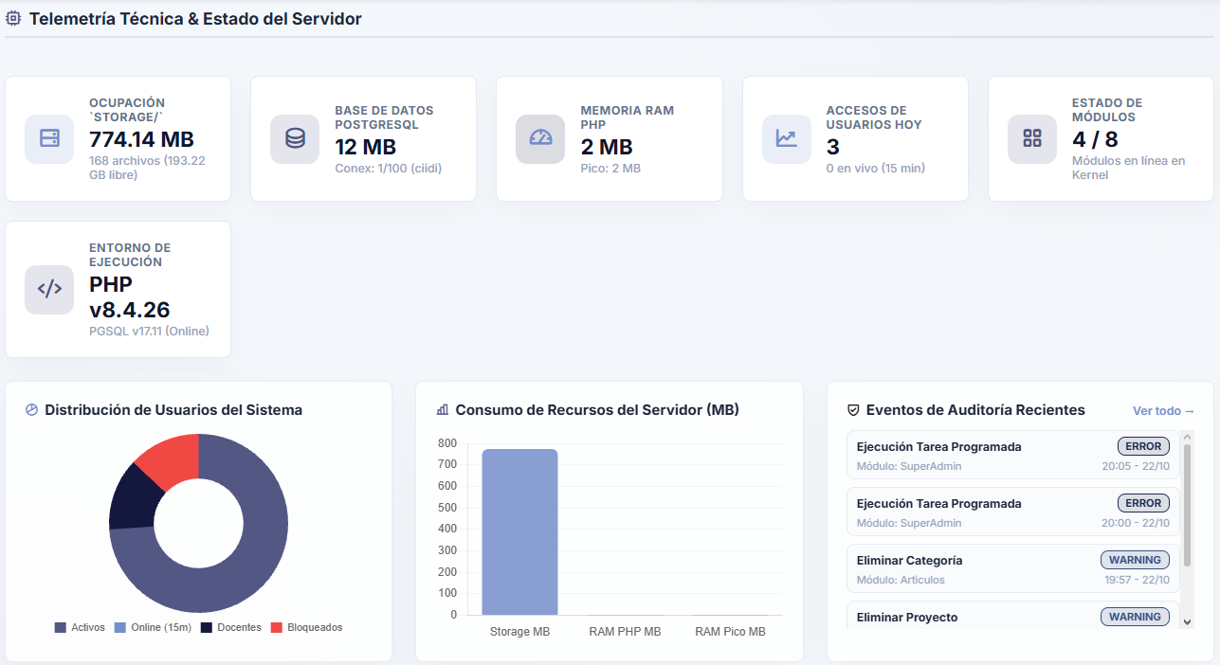
Note. Real-time monitoring panel displaying storage consumption, RAM usage, PostgreSQL connection status, user charts, and recent audit alerts. Source: The authors (2026).
Clicking the test button located in the dashboard header opens the Core Health Diagnostics modal window (see Figure 101), which executes a real-time syntactic and operational evaluation of the system core. This tool immediately reports the overall health status and measures exact response latency in milliseconds, presenting a verifiable technical breakdown across four pillars: connection stability and latency with the PostgreSQL database, proper loading of the Kernel and routing system constants (CORE_PATH), validation of write permissions and free space in the storage/ directory, and functional presence on disk of the essential Authentication and SuperAdmin modules.
Figure 101
Real-time core health diagnostics modal window
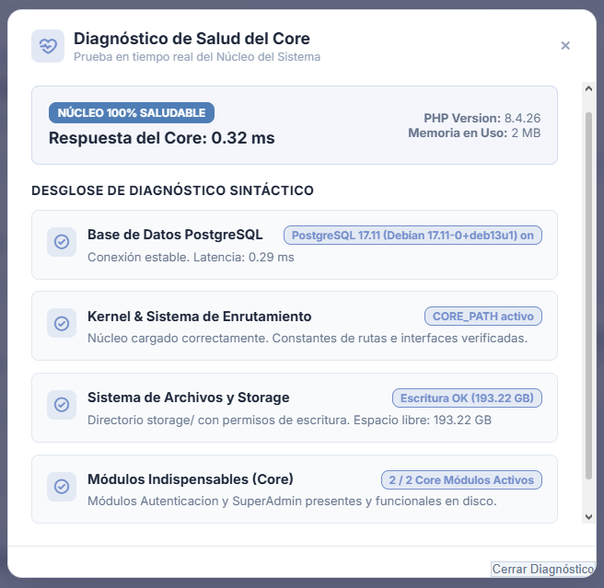
Note. Instant verification tool evaluating server response latency and certifying the operational status of the database, router, write permissions, and core modules. Source: The authors (2026).

6.2. User Management and RBAC Matrix
Digital identity administration and account provisioning are carried out through two mechanisms that remain visible to the administrator regardless of which tab is active; to directly register any member of the ecosystem, the administrator uses the "Register New User" modal (see Figure 102), a form requesting the national or foreign identity document number (ID), full name, institutional email address, immediate assignment of an initial role within the hierarchy, and a temporary access password—importantly, this is the only section where users with the “Super Administrator” role can be created.
Complementarily, to streamline the secure onboarding of academic staff, the system provides the "Invite New Faculty Member / Professor" modal (see Figure 103); this function requires only the faculty member's ID number, name, and email address to dispatch a cryptographically signed invitation token to their inbox, allowing them to set their own secret password and activate their account autonomously.

Figure 102
Modal form for direct registration of new users
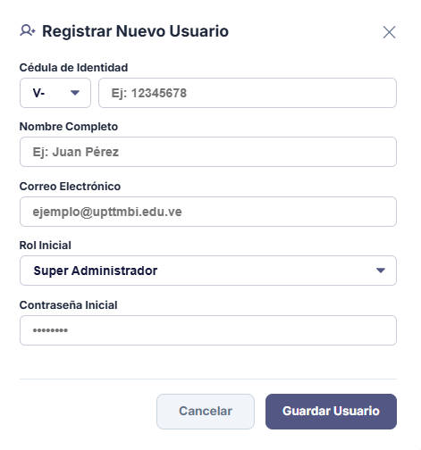
Note. Administrative interface allowing manual account creation by specifying identity details, access role, and initial password. Source: The authors (2026).
Figure 103
Modal window for issuing signed invitations to faculty members
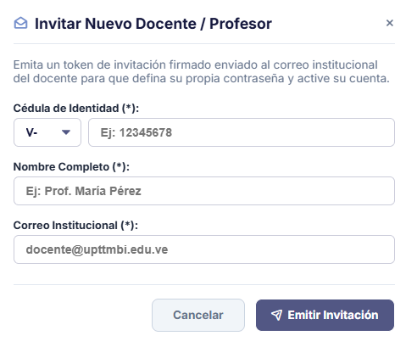
Note. Secure provisioning tool sending a link with a cryptographic token to the professor's institutional email for autonomous profile activation. Source: The authors (2026).

6.2.1. User Community
Centralized control of registered accounts is performed from the "User Community" tab (see Figure 104), which presents the General Directory of Registered Users in a high-density interactive table; this view displays identification data (name, ID number, and email), assigned access role, last-activity timestamp, and account operational status, integrating an instant text search bar at the top alongside dropdown selectors to filter the roster by role or status.
In the right-hand column of each row, the system enables four critical security buttons: selecting the "Edit" option invokes a modal window (see Figure 105) allowing the SuperAdmin to modify the individual's ID number, name, email, or role, as well as offering optional fields to force a password reset without needing to know the previous password.
Figure 104
General directory of the registered user community
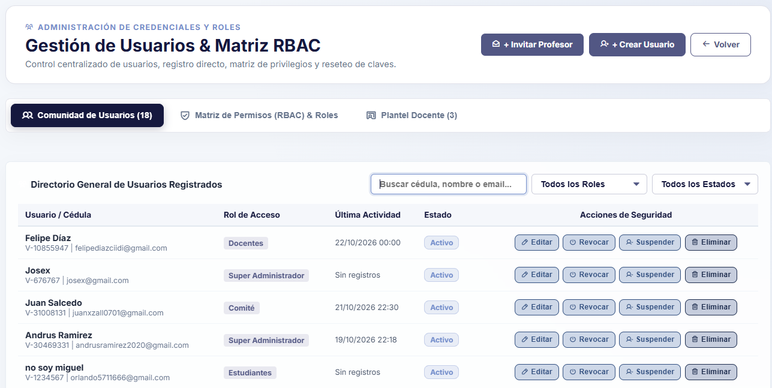
Note. Main account control panel integrating combined search filters, recent activity indicators, and per-row security action buttons. Source: The authors (2026).
Figure 105
Modal form for administrative editing of user accounts
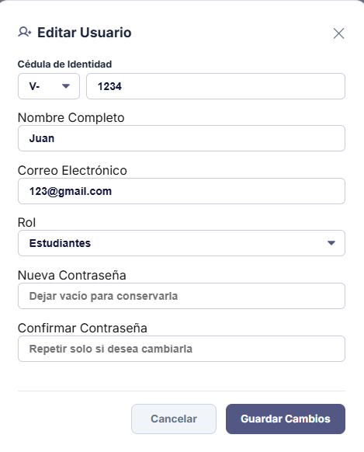
Note. Interface empowering the SuperAdmin to rectify personal data, reassign hierarchical roles, or force a user password change. Source: The authors (2026).
Furthermore, in the realm of session control and live incident mitigation, the directory provides immediate containment tools for active accounts; pressing the "Revoke" button displays a confirmation dialog (see Figure 106) designed to forcibly expel the user from the system, destroying their active session and invalidating their authentication tokens instantaneously. Conversely, if an individual's access needs to be disabled indefinitely without archiving their account and releasing their credentials, the "Suspend" button invokes a validation alert (see Figure 107) that preventively locks the account, blocking future sign-ins until an administrator authorizes lifting the suspension.
Figure 106
Confirmation modal for forced revocation of an active session
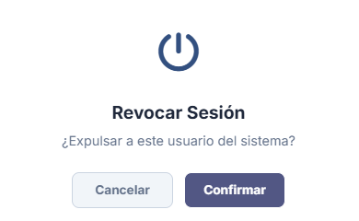
Note. Security mechanism allowing immediate expulsion of a connected user by invalidating their server session. Source: The authors (2026).
Figure 107
Confirmation alert for preventive account suspension
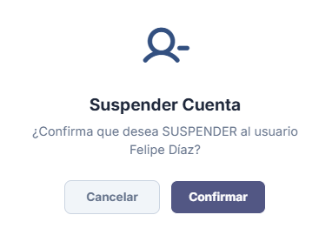
Note. Validation window temporarily locking a user's access credentials without deleting their historical records from the database. Source: The authors (2026).
Lifecycle management of suspended or deactivated users is handled seamlessly from the same general directory; applying the "Suspended" status filter in the upper selector (see Figure 108) isolates disabled accounts exclusively and dynamically transforms the suspend button into the "Restore" action; pressing it displays a confirmation modal (see Figure 109) that immediately reinstates sign-in privileges for the affected user.
Finally, when permanent offboarding of an individual is determined via the "Delete" button, the system presents the "Delete and Archive User" modal (see Figure 110), a secure deprovisioning routine that archives historical activity so as not to break the referential integrity of published projects while immediately releasing the ID number and email address in the database for potential future registrations; such archived users remain visible exclusively in reports.
Figure 108
Filtered directory view showing accounts in suspended status
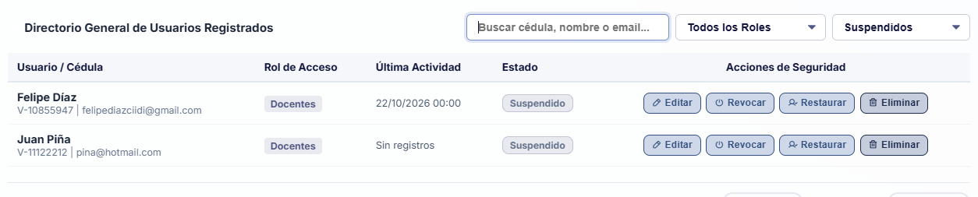
Note. Segmented listing displaying temporarily locked users and enabling the contextual button to restore their privileges. Source: The authors (2026).

Figure 109
Confirmation modal for restoring suspended accounts
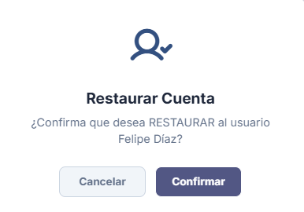
Note. Dialog box confirming the operational reactivation of credentials for a previously disabled user. Source: The authors (2026).
Figure 110
Validation window for permanent deletion and archiving of users
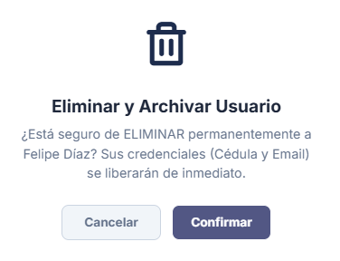
Note. Critical alert executing permanent user removal, archiving their historical traceability and releasing their unique credentials in the system. Source: The authors (2026).

6.2.2. Permissions Matrix (RBAC) and Roles
The second tab of this submodule hosts the "Permissions Matrix (RBAC) & Roles" (see Figure 111), the engine where the hierarchical security architecture of the entire platform is defined; this interface presents a list of collapsible panels organized by privilege levels (from Level 1 up to Level 6 or higher, with additional levels addable as needed), allowing the SuperAdmin to assign dynamic permissions without modifying a single line of code.
Expanding any of these blocks, as shown in the configuration detail (see Figure 112), displays a Boolean checkbox matrix crossing each module installed in the ecosystem (Articles, Courses, Research, Research Lines, PST Repository, and Business Linkage) against the four fundamental control operations: Create, Edit, Delete, and Audit; each module implements stepped verification checks, with Audit serving as the baseline permission to access module configurations and the remaining flags granting permissions for their respective actions within the selected module.

Figure 111
General panel of the Granular Permissions Matrix (RBAC) by levels
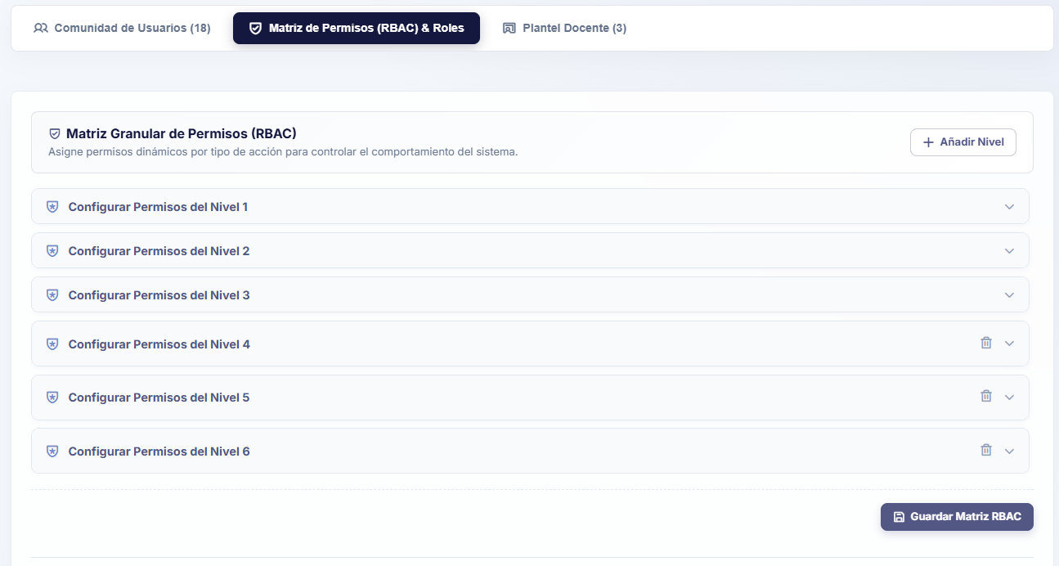
Note. Collapsible interface structuring the system's hierarchical security levels for dynamic assignment of operational privileges. Source: The authors (2026).
Figure 112
Per-module permission configuration breakdown for Level 2
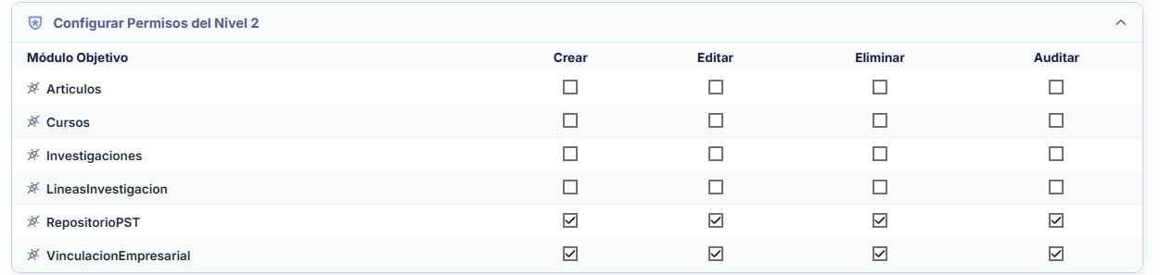
Note. Interactive checkbox matrix enabling or restricting create, edit, delete, and audit actions across each module. Source: The authors (2026).
The hierarchical structure of the matrix is completely elastic and incorporates relational integrity safeguards; if the institution needs to expand its digital organizational chart, the upper "+ Add Level" button invokes the "Extend Privileges" modal (see Figure 113), creating a new hierarchical tier in the database ready to be parameterized while always assigning the lowest available integer—for instance, if privilege levels 1 through 6 exist and level 4 is deleted, the next level added will fill the missing level 4; furthermore, permissions for privilege level 0 cannot be modified as they are reserved for the Super Administrator, meaning system restrictions do not apply to that tier.
Figure 113
Confirmation modal for extending a new privilege level

Note. Validation window authorizing the creation of a new hierarchical level within the database's RBAC structure. Source: The authors (2026).
Conversely, if an existing tier is to be removed via the trash icon, the system requires confirmation through the "Delete Level" modal (see Figure 114); however, if that level still has active roles linked to it, the security engine aborts the operation and displays a blocking alert at the top of the screen (see Figure 115), requiring the administrator to first reassign or delete the dependent roles before removing the tier.

Figure 114
Validation alert for deleting a hierarchical level

Note. Preventive confirmation dialog warning about integrity constraints before deleting a privilege level. Source: The authors (2026).
Figure 115
Security block notification due to active role dependencies
Note. Error message issued by the system when attempting to delete a hierarchical level that still has assigned roles and users. Source: The authors (2026).
Located in the lower section of this same tab is the "Edit Role Naming and Hierarchy" area (see Figure 116), where abstract numerical levels are linked to real institutional positions. While the "Super Administrator" role is shown locked at Level 0 as an unalterable system role, the remaining cards (Committee, Faculty, Students, etc.) allow freely modifying their display name and reassigning their privilege level via a dropdown selector; privilege level 0 cannot be assigned in this section as it is reserved exclusively for administrators.
Figure 116
Role naming and hierarchical linkage editing panel
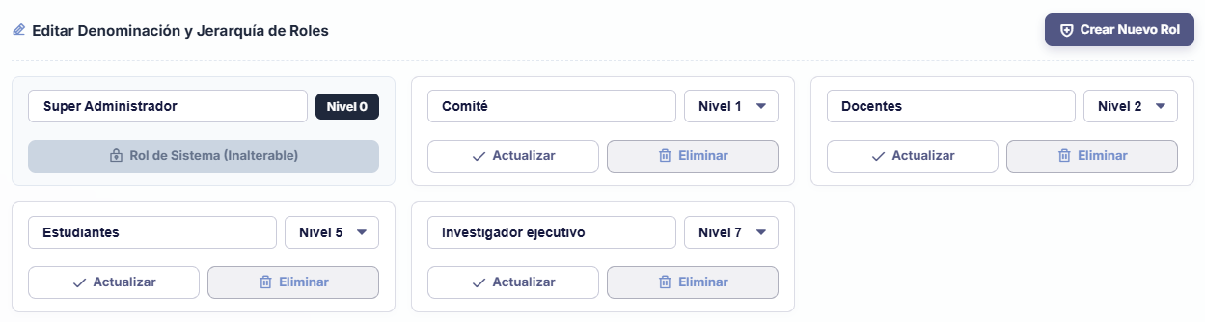 Note. Control cards allowing system roles to be renamed and dynamically associated with the various levels of the RBAC matrix. Source: The authors (2026).
To incorporate a new position, the "+ Create New Role" button opens a modal form (see Figure 117) requesting the role name and its base level; similarly, when attempting to delete a position via the "Delete Role" modal (see Figure 118), the platform checks the database and blocks the action with a security alert (see Figure 119) if it detects users currently registered under that role.
Figure 117
Modal form for creating a new institutional role
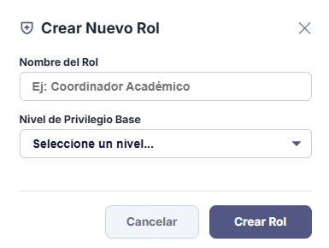
Note. Pop-up interface for registering new role titles and linking them to a base privilege level. Source: The authors (2026).
Figure 118
Confirmation modal for deleting a system role

Note. Security window requesting explicit validation before removing a role title from the platform. Source: The authors (2026).
Figure 119
Restriction alert upon attempting to delete a role with assigned users

Note. Preventive notification avoiding orphaned accounts by blocking the deletion of a role currently in use. Source: The authors (2026).

6.2.3. Teaching Staff
Finally, the third tab of this section, titled "Teaching Staff" (see Figure 120), offers a simplified card-based visual directory exclusively grouping active professors with direct access to their records; clicking the arrows beside the cards locates the faculty member directly within the “User Community” tab by searching for their ID number.

Figure 120
View of the registered professors and teaching staff
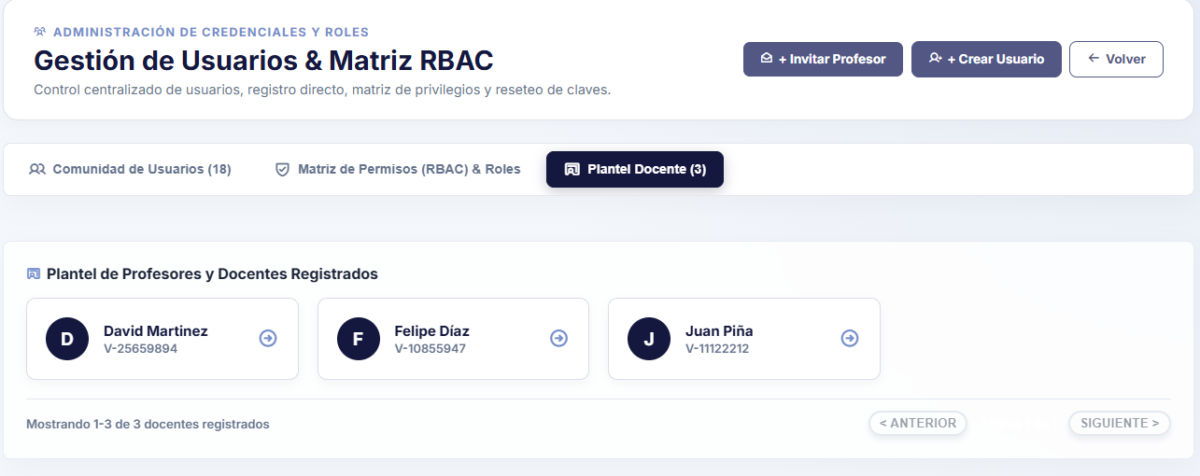
Note. Tab consolidating the list of all users holding a faculty role within the institution via quick-access cards. Source: The authors (2026).

6.3. Reports and Export
The Reports and Export submodule, titled "Institutional PST Export Studio" (see Figure 121), equips the SuperAdmin with an analytical generator of official documents for decision-making and academic audits. The interface structures the workflow starting with step "1. Select the Data Domain," presenting four interactive cards that segment system information alongside real-time total metrics: Academic PST (Socio-Technological Projects), Productive Sector (Company Proposals), Accounts and Users (Registered Roster), and WAF Auditing (Security Events).

Figure 121
Data domain selector in the Institutional Export Studio
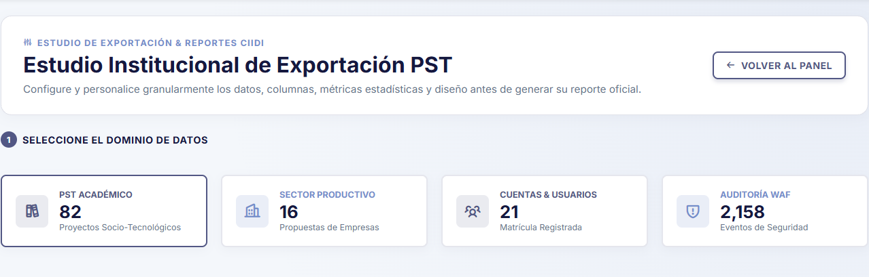
Note. Report generator header allowing selection among the four master data domains (PST, Productive Sector, Users, and WAF Auditing). Source: The authors (2026).

6.3.1. Reports – PST
Upon selecting the academic projects domain, the system displays the "Granular PST Export and Chart Configuration" panel (see Figure 122), allowing detailed customization of the report structure prior to issuance. In the upper strip, the administrator can use checkboxes to select the exact columns to include in the data table (Title, Degree Program, Level, Track, Year, Community, Research Line, Defense Date, or General Objective).
In the lower-left block, statistical variables can be parameterized by choosing the grouping criterion for the chart, applying filters by track or research line, selecting the visual style (e.g., Vertical Bar Chart), and viewing a real-time preview; simultaneously, the right-hand block allows customizing the PDF document by defining a custom title, subtitle, inclusion of official UPTTMBI letterhead and insignia, and closing notes for the evaluation committee, enabling buttons at the bottom to export the package in PDF, CSV/Excel, or JSON format.
Figure 122
Granular configuration and statistical preview panel for PST reports
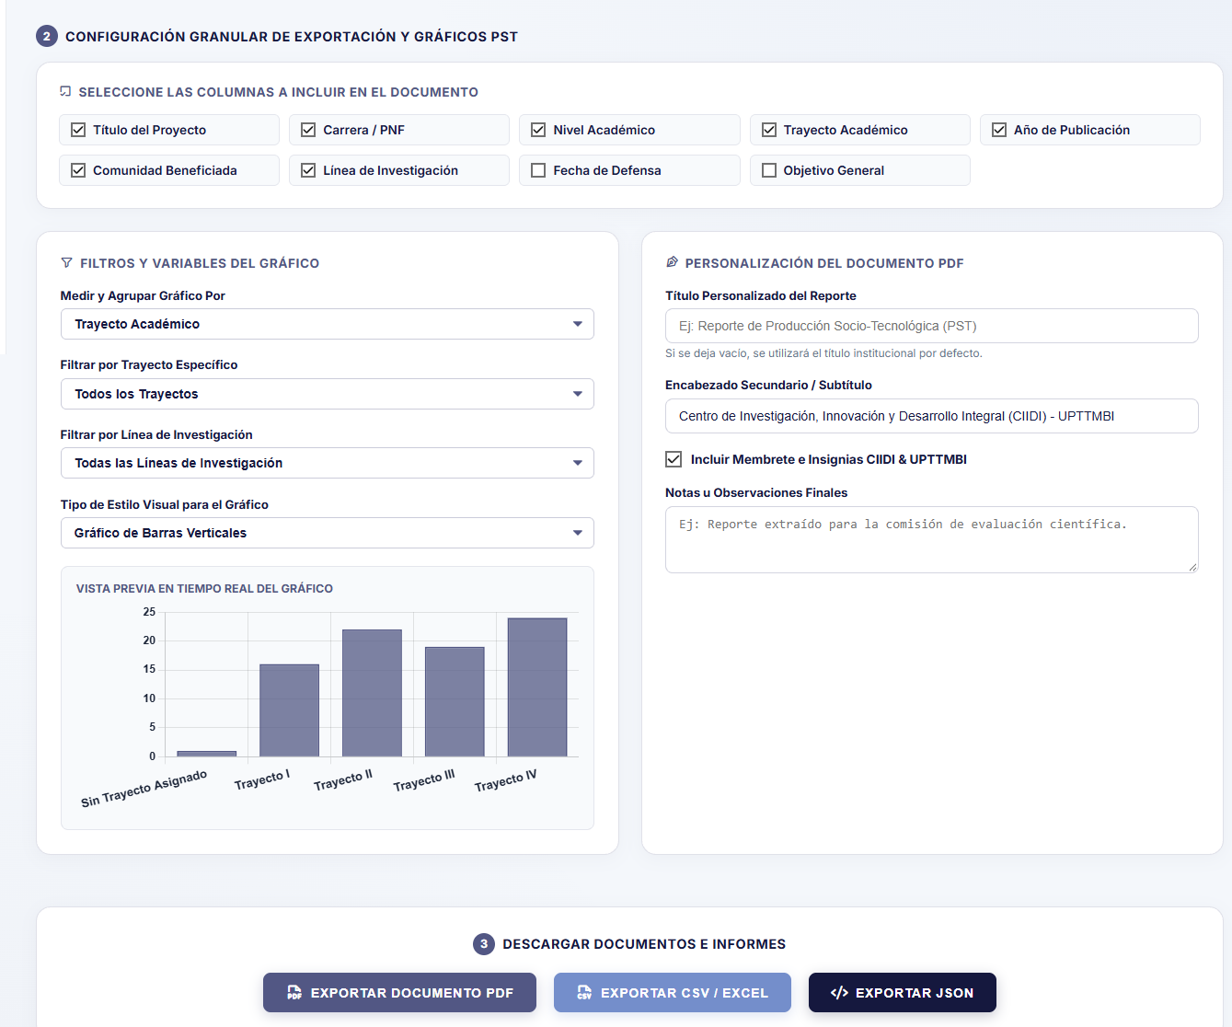
Note. Customization interface allowing selection of data columns, real-time chart configuration, drafting of official headers, and export to PDF, Excel, or JSON. Source: The authors (2026).
Selecting document export opens the "Official CIIDI Report Preview" (see Figure 123), presenting the formatted document complete with institutional letterheads, issuance timestamp, responsible officer, rendered statistical chart, and tabular listing ready for printing or direct download.
Figure 123
Preview of the formatted official Socio-Technological Production report
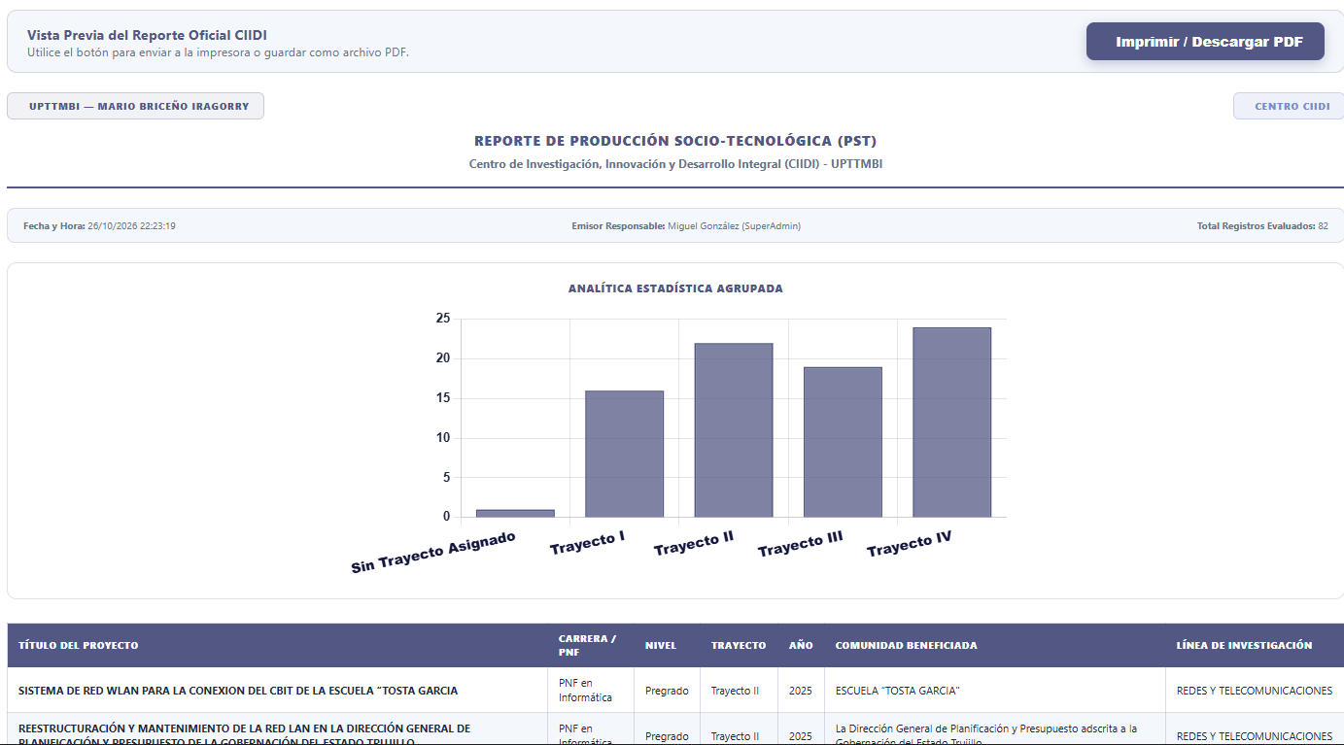
Note. System-generated official document integrating institutional letterhead, analytical chart grouped by tracks, and detailed project table for PDF download. Source: The authors (2026).

6.3.2. Reports – Productive Sector
Selecting the "Productive Sector" card in the upper selector (see Figure 124) dynamically adapts the interface controls to audit technological proposals and requirements submitted by external companies and institutions through the linkage module; the panel retains real-time previewing of the graphical distribution of requests grouped by academic track, alongside the customization form for official titles, letterheads, and remarks for export in PDF, CSV/Excel, or JSON formats.
Figure 124
Export configuration and live chart for the Productive Sector domain
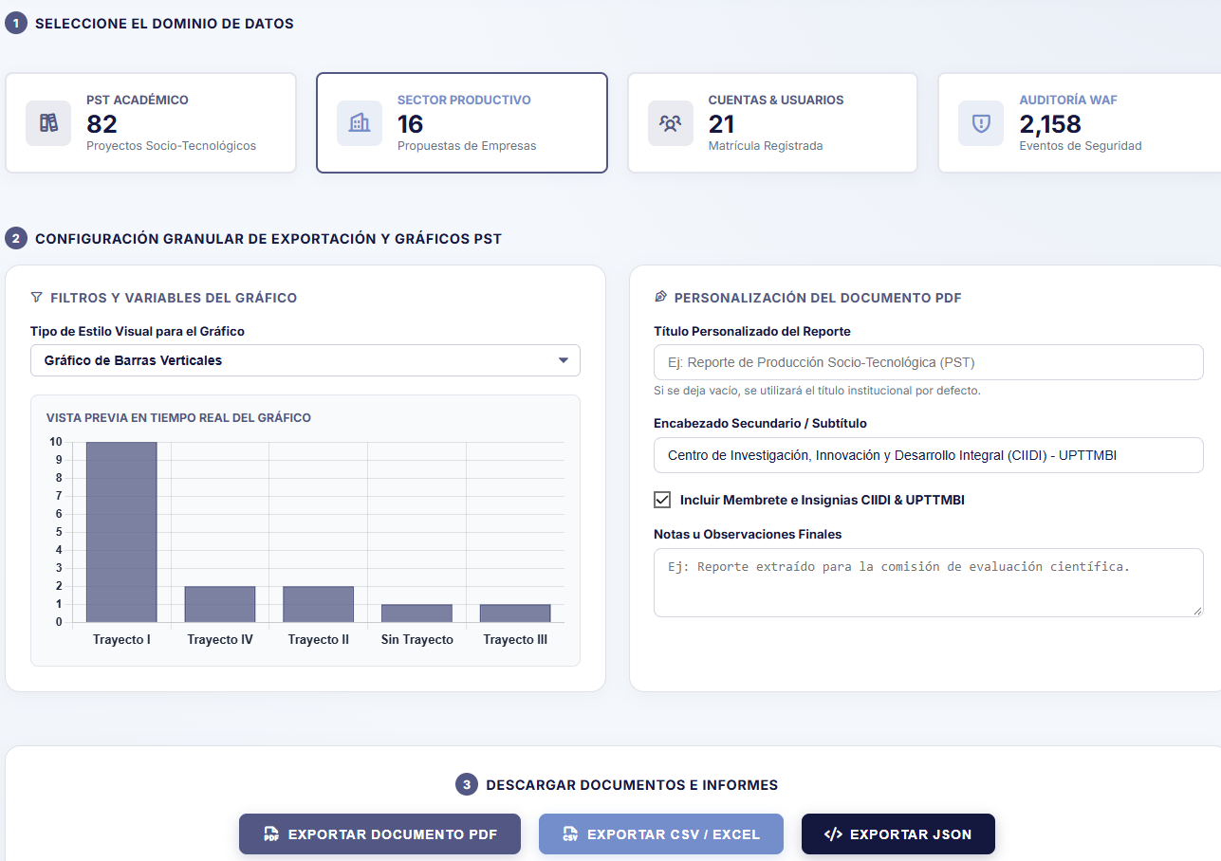
Note. Panel tailored for statistical analysis and export of technological proposals registered by external companies and entities. Source: The authors (2026).
Generating the document preview (see Figure 125) produces the "Linkage and Productive Sector Report," presenting the upper statistical chart followed by a detailed matrix documenting the requesting company's name, contact person, assigned track, full description of the stated problem, evaluation status, and exact registration date.
Figure 125
Preview of the Official Linkage and Productive Sector Report
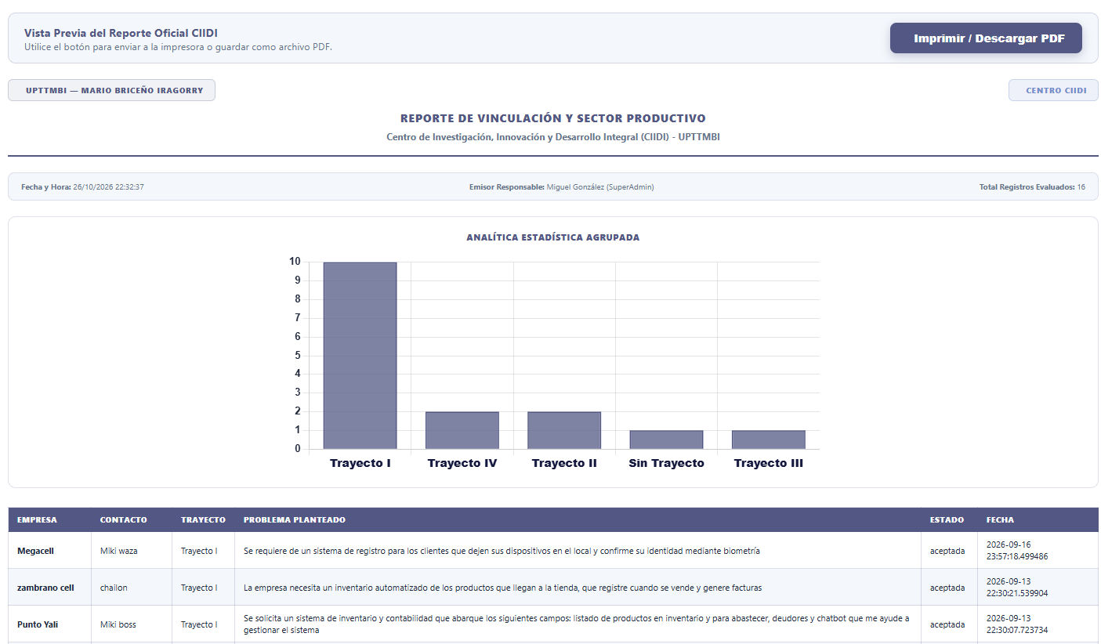
Note. Print-ready formatted report consolidating external request metrics alongside a tabular breakdown of companies, stated problems, and approval statuses. Source: The authors (2026).

6.3.3. Reports – Users
When the administrator selects the "Accounts & Users" card in the domain selector (see Figure 126), the export studio configures itself to audit the platform's user roster, detailing on the card itself a quick breakdown of active, suspended, and archived accounts; the chart preview canvas automatically groups the roster according to assigned hierarchical roles, allowing document aesthetics to be adjusted prior to extraction—just like the remaining sections, this view includes configuration options for the title, header, and other elements of the exported document.
Figure 126
Report configuration and role-based chart distribution for the Users domain
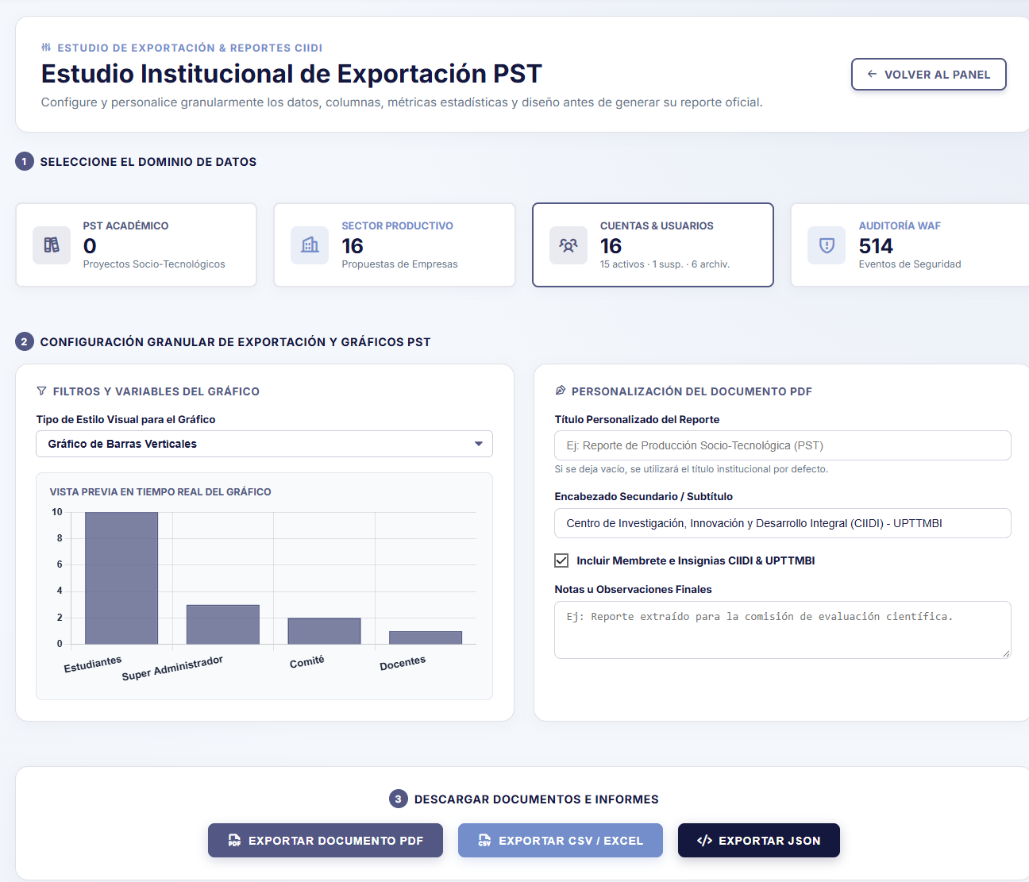
Note. Report preparation interface for the registered user roster, displaying live user proportions by hierarchical role. Source: The authors (2026).
The corresponding print preview generates the "General System Users Report" (see Figure 127), a formal dossier certifying the total number of evaluated records and listing each account with its ID number, full name, email address, current role, and operational status, transparently including deactivated historical records under the [Archived] tag.

Figure 127
Preview of the General System Users Report
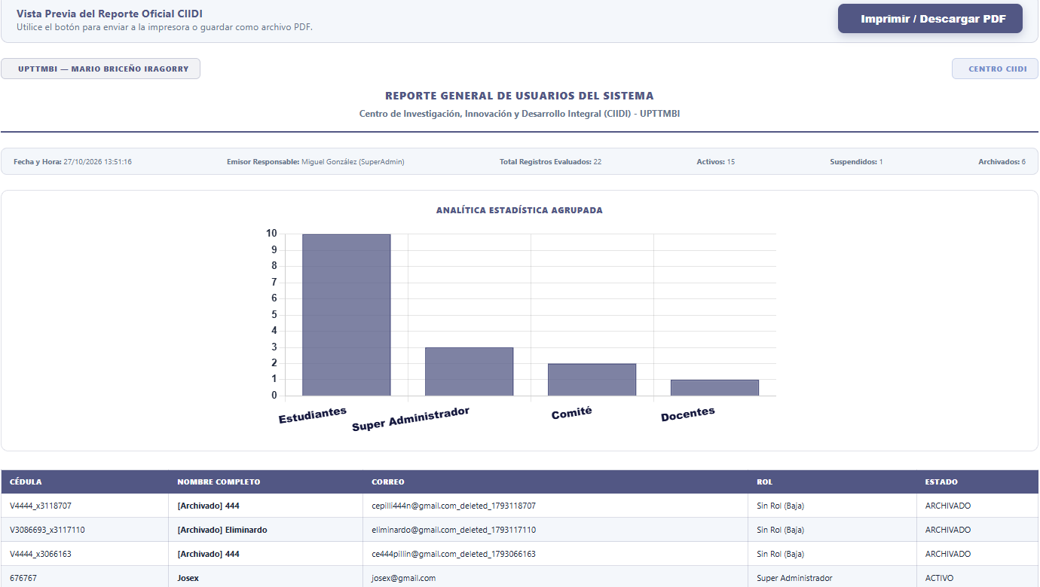
Note. Account audit document displaying the role demographic chart and the complete roster of active, suspended, and archived users. Source: The authors (2026).

6.3.4. Reports – Auditing
The fourth export axis corresponds to the "WAF Auditing" domain (see Figure 128), designed to generate reports on server security and operational stability; in this mode, the statistical generator classifies and charts in real time all recorded events according to their criticality or technical severity level: INFO, WARNING, ERROR, CRITICAL, and SECURITY.

Figure 128
Report configuration panel for the WAF Auditing and security events domain
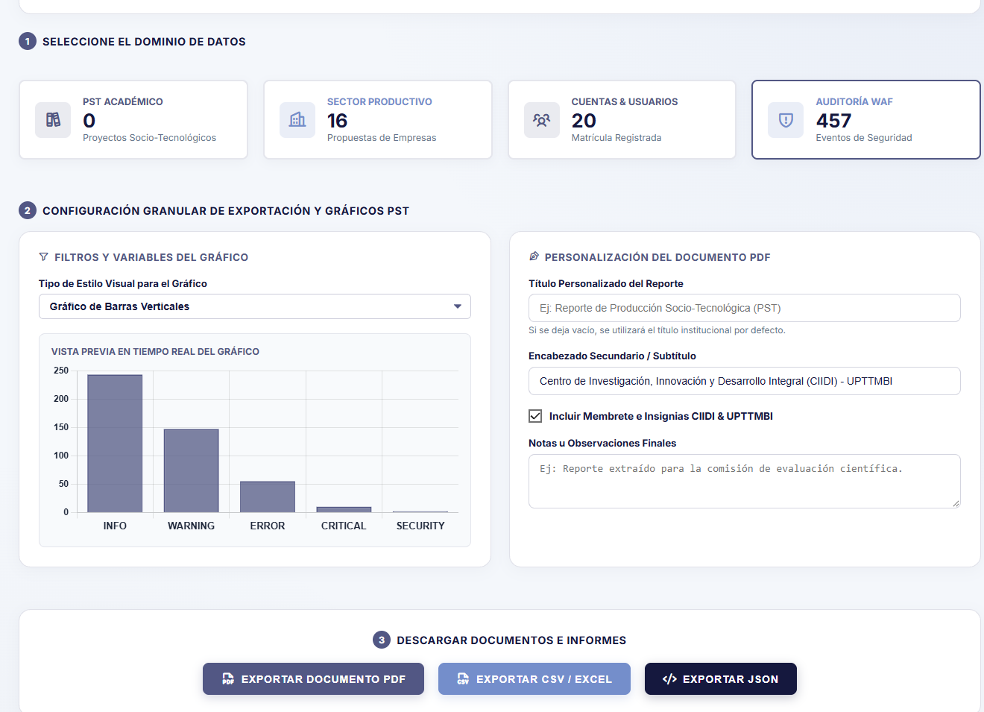
Note. Forensic export environment charting the incidence of system events classified by technical severity levels. Source: The authors (2026).
Upon requesting the generation of the PDF document, the platform renders the "Audit and Technical Errors Report" (see Figure 129), providing executive management or the security committee with an unalterable report featuring a graphical incident summary and a chronological table recording the unique log identifier, the exact date and time stamp, the severity level, the description of the action or technical error, and the source IP address.

Figure 129
Preview of the Official Audit and Technical Errors Report
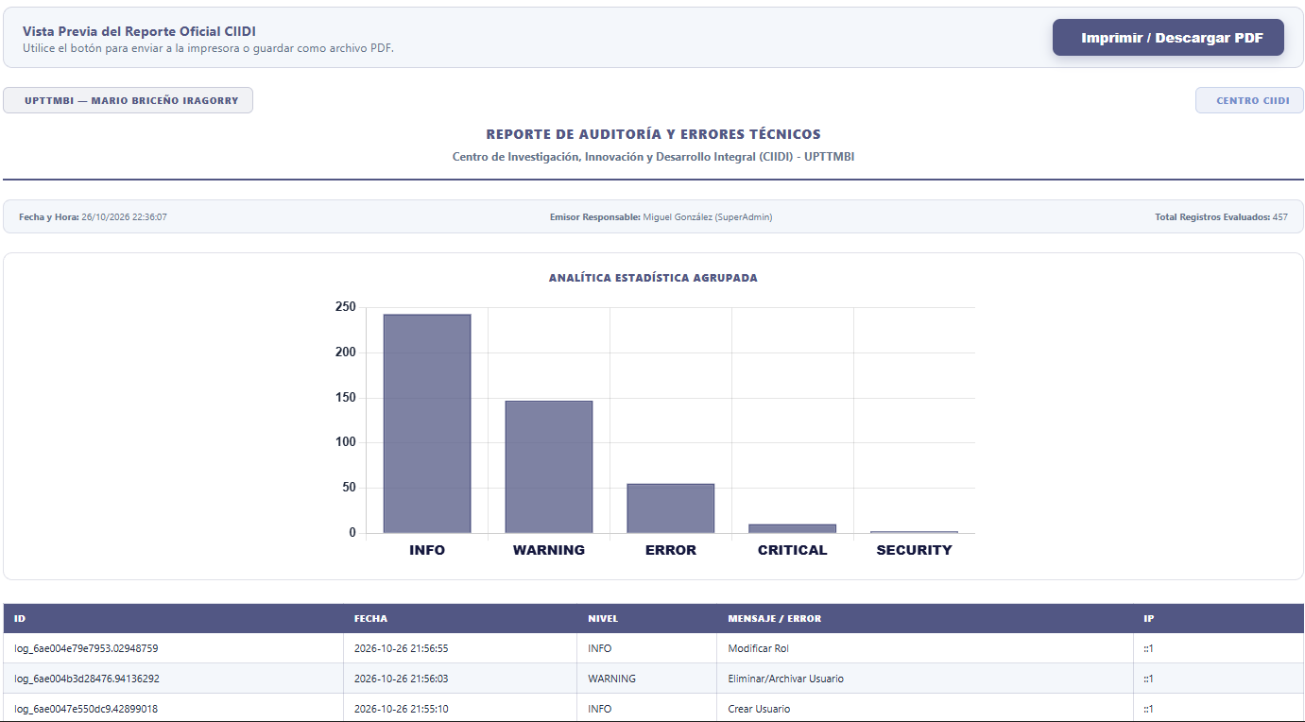
Note. Exportable technical report consolidating severity metrics alongside the detailed record of events, log identifiers, and involved IP addresses. Source: The authors (2026).

6.4. Module Manager
The modular architecture of the CIIDI system is comprehensively managed from the "Module Manager" (see Figure 130), a console that enables controlling the availability of each subsystem without modifying the source code. This view features buttons in its header to export or import the global system configuration in portable packages, displaying below a grid with all installed modules: Digital Journal and Articles, Access and Security, Training and Courses, Research, Research Lines, and PST Repository; this list varies depending on the modules installed in the system by reading the folder that contains them.
While indispensable modules bear the immutable CORE badge, extensible subsystems incorporate a dynamic toggle switch that allows the SuperAdmin to hot-enable (ONLINE) or hot-disable (OFFLINE) them with a single click, displaying instant notifications in the upper-right corner whenever a package's state is toggled.
Figure 130
Main console of the Module Manager and integrated subsystems
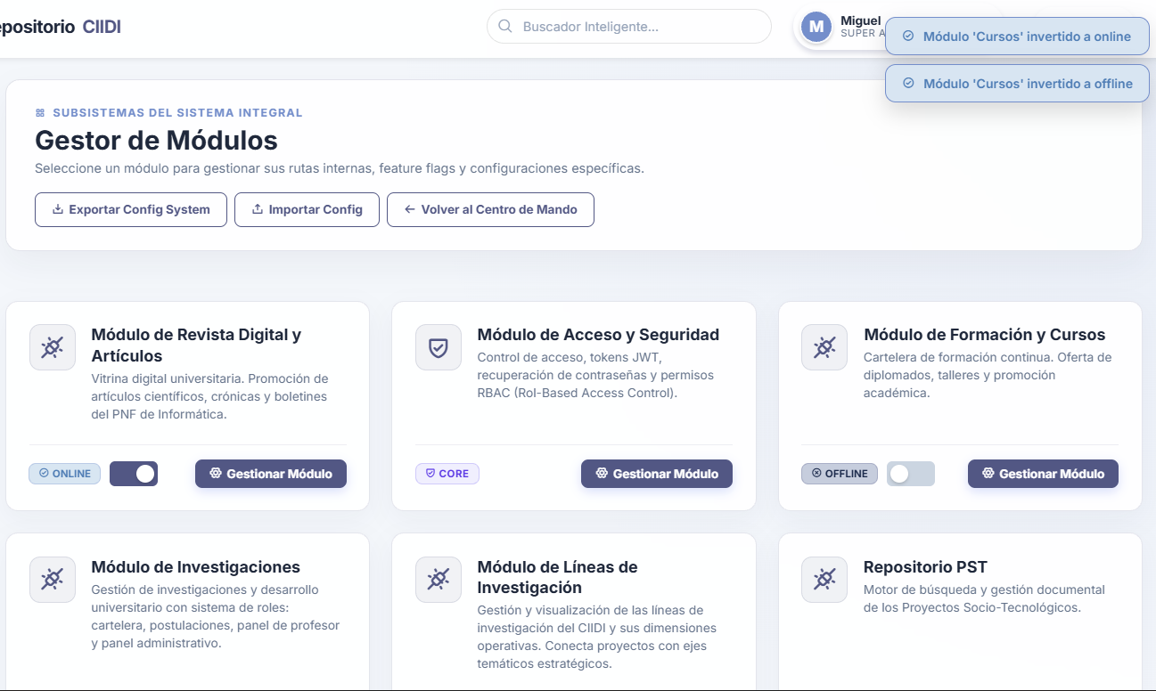
Note. Administration panel allowing real-time toggling of the operational status (Online/Offline) of extensible modules and exporting the global configuration. Source: The authors (2026).

6.4.1. Routes and Feature Flags
Upon clicking the "Manage Module" button on any of the cards, the administrator accesses the dedicated manager for the selected package, exemplified by the "PST Repository" interface (see Figure 131); the header of this console exposes a button to purge the module-specific cache and presents five metric indicators: total internal routes, active routes, restricted routes, recorded click traffic, and the name of its dedicated configuration file (config_pst.json).
In its first tab, "Routes & Feature Flags (RBAC)", a matrix is displayed listing every internal route of the module along with its associated controller, method, and view, making it possible to run individual health checks via the "Test Route" button or disable specific views by selecting the "Disabled (Offline)" state in its Feature Flag selector.
Figure 131
Dedicated module manager displaying the routes and Feature Flags matrix
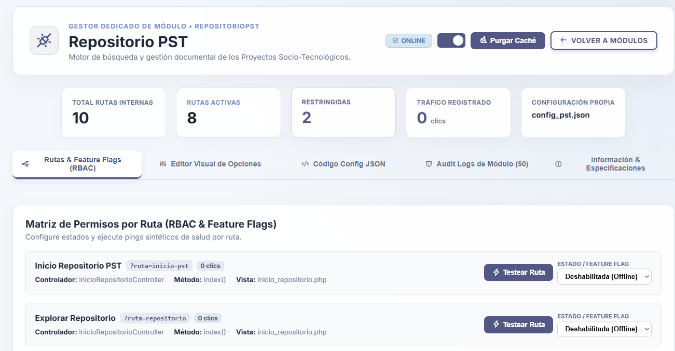
Note. Internal console of the PST Repository module detailing controller mappings, per-route traffic metrics, and selectors to disable individual views. Source: The authors (2026).
When an entire module or a specific route is disabled through this mechanism, any user attempting to access that address is intercepted by a user-friendly HTTP "503 System Under Planned Maintenance" blocking screen (see Figure 132), informing them that the functionality has been temporarily deactivated by the administrator without affecting the rest of the platform.
Figure 132
Public 503 blocking screen for a temporarily disabled module or route
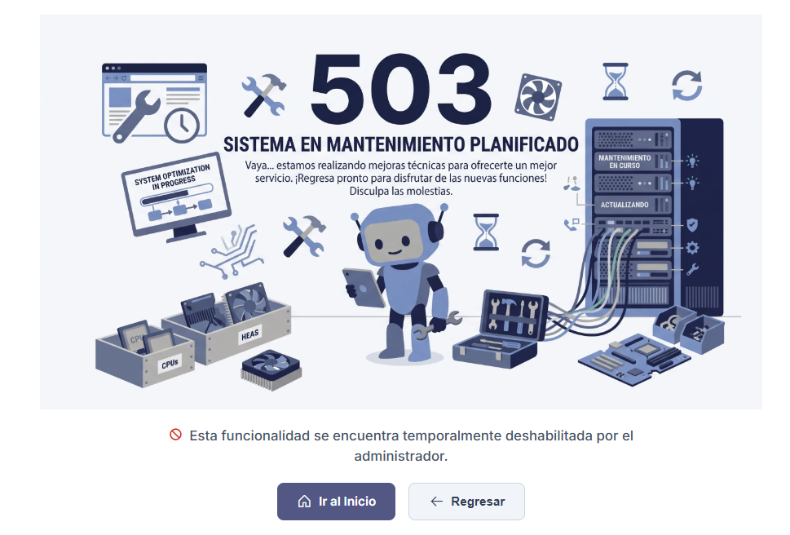
Note. Containment interface displayed to end users when attempting to navigate to a module or feature turned off via Feature Flags. Source: The authors (2026).

6.4.2. Editing JSON Configurations
The remaining four tabs of the dedicated manager provide deep configuration and technical traceability tools for the package; the second tab, "Visual Options Editor" (see Figure 133), divides the configuration file properties into interactive blocks (citations, pagination, resources, search engine, PDF viewer, files, team limits, and ONNX network) for segmented and safe editing, whereas for advanced administrators who prefer to manipulate the data structure directly, the third tab enables a dark-themed code editor displaying the raw "JSON Source Code" (see Figure 134).
Figure 133
Formatted visual options editor organized by property blocks
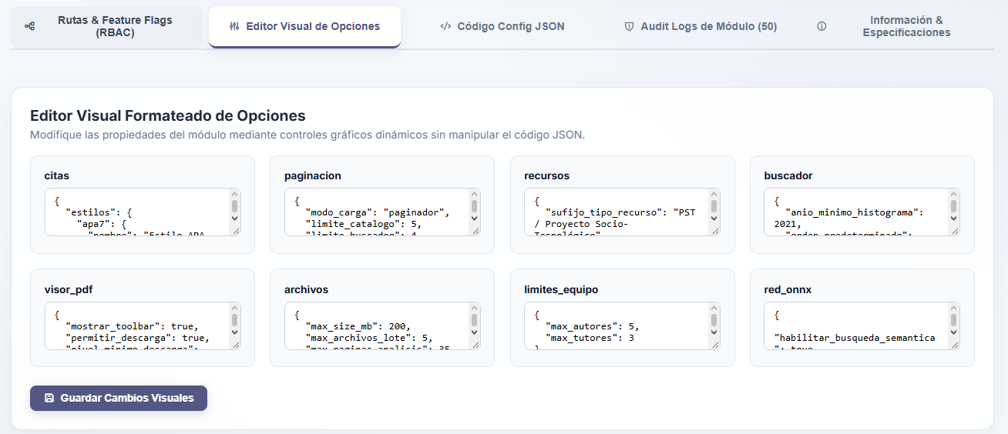
Note. Modular interface grouping internal configuration parameters into independent cards to facilitate editing without manipulating the entire file. Source: The authors (2026).
Figure 134
Advanced raw JSON source code editor for the module
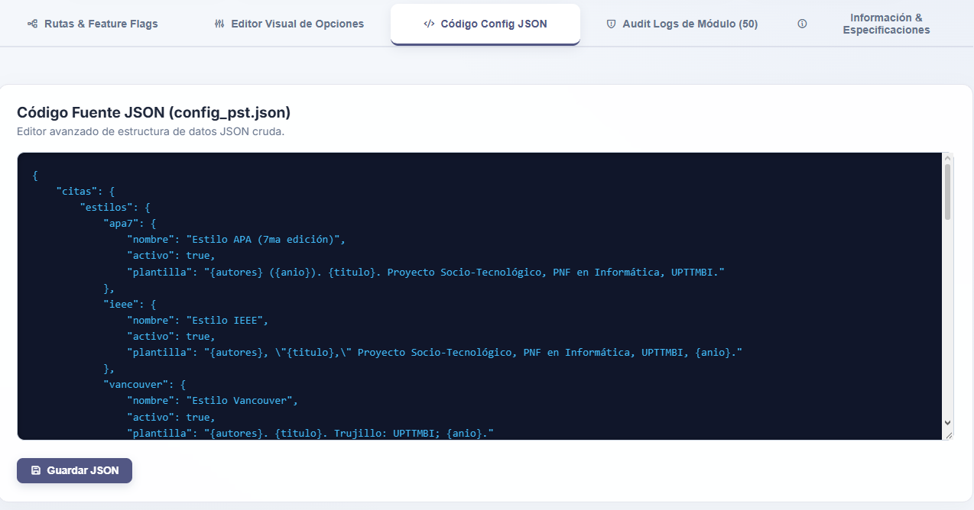
Note. Direct editing environment for the config_pst.json file data structure to perform low-level technical adjustments. Source: The authors (2026).

6.4.3. Module Auditing and Specifications
Meanwhile, the fourth tab, "Module Audit Logs" (see Figure 135), filters and displays a dedicated table containing the last 50 administrative events recorded within that subsystem (such as project deletions or ONNX model training runs); finally, the fifth tab, "Information & Specifications" (see Figure 136), documents the package's technical datasheet, detailing its unique identifier, its classification as an extensible module, the modules on which it depends to operate, and its exact physical path on the server's hard drive.
Figure 135
Module-specific filtered audit history
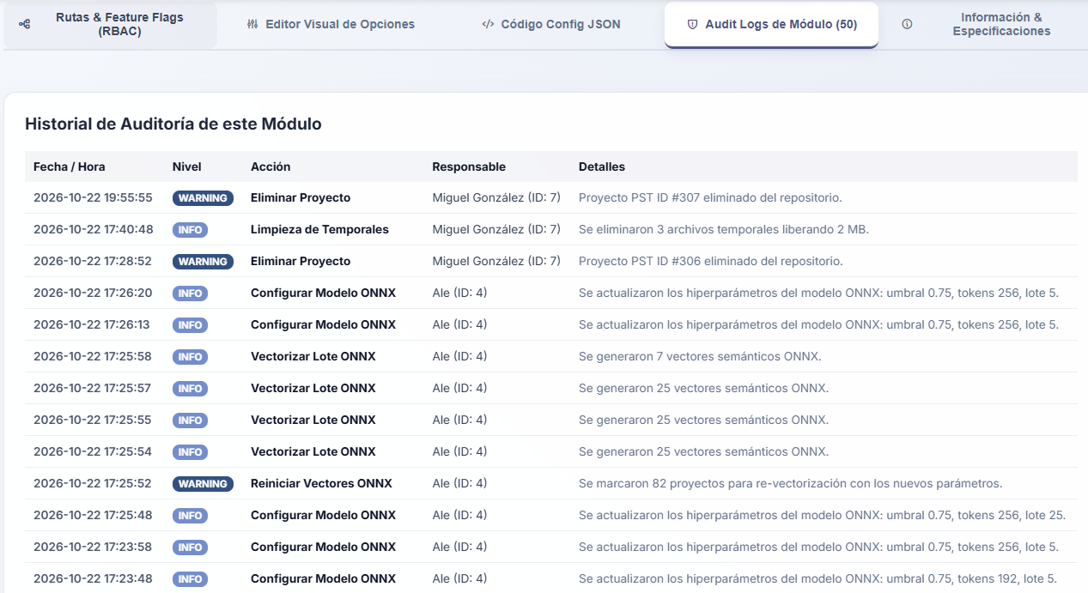
Note. Chronological log isolating the last 50 administrative actions and technical events executed exclusively within the selected module. Source: The authors (2026).

Figure 136
Module technical specifications and dependencies datasheet
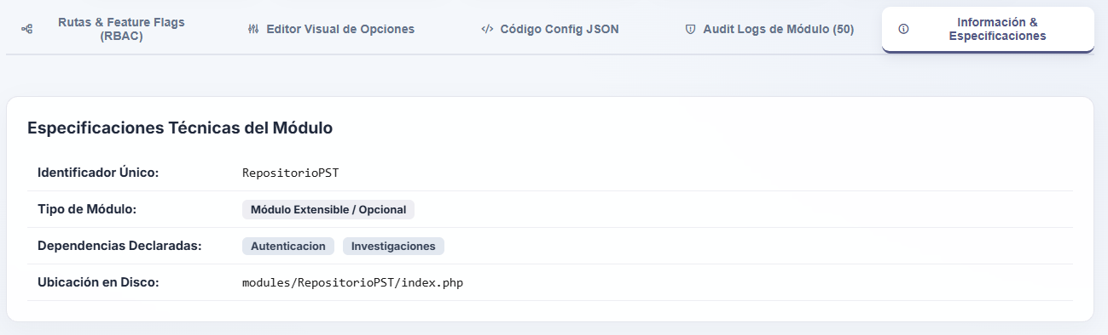
Note. Informational panel declaring the package identifier, its extensible nature, its system dependencies, and its physical path within the modules/ directory. Source: The authors (2026).

6.5. Backups and Maintenance
Operational continuity and the preservation of the institutional repository are managed from the "DB Maintenance & Backups" center, a critical console structured into three specialized tabs for PostgreSQL administration, emergency credential protection, and maintenance window control.

6.5.1. Database Backups and Import
The first tab, "1. DB Backups and Import" (see Figure 137), divides its interface into several operational columns. In the left panel, the "Export Database / Tables" section enables the SuperAdmin to generate on-demand dumps in compressed (.sql.gz) or plain-text (.sql, .txt) formats, allowing selection among three modes: a Full Dump (Structure + Data), exporting only the DDL Schema (table structures only, without records), or extracting the contents of a Specific Table selected from a dropdown menu.
In parallel, the right column displays the "Local Storage (storage/backups/)" inventory, listing all backup copies hosted on the server along with their date, format, and size in kilobytes; from this table, it is possible to purge backups older than 30 days, download the files, delete them, or execute a direct one-click restoration.
Figure 137
SQL dump export panel and local backup storage manager
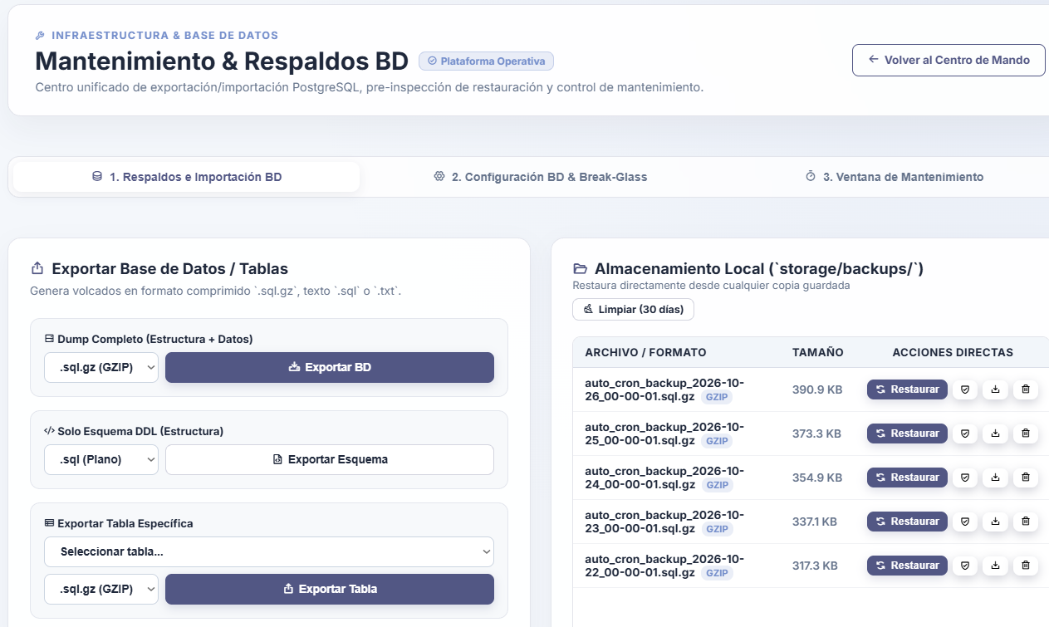
Note. Interface enabling the generation of full, schema-only, or per-table backups, as well as restoring or downloading backups hosted on the server. Source: The authors (2026).
Scrolling down the left panel (see Figure 138), the system provides the "PostgreSQL Optimization (VACUUM)" tool, which analyzes the space used by the main tables and reclaims dead space while updating query statistics via the "Optimize DB Now" button, accompanied at the bottom by the "Import External Script" uploader, which allows uploading an external file while automatically creating a Safety Auto-Checkpoint before pre-inspecting and restoring the data.
Figure 138
PostgreSQL VACUUM optimization tool and external script importer
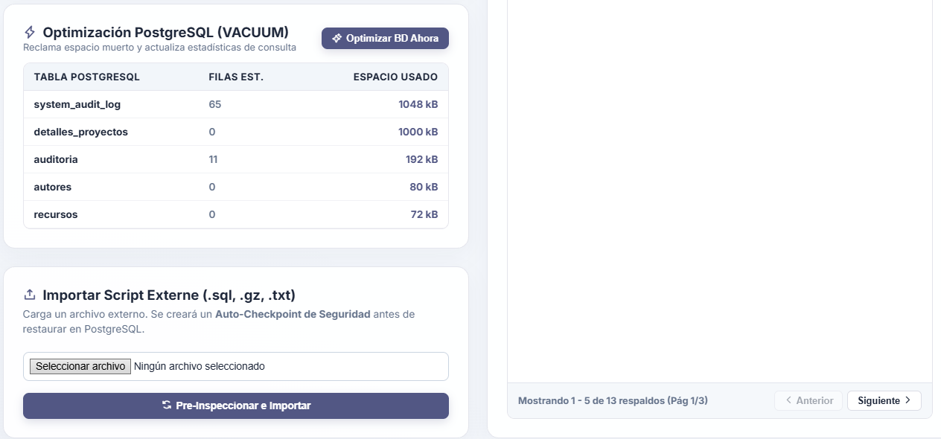
Note. Lower maintenance section facilitating dead-space reclamation in database tables and safe uploading of external backups with an automatic checkpoint. Source: The authors (2026).

6.5.2. Database Configuration and Emergency Account
The second tab, titled "2. DB Configuration & Break-Glass" (see Figure 139), concentrates the system's survival mechanisms against catastrophic infrastructure failures; in the left block, "Dynamic PostgreSQL Connection (.env Shield)", the administrator can hot-update the database engine connection parameters (Host, Port, DB Name, User, and Password), which are safeguarded from public access via .htaccess rules (403 Forbidden).
In the right block, the "Local Emergency Account (Break-Glass)" is configured as a failsafe mechanism that stores an independent super-access profile in an encrypted local JSON file; this account is designed to allow entry into the administrative dashboard to repair settings even if the PostgreSQL server suffers a complete outage. For maximum security, any modification in either panel requires entering the current SuperAdmin password as a mandatory re-authentication measure.
Figure 139
Dynamic PostgreSQL connection configuration and Break-Glass emergency account
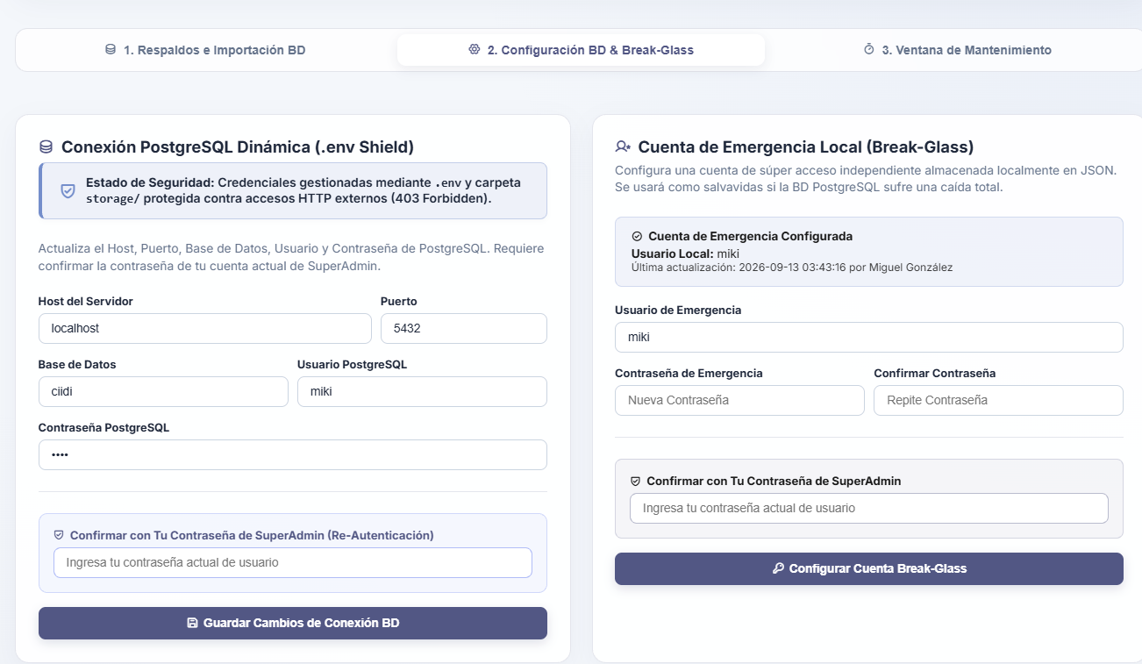
Note. High-security panel protected by re-authentication for modifying .env file credentials and configuring the local failsafe user against database outages. Source: The authors (2026).

6.5.3. Maintenance Window
The third tab, "3. Maintenance Window" (see Figure 140), makes it possible to temporarily isolate the platform from public access during infrastructure upgrades or sensitive migrations. The upper-left panel, "Immediate Isolation Control", allows forcing a real-time system lockdown by defining an informational public message and an estimated duration in minutes before clicking the "Activate Maintenance Now" button.
Meanwhile, the right panel, "Schedule Maintenance Window", enables the administrator to plan future technical downtimes by selecting the exact start date and time, the duration in minutes, and the reason for the intervention. All scheduled downtimes are listed in the lower "Scheduled Maintenance Agenda" table (also reflecting a countdown timer in the module's general header), from which individual events can be canceled or the entire planned schedule cleared with a single click.

Figure 140
Immediate isolation control panel and scheduled maintenance agenda
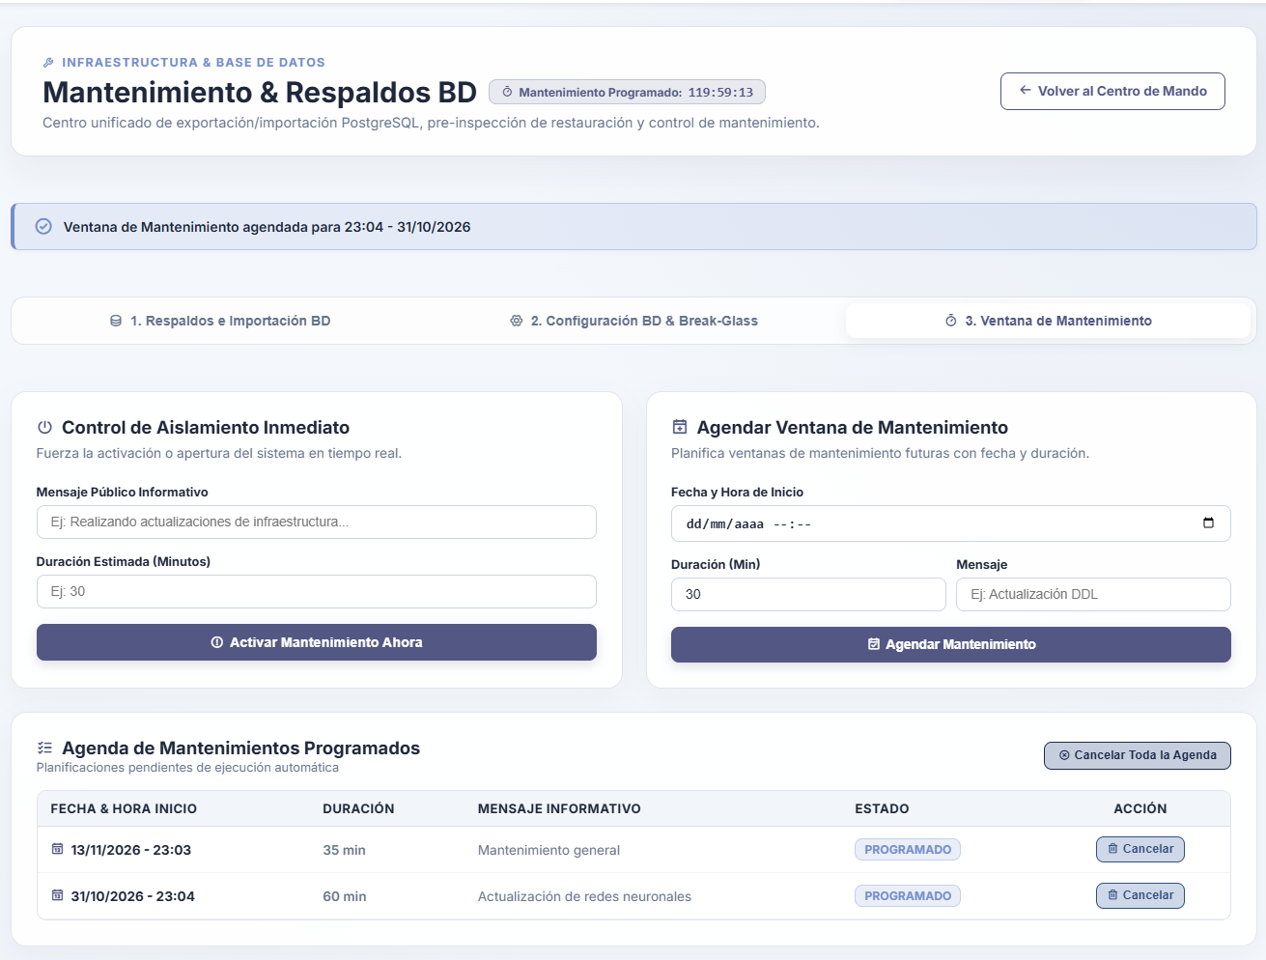
Note. Interface for activating live maintenance mode or scheduling future technical downtimes with custom notices and an automatic timer. Source: The authors (2026).

6.6. Scheduled Tasks Control
The automation of background operational routines is governed from the "Scheduled Tasks Control & Cron Jobs" console (see Figure 141); in its upper bar, the module displays the "Operating System Scheduler Status" block, which verifies that the server's Cron service (e.g., Debian Linux) is active, shows the timestamp of its latest heartbeat, and exposes the exact command line registered in the crontab alongside quick buttons to copy the instruction or synchronize the daemon automatically.
Figure 141
Main Scheduled Tasks Control console and Cron daemon status
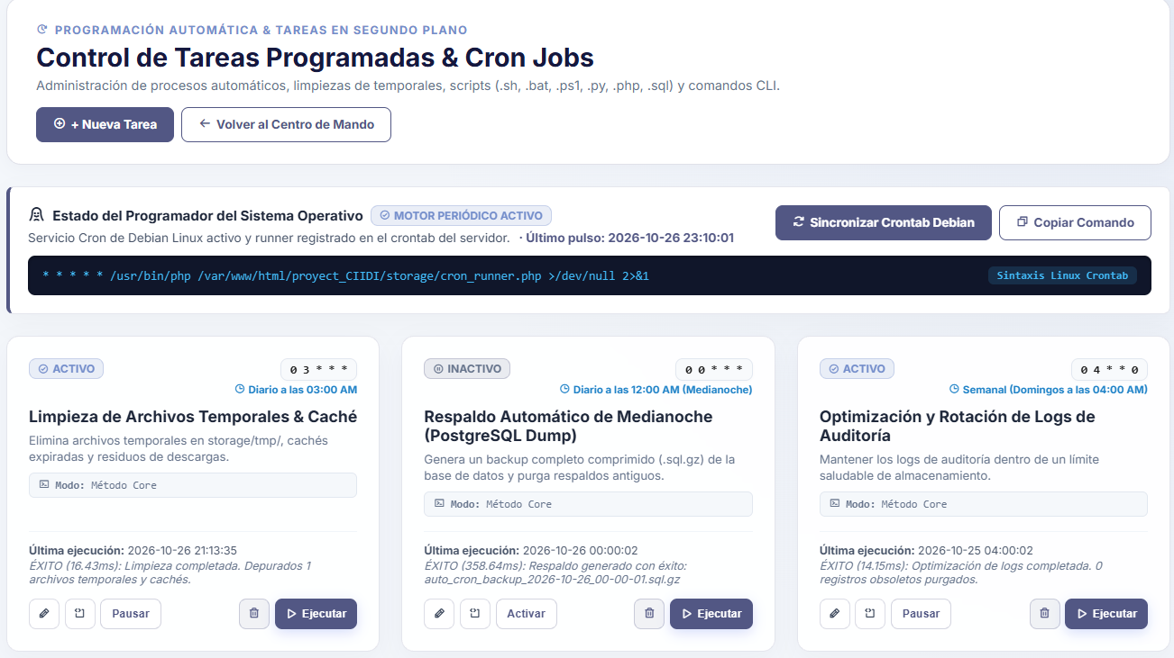
Note. Background process administration panel showing the command registered on the server and the status cards for each automated routine. Source: The authors (2026).
Upon clicking the synchronization button, the system registers the runner in the operating system and displays a confirmation banner at the top (see Figure 142); beneath this block, configured tasks are presented on individual cards (such as Temporary File Cleanup at 03:00 AM, Midnight Automatic Backup, and Weekly Log Optimization), detailing their Cron expression, their status (ACTIVE or INACTIVE), the duration and success report of their last execution, and a bottom toolbar to edit, view the console log, pause/activate, delete, or force the immediate manual execution of the task.
Figure 142
Notification of successful runner synchronization in the server Crontab
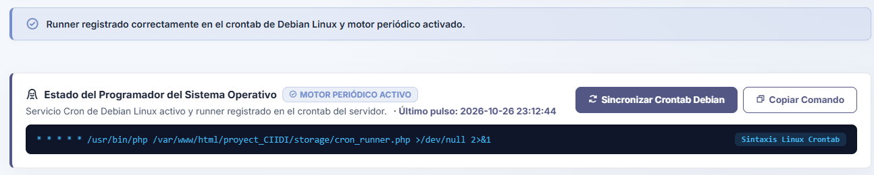
Note. Informational alert confirming the automatic registration of the task dispatcher script within the operating system's native scheduler. Source: The authors (2026).
To add a new automated routine or modify the parameters of an existing one, the system displays the "Create New Scheduled Task" (see Figure 143) and "Edit Scheduled Task" (see Figure 144) modal forms. These interfaces have been designed to eliminate the complexity of memorizing technical Cron syntax.
In addition to allowing manual entry of the expression, they integrate a "1-Click Quick Shortcuts" toolbar (Every 15 min, Hourly, Midnight, Noon, Early Morning, Mon-Fri, or Sundays) and a dynamic natural-language translator that explains exactly when the command will run alongside a visual breakdown of its five fields (Minute, Hour, Day of Month, Month, and Day of Week). In the lower section of the form, the administrator selects the engine type (such as PHP's internal SchedulerService), chooses the core method to invoke (e.g., limpiarTemporales or ejecutarBackupAutomatico), and writes a technical description of the task's purpose.

Figure 143
Interactive modal form for creating new scheduled tasks
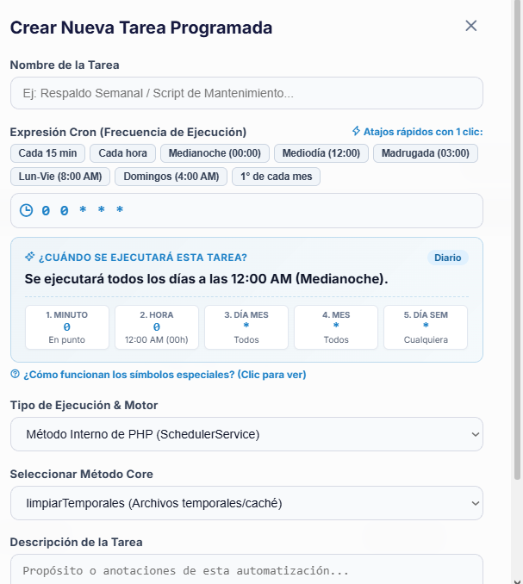
Note. Configuration wizard featuring one-click frequency shortcuts, a real-time Cron expression translator, and an internal core method selector. Source: The authors (2026).

Figure 144
Parameter and frequency editing modal for existing scheduled tasks
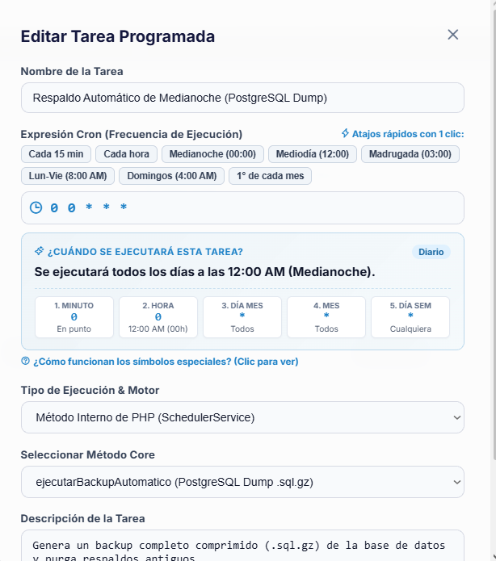
Note. Preloaded interface containing an automatic backup routine configuration for adjusting its schedule expression or execution method. Source: The authors (2026).
Technical monitoring and lifecycle control for each routine include direct diagnostic tools on the task card. Clicking the terminal-icon button at the bottom of any card opens the "Console Output Log (stdout/stderr)" viewer (see Figure 145), a dark terminal displaying the raw log of the latest execution, detailing the exact date, duration in milliseconds, returned status, and standard output message generated by the script.
Figure 145
Console viewer displaying the standard output log (stdout/stderr) of a task
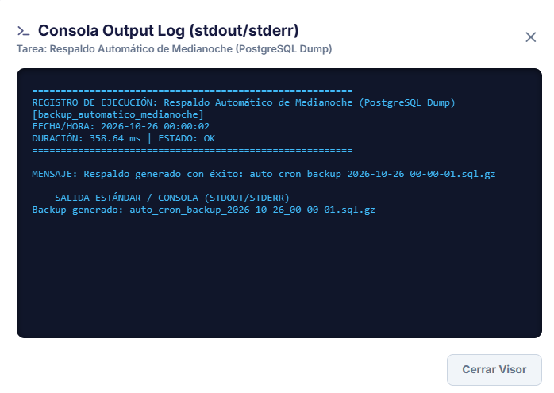
Note. Diagnostic terminal exposing the execution trace, response time in milliseconds, and messages returned by the background process. Source: The authors (2026).
If an administrator wishes to remove a routine using the trash icon, the platform requires validation via the "Security Confirmation" modal (see Figure 146) to prevent the accidental deletion of critical processes; conversely, clicking the "Run" button triggers the task in real time outside its regular schedule and displays a top alert confirming the immediate outcome, such as the instant generation of a compressed backup file (see Figure 147).
Figure 146
Security confirmation modal for deleting a scheduled task
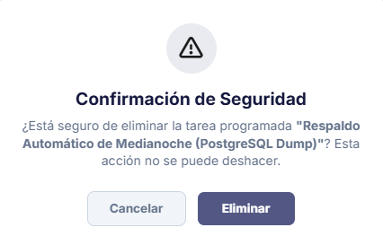
Note. Preventive validation window protecting automated maintenance routines against accidental deletion. Source: The authors (2026).
Figure 147
Visual confirmation after forcing the immediate manual execution of a Cron Job
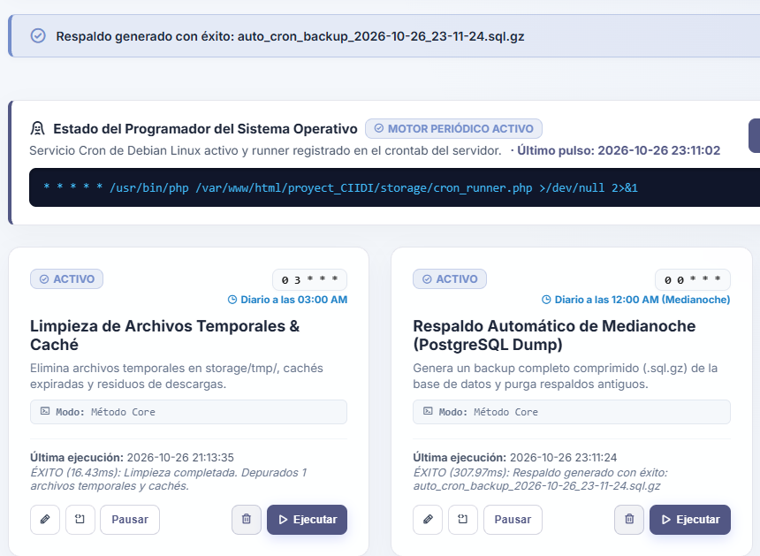
Note. Top notification certifying the successful completion of a database backup manually triggered from the control card. Source: The authors (2026).

6.7. WAF and IP Monitor
Active perimeter defense for the web application is managed from the "WAF Monitor, Injection Detection & Whitelist" console (see Figure 148). This intelligent security center oversees heuristic inspection against SQL Injection (SQLi) and Cross-Site Scripting (XSS) attacks, structuring its diagnostics across several hardening blocks: the first horizontal panel, "Cryptographic Audit Chain (SHA-256 Hash)", verifies the immutability of event records and alerts immediately if it detects inconsistencies or external tampering in cryptographic signatures.
The second panel, "Storage & Credentials Protection (.env Shield)", certifies that the .env file and sensitive directories are isolated against direct HTTP downloads; in the lower section, three cards divide network traffic control: the "Login Brute-Force Attempts (Rate Limiting)" monitor, the "WAF Blacklist" containing blocked addresses, and the "Trusted Whitelist", which exempts authorized administration or local development IPs from blocks.

Figure 148
Central console of the WAF Monitor, SHA-256 cryptographic integrity, and IP control
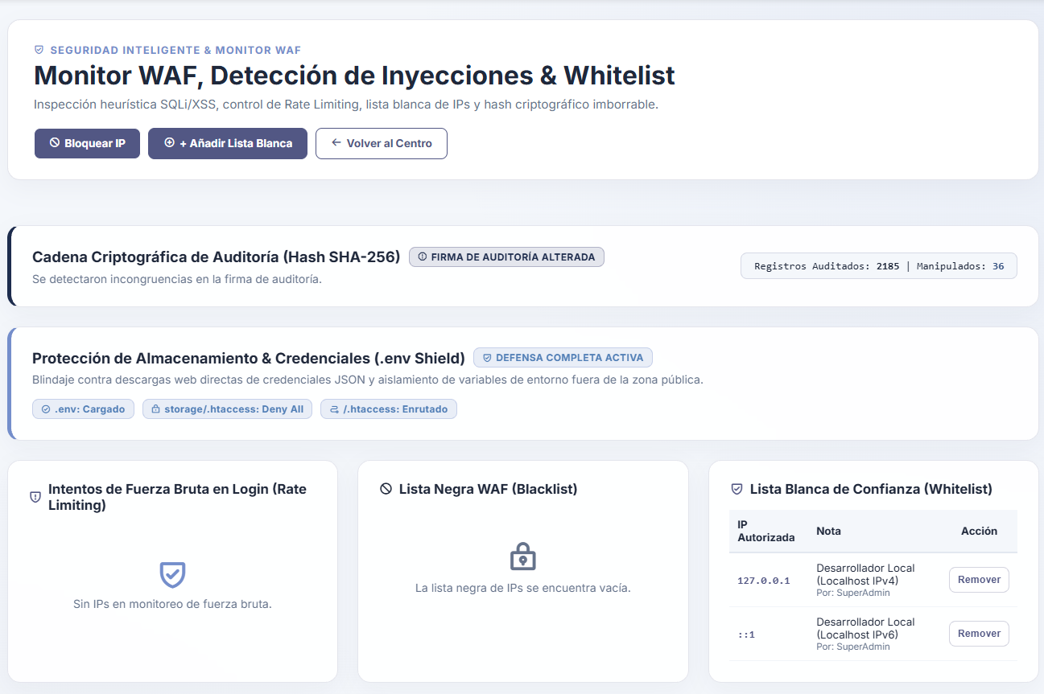
Note. Perimeter defense dashboard monitoring audit signature tampering, .env file shielding, brute-force control, and network whitelists and blacklists. Source: The authors (2026).
To manually manage these lists from the module header, the "+ Add to Whitelist" and "Block IP" buttons open their respective modal forms (see Figures 149 and 150), allowing the SuperAdmin to authorize new trusted addresses or permanently restrict access to malicious IPs while documenting the technical note or reason for the block.

Figure 149
Modal form for authorizing an IP address in the Trusted Whitelist
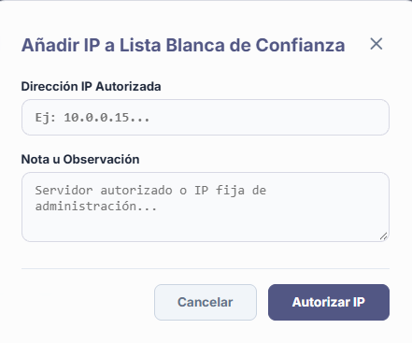
Note. Interface enabling the registration of static server or administrator IP addresses to exempt them from automated Firewall restrictions. Source: The authors (2026).
Figure 150
Modal form for adding an IP address to the Global WAF Blacklist
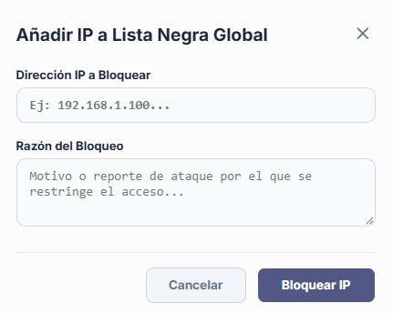
Note. Manual perimeter blocking tool requesting the offending IP address and the technical reason for the attack report in order to deny system access. Source: The authors (2026).

6.8. Logs and Audit Viewer
Forensic traceability of all operations occurring within the platform is centralized in the "Logs & Active Auditing Viewer" submodule (see Figure 151), which divides its monitoring across three levels of depth through dedicated tabs: Active Auditing (Audit Trail), DB Traceability (Triggers), and Access Control.
Figure 151
Navigation header of the Logs and Active Auditing Viewer
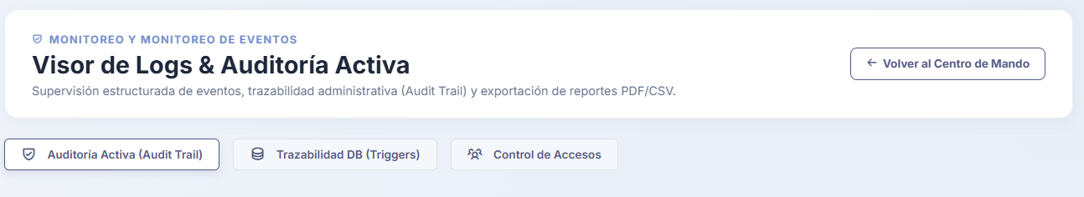
Note. Main selector of the forensic module segmenting oversight into application events (Audit Trail), database triggers (Triggers), and access control. Source: The authors (2026).

6.8.1. Active Auditing (Audit Trail)
When positioned on the first tab (see Figure 152), the system displays the "Administrative Actions History", a detailed table recording every event with its date and time, severity level (INFO, WARNING, ERROR), originating module, executed action, technical event details, and the responsible user alongside their IP address.

Figure 152
Administrative Actions History table with severity and date filters
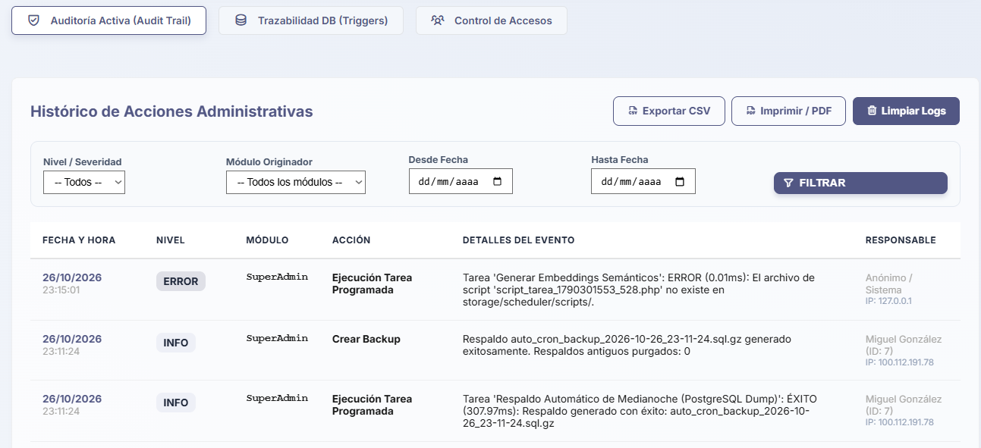
Note. Detailed Audit Trail log exposing system events, script execution errors, and responsible parties identified by user and IP. Source: The authors (2026).
At the top, this interface provides selectors to filter the history by severity, module, or date range, along with buttons to purge old records, export the table to CSV, or generate a printable view; clicking "Print / PDF" displays the "System Audit and Monitoring Report" (see Figure 153) in a clean tabular layout designed for physical audits or documentary archiving.

Figure 153
Print and PDF export format of the Audit and Monitoring Report
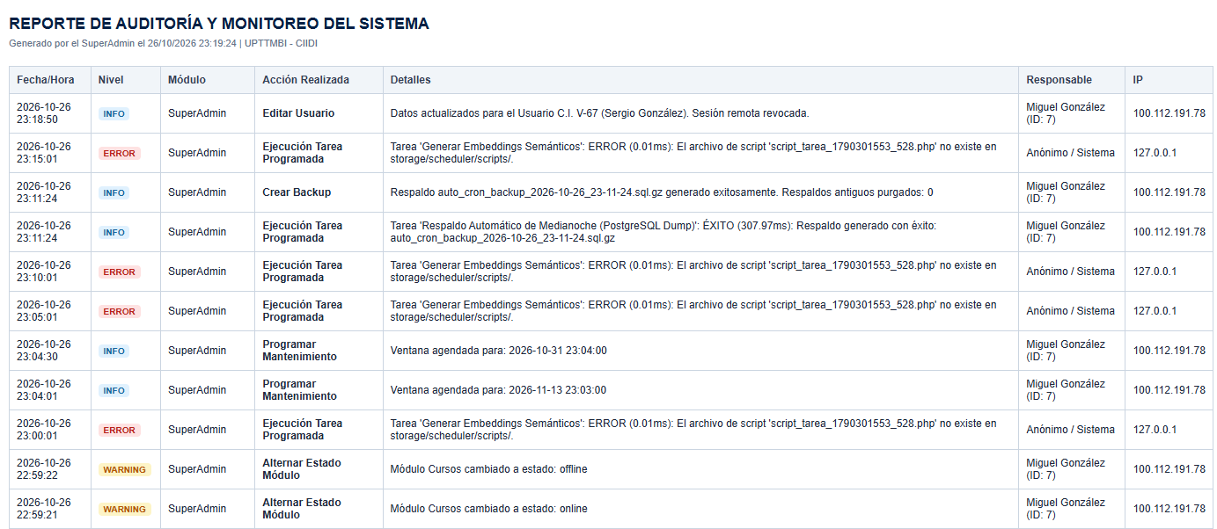
Note. High-readability consolidated view generated by the log viewer for direct downloading or printing of the administrative event history. Source: The authors (2026).

6.8.2. Database Traceability
For relational-engine-level forensic inspection, the second tab presents "Database Traceability", fed directly by internal PostgreSQL triggers (Triggers) (see Figure 154); this immutable view records every low-level operation (INSERT, UPDATE, DELETE) executed on sensitive system tables, displaying the exact timestamp, the user who triggered the query, the affected table and record identifier, and a JSON comparison contrasting the Previous column state against the resulting New state after the modification.

Figure 154
Trigger-based Database Traceability log with JSON comparison
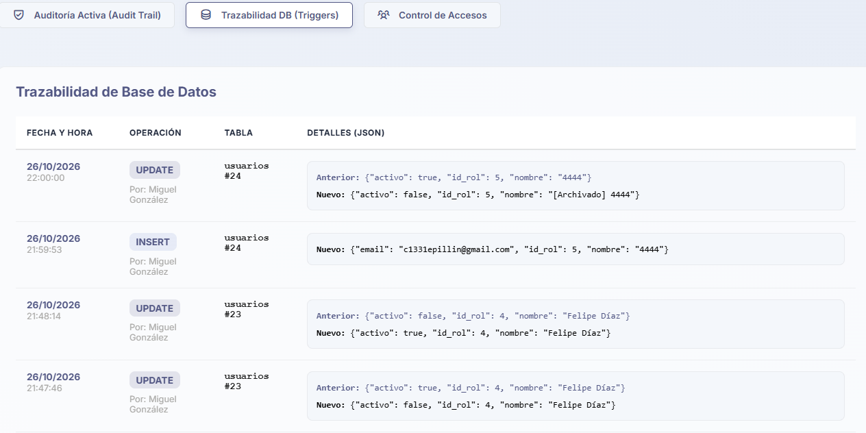
Note. Deep-audit table capturing PostgreSQL INSERT and UPDATE operations, exposing exact values before and after every change. Source: The authors (2026).

6.8.3. Access Control
Finally, the third tab, titled "Access Control" (see Figure 155), summarizes the sign-in behavior of the entire community, listing each user along with their national ID number, the exact timestamp of their last recorded activity, and a cumulative counter showing the historical total number of times they have signed in to the platform.

Figure 155
Access Control panel and historical session count per user
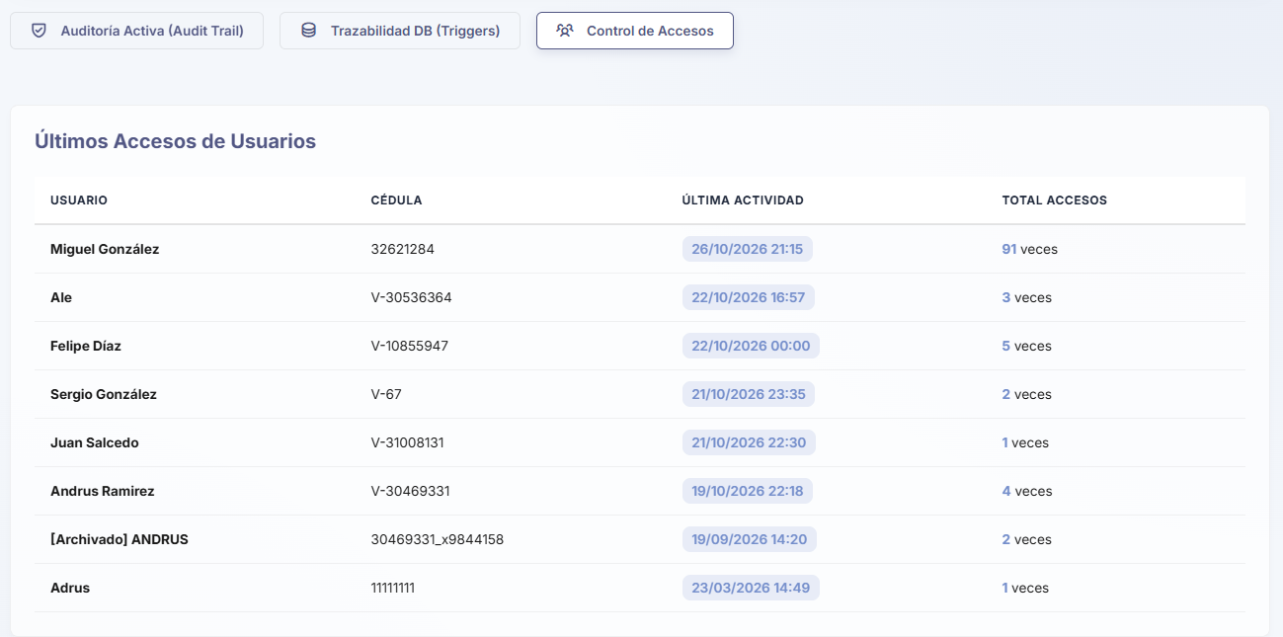
Note. Monitoring list consolidating the date and time of the latest detected activity alongside the total sign-in frequency for each registered account. Source: The authors (2026).

6.9. SMTP Mail and Templates Manager
The repository's external communications and transactional notifications infrastructure is governed from the "SMTP Mail & Templates Manager" submodule, an environment divided into five tabs spanning from direct message composition to HTML code design for institutional email wrappers.

6.9.1. Send Direct Email
The first tab, "Send Direct Email" (see Figure 156), provides an official correspondence dispatch client integrated into the platform; in the upper section of the form, the SuperAdmin can choose whether to send the message via "Interactive / Multi-Recipient Selection"—searching for specific database users or manually adding external addresses—or address a mass announcement to a "Full User Group / Role".
Beneath the subject field, the system provides a rich-text editor accompanied by quick buttons to insert pre-formatted sections (Section Heading, Callout Box, or Link Button), a checkbox to automatically wrap the message with the official UPTTMBI header and footer, and a right-hand side panel from which "Reusable Templates" can be loaded or saved for recurring notices. Before dispatching the announcement or storing it as a template, the "Message Preview" button invokes a modal window (see Figure 157) that renders the email exactly as the end recipient will view it in their inbox.

Figure 156
Direct email composition interface with multi-recipient selector and templates
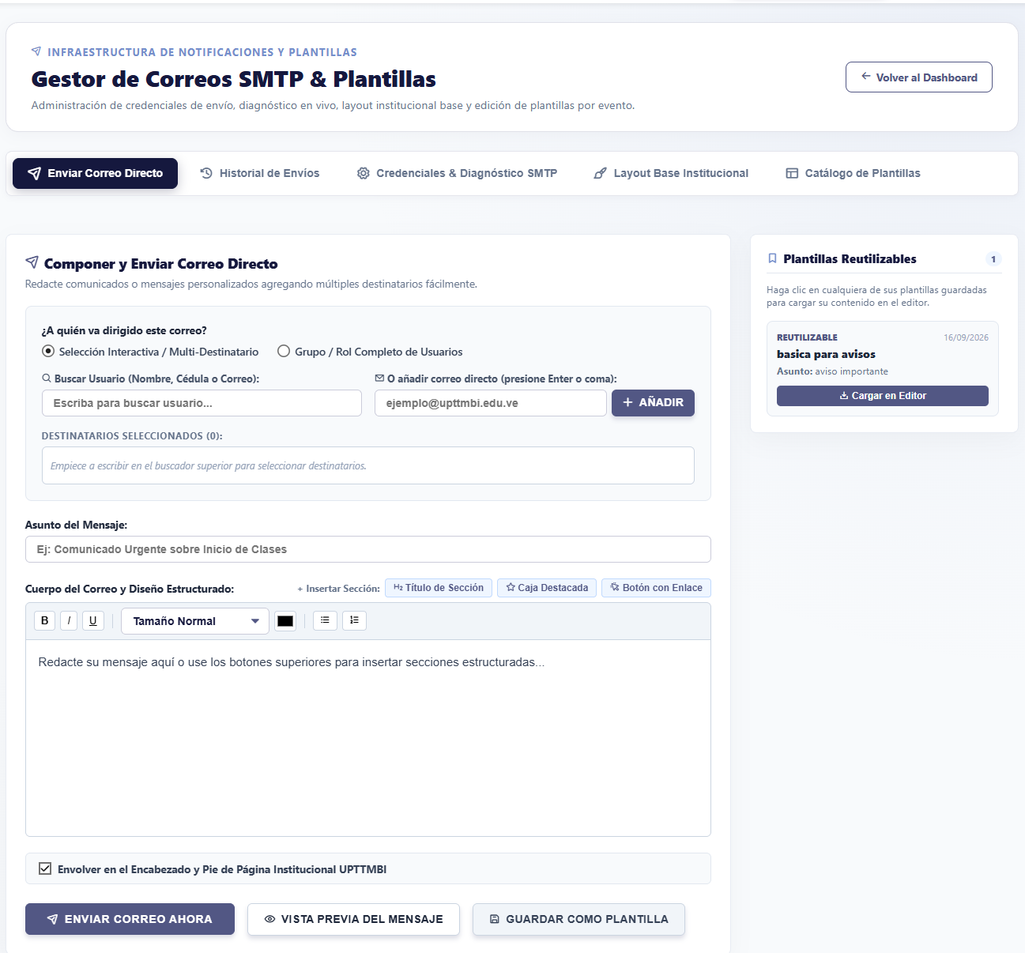
Note. Official announcements editor allowing recipient selection by role or individual search, structured layout block insertion, and saved template reuse. Source: The authors (2026).

Figure 157
Institutional rendering preview modal for direct emails
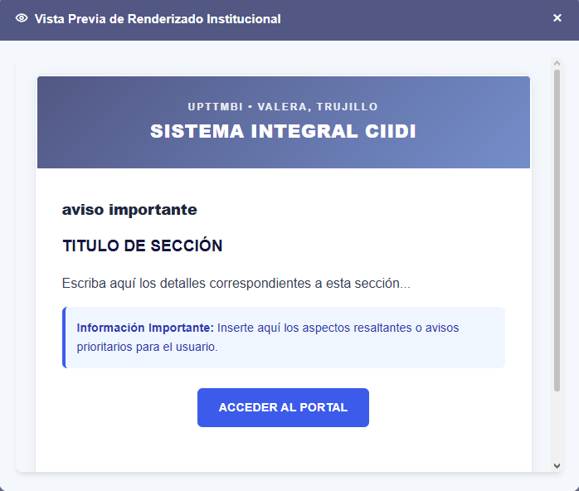
Note. Visual simulation demonstrating how composed content integrates within the university's official graphic wrapper prior to sending. Source: The authors (2026).

6.9.2. Delivery History
The second tab, "Delivery History" (see Figure 158), serves as an immutable audit log for all notifications processed by the institution's mail server; this chronological table documents the exact dispatch date and time, the recipient's name and email address, the message subject, a badge certifying the operation status (e.g., SUCCESSFUL or FAILED), and a technical detail column capturing the response or exception code returned by the server (such as SMTP connection errors), while providing a quick search bar in the upper-right corner to trace emails by address or subject.
Figure 158
Immutable log and delivery history of dispatches processed by the SMTP server
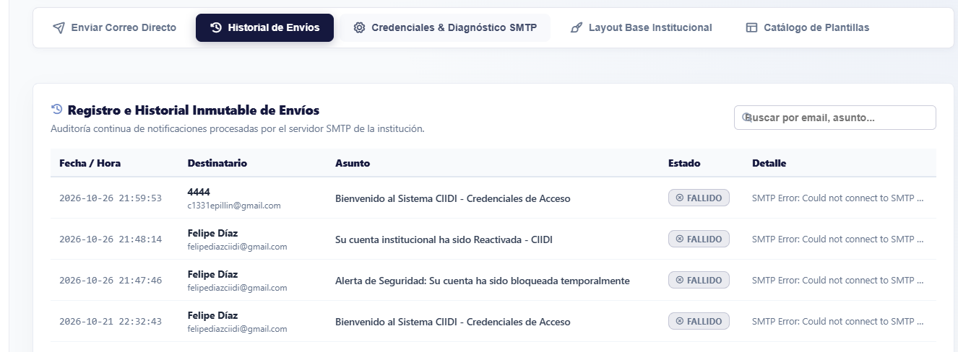
Note. Traceability table auditing the delivery status of every automated or manual notification, detailing error traces in the event of connection failures. Source: The authors (2026).

6.9.3. SMTP Credentials and Diagnostics
The third tab, "SMTP Credentials & Diagnostics" (see Figure 159), centralizes the technical connection parameters for the outgoing mail server; in the upper block, "Institutional SMTP Server Connection Settings", the administrator configures the Host address (e.g., smtp.gmail.com or a dedicated server), the secure transmission port (TLS/SSL, such as port 587), the authentication email address, the encrypted app password, and the public address displayed in the sender header (Header From).
To verify that these credentials function properly without waiting for an actual system event to occur, the lower block incorporates the "Real-Time Diagnostics & Connectivity Test" tool, which allows selecting a test message type and entering a destination email address to instantly verify the SMTP handshake and server authentication.
Figure 159
SMTP credentials configuration panel and live diagnostics tool
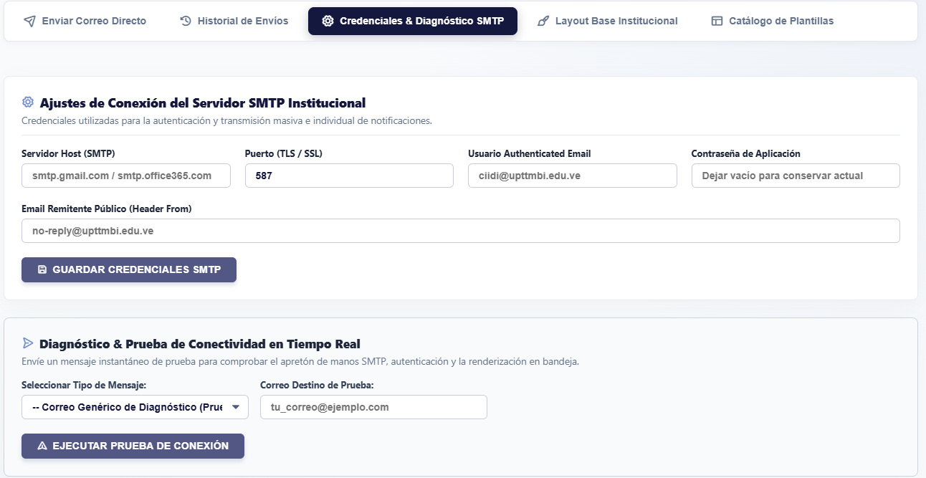
Note. Technical form for configuring the outgoing mail server and executing instant connectivity and inbox delivery tests. Source: The authors (2026).

6.9.3.1. How to Obtain an App Password?
- Sign in to your Google Account and navigate to the Security section.
- Enable 2-Step Verification (requires linking a valid phone number).
- Use the internal search bar in Google Account settings and type "App passwords".
- Generate a new password by assigning a descriptive name to identify it (for example, "CIIDI System").
- Copy the generated 16-character key without spaces.

6.9.4. Institutional Base Layout
The cross-cutting visual identity of all emails issued by the platform is designed in the fourth tab, "Institutional Base Layout". This interface allows editing the master template or wrapper (header, corporate colors, and footer) that automatically encloses all system notifications, offering buttons to inject the structural container variables: +{TITULO}, +{CUERPO}, and +{YEAR}.
The administrator can freely switch between a "Visual Mode (WYSIWYG)" (see Figure 160) for quick text and formatting adjustments, or toggle to "HTML Code" mode (see Figure 161) to directly manipulate layout tables and inline CSS styles that ensure compatibility across different email clients; likewise, it provides the "Layout Preview" button (see Figure 162) to inspect, via a sample message, how the base wrapper will render before saving changes.

Figure 160
Visual Mode (WYSIWYG) editor for the Institutional Base Layout of emails
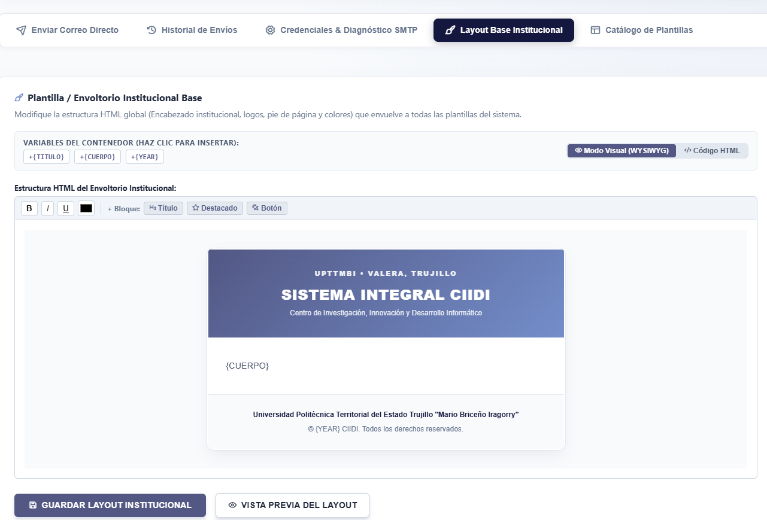
Note. Graphical interface for modifying the master notification wrapper using visual controls and container variable injection. Source: The authors (2026).
Figure 161
HTML source code editor for the institutional wrapper structure
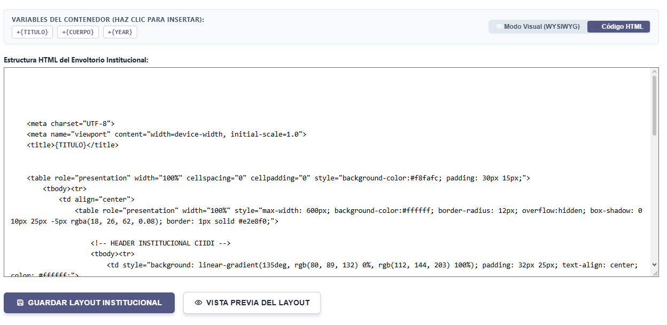
Note. Low-level editing view allowing direct adjustment of HTML tags and CSS properties in the global email design. Source: The authors (2026).
Figure 162
Rendering preview modal for the Institutional Base Layout
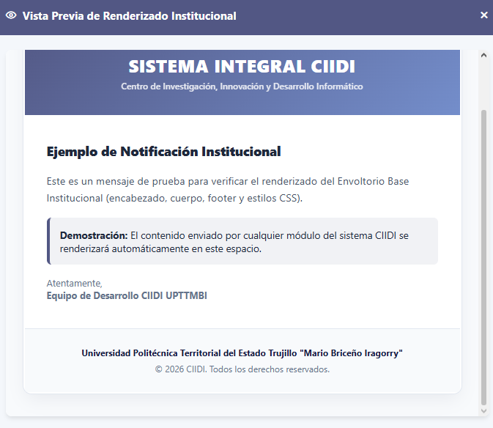
Note. Test window displaying a sample message integrated into the institutional wrapper to verify its final visual appearance. Source: The authors (2026).

6.9.5. Templates Catalog
The specific content of each automated notification triggered by system events is managed from the fifth tab, "Templates Catalog" (see Figure 163); this screen is divided into a left sidebar column listing all "Templates by Event" categorized by module and indicating their active status (Password Reset, Welcome Message, Suspended Account Alert, Company Request Confirmation, User Creation, Faculty Invitation, Role Change, Account Reactivation, and Maintenance Notice), alongside a main workspace on the right.
Selecting any event from the list loads its properties into the right panel, making it possible to enable or disable sending that particular notification, opt to bypass the base layout, modify the internal title and email subject, and edit the message body (in visual or HTML mode) while injecting context-specific dynamic variables with a single click (such as +{NOMBRE_USUARIO}, +{ENLACE_ACCION}, or +{TIEMPO_EXPIRACION}).
Figure 163
Event-based transactional templates catalog and editor with dynamic variables
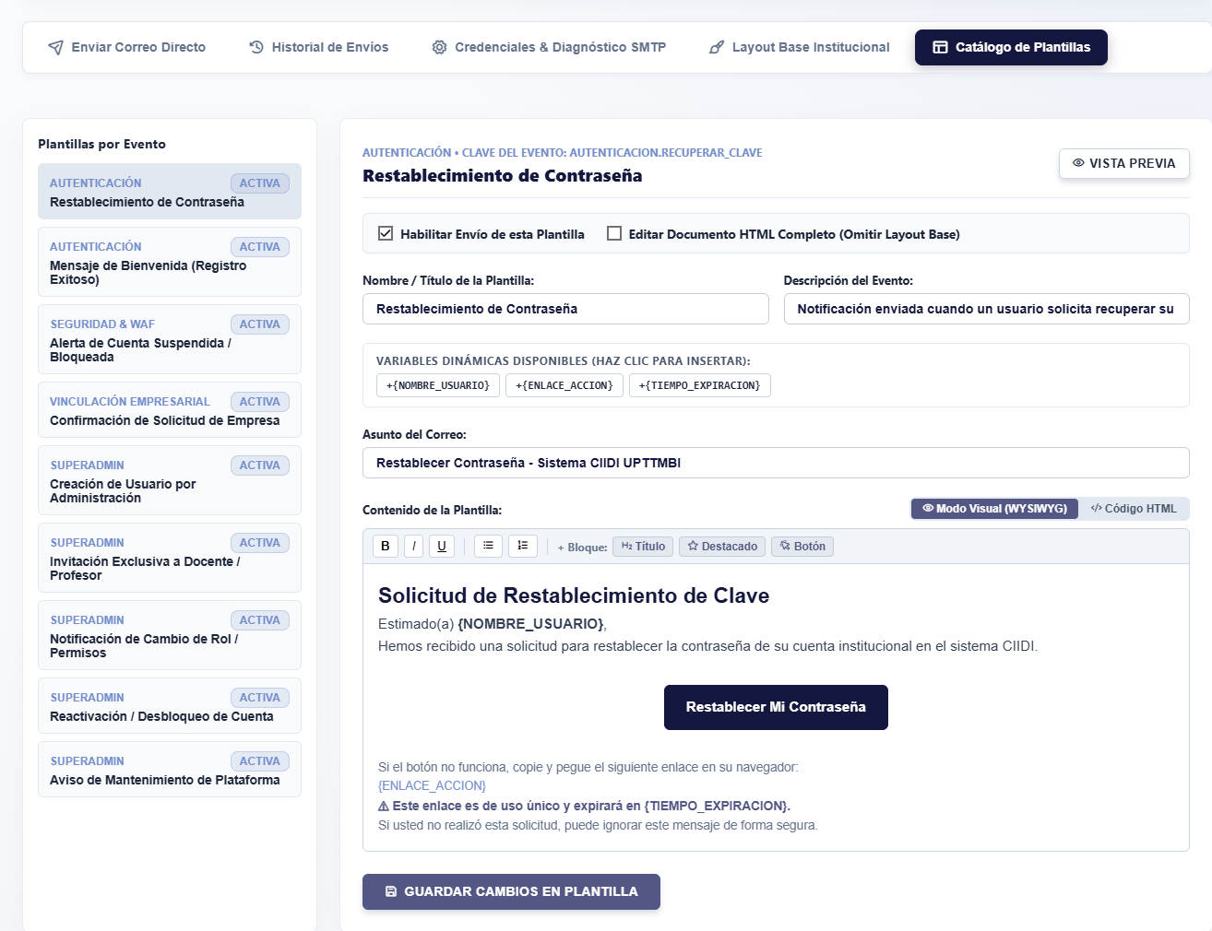
Note. Centralized environment for customizing the subject, content, and contextual variables of each automated notification issued by platform modules. Source: The authors (2026).

6.10. Environment Variables and Configuration
The final section of the SuperAdmin console corresponds to "Environment Variables and Configuration", a panel designed to globally adjust memory performance, authentication rules, error debugging behavior, numeric per-module access thresholds, and institutional footer customization.

6.10.1. Pagination
The first tab of this section, titled "Pagination" (see Figure 164), enables regulating "Table Rendering Limits" across administrative panels. In order to prevent server RAM saturation and speed up browser load times once the database accumulates thousands of records, the SuperAdmin can numerically define how many items load by default per page block across three key directories: the Users per page table in the general manager, the Faculty members per page listing, and the volume of Audit Logs rendered per view.

Figure 164
Global rendering and pagination limit settings for administrative tables
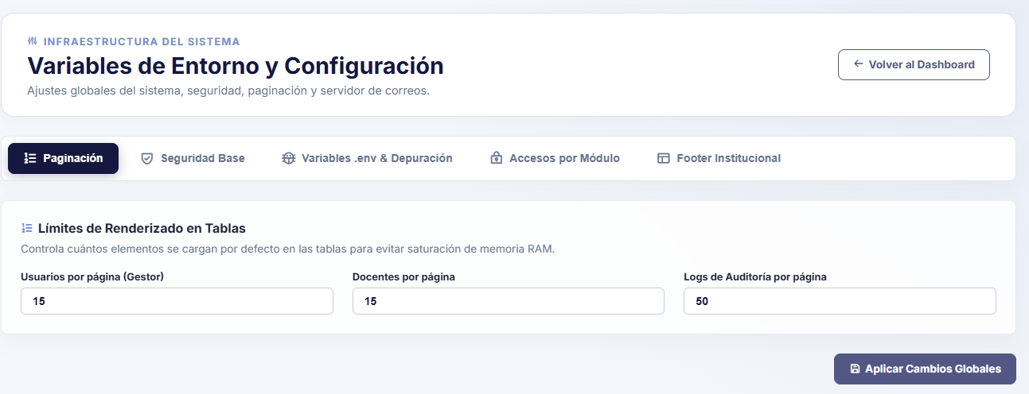
Note. Performance panel allowing administrators to set the maximum number of rows loaded per page across the user, faculty, and audit log managers. Source: The authors (2026).

6.10.2. Base Security
In the second tab, "Base Security" (see Figure 165), the "Authentication Environment Rules" protecting account access across the entire community are configured. This panel provides two fundamental numeric controls: "Inactivity Timeout (Minutes)", which sets the maximum time a session may remain idle without interaction before the system automatically closes it as a precaution (e.g., 120 minutes), and the "Failed Login Attempts" limit (e.g., 5 attempts), the threshold beyond which the Rate Limiting mechanism and the WAF will temporarily block sign-in requests to neutralize automated brute-force attacks.

Figure 165
Configuration of session inactivity rules and failed login attempts limit
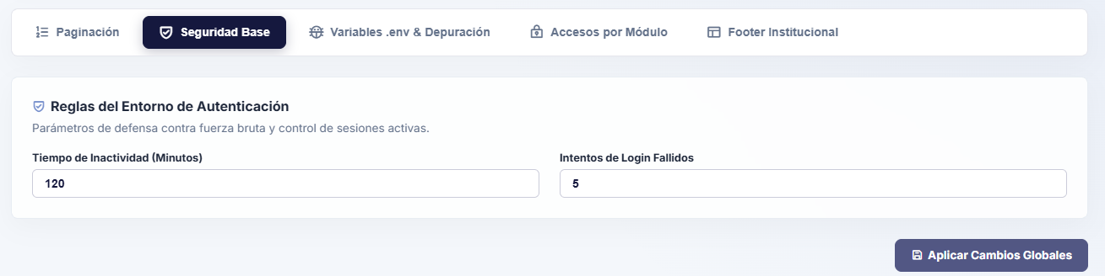
Note. Interface for configuring automatic expiration of inactive sessions and maximum tolerance against brute-force attacks on the sign-in form. Source: The authors (2026).

6.10.3. Environment Variables and Debugging
The third tab, ".env Variables & Debugging" (see Figure 166), controls the core execution profile and the exposure of technical stack traces upon system failures. Through two dropdown selectors protected by .env Shield technology, the administrator manages "Debug Mode (APP_DEBUG)" and "Execution Environment (APP_ENV)". When the platform operates on a live production server, the environment is set to Production and debug mode is disabled (false); this configuration ensures that, upon any database exception (PDO) or critical server failure, the end user receives only a safe, generic Error 500 message—preventing the leakage of sensitive information regarding the code structure—while technical error details are silently recorded in the internal storage/logs/system_errors.log file for subsequent administrative review.

Figure 166
Debug mode (APP_DEBUG) and execution environment profile (APP_ENV) control
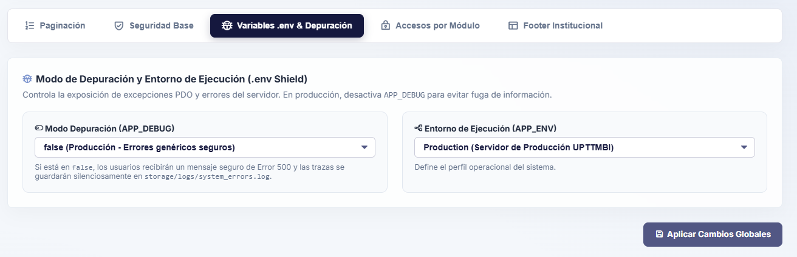
Note. Information-leakage hardening panel enabling switching between development and production modes while hiding technical database exceptions from the general public. Source: The authors (2026).

6.10.4. Per-Module Access
The fourth tab, "Per-Module Access" (see Figure 167), enables defining "Privilege Levels per Module" at a macroscopic level, following the system's hierarchical scale where Level 0 represents the absolute authority of the SuperAdmin and higher numbers represent lower privileges (with 999 representing unrestricted public access without a session and 998 representing the minimum level for visitors on sign-in/registration screens); this section works hand in hand with RBAC regarding system permissions: whereas RBAC governs specific action permissions and privilege level creation, this panel assigns the minimum privilege level required to enter each module.
This grid displays cards for every installed module—serving as another section that dynamically reads the storage folder to ensure scalability; on each card, the administrator can numerically specify the minimum "Public Level (View)" required to browse consultation screens and the "Admin Level (Manage)" required to access its internal administration panels. For instance, all users—even without an account—may browse the repository or articles, whereas specific modules such as research, which require an application submitted by university students, demand at least authentication within the system.
Figure 167
Configuration of minimum numeric privilege levels to view and manage each module
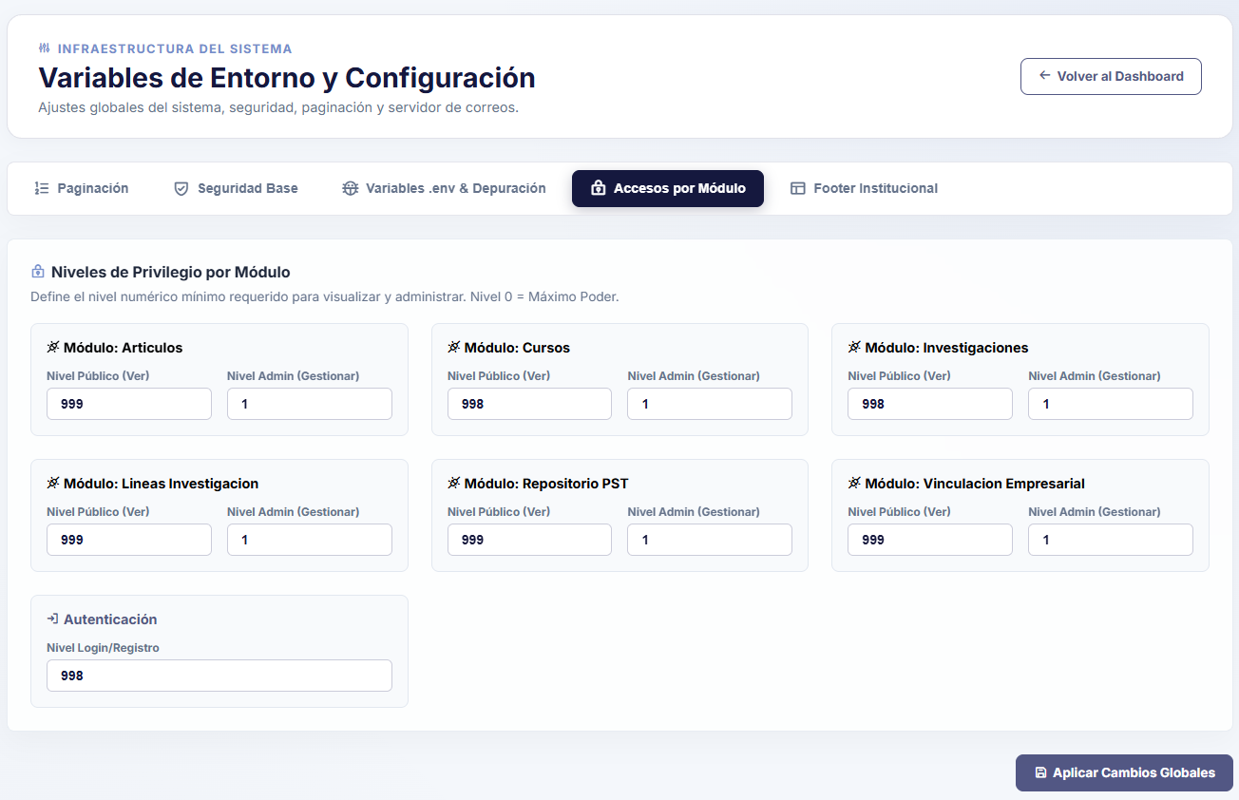
Note. Macroscopic access control grid defining which numeric hierarchical rank is required to browse public views or administer the internal panels of each package. Source: The authors (2026).

6.10.5. Footer Configuration
Finally, the fifth tab, titled "Institutional Footer" (see Figure 168), materializes the dynamic manager mentioned in the basic components section of this manual, enabling "Scalable Institutional Footer Customization" without touching view code; this interface organizes each footer column into independent cards (with header options to add new columns or restore the default layout), allowing administrators to edit the column title, assign its graphic icon using Phosphor Icons library classes (e.g., ph-fill ph-map-pin), add or remove paragraph blocks supporting <strong> tags and line breaks, manage the list of social media links with their respective icons, and define a motto or highlighted note at the bottom of each column.
In the lower bar of the panel, titled "Bottom Copyright and Credits Bar (Footer Bottom)", the SuperAdmin can directly update the left-hand text corresponding to the official Copyright notice and the right-hand text reserved for the PNF Informatics development team credits, applying changes instantaneously across all platform pages upon clicking "Apply Global Changes".

Figure 168
Scalable customization manager for Institutional Footer columns and credits
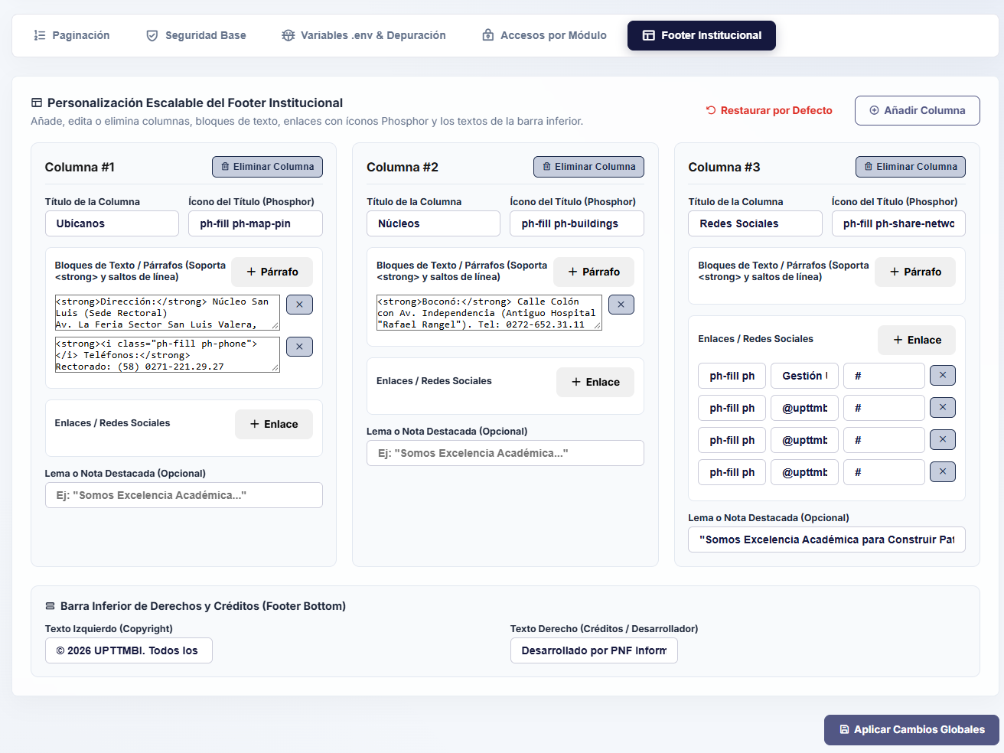
Note. Dynamic interface enabling administrators to add or edit columns, address paragraphs, Phosphor icons, social media links, and legal copyright notices in the global footer. Source: The authors (2026).

